Texas Map Projections
Summary and Commentary by Clark Thompson
6 Nov 2001, with additions by M. Helper, 07- 2003

- State-wide Projections
  - Texas State Mapping System – Lambert Conformal
  - Texas State Mapping System – Albers Equal Area
  - Texas Water Development Board GAM
- Regional Projections
  - UTM family
  - Texas State Plane family

Texas State Mapping System - Lambert Conformal Projection

Projection Type: Lambert Conformal Conic
Spheroid: GRS80
Datum: NAD83
Central Meridian: -100 00 00 (-100)
Reference Latitude: 31 10 00 (31.166667)
Standard Parallel 1: 27 25 00 (27.416667)
Standard Parallel 2: 34 55 00 (34.916667)
False Easting: 1,000,000 (meters)
False Northing: 1,000,000 (meters)
Units: meters

Nomenclature: This projection was formerly called simply “Texas State Mapping System” and this term is still widely used. The coordinates of the TSMS-LC were formerly called “Shackelford coordinates”. Since a projection and its coordinate system are essentially equivalent, “Shackelford coordinates” and “Texas State Mapping System (Lambert Conformal)” are synonymous in that they both refer to data in the same projection.

Usage: This projection is widely used by state agencies. The advantage to using one projection for the entire state is that GIS data from various sources or projects can be seamlessly integrated into mosaic map views. Most of the TNRIS database is in TSMS-LC projection (coded in the file names as “ts”). Because much of this data was created before the “LC” qualifier was added, the projection will be called simply “Texas State Mapping System” in the metadata and any accompanying text files.

Advantages: Vast amount of data already exists in this projection. As a Lambert Conformal Conic projection, the TSMS-LC gives a pleasing rendition of Texas with good shape and direction preservation. Symmetry of the offsets (false easting and false northing) allows easy determination of quadrant.

Disadvantages: Like any state-wide projection, projection distortion is not minimized for most small study areas. The original definition of the lines of secancy (the standard parallels) was in deg-min-sec format, causing awkward decimals when converted to decimal-degree format. Lack of good area preservation of the LC projection may be an issue for small study areas.

Warning: A rare “foot” variant of the TSMS-LC exists. It has identical projection parameters except that the offsets (false easting and false northing) are set to 3,000,000 ft and 3,000,000 ft, and, of course, the coordinates are measured in feet so the coordinate values are roughly three times as great as if they were in meters. [Note that this change in offset changes the physical location of the origin of the projection since 3 feet are not exactly 1 meter.] While this TSMS-LC “foot” variant is very uncommon, if you run into it you will not be able to overlay such data with normal “meter” TSMS-LC data unless you first re-project one to match the other. I recommend you choose the standard meter version.
Texas State Mapping System – Albers Equal Area Projection

Projection Type: Albers Equal-area
Spheroid: GRS80
Datum: NAD83
Central Meridian: -100
Reference Latitude: 31.25 (31 15 00)
Standard Parallel 1: 27.5 (27 30 00)
Standard Parallel 2 35 (35 00 00)
False Easting: 1,500,000 (meters)
False Northing: 6,000,000 (meters)
Units: meters

Nomenclature: This projection was formerly called “Texas Centric Projection / Albers” (abbreviated “TCP/A”) or simply “Texas Centric.” It is now called “Texas State Mapping System – Albers Equal Area” (abbreviated “TSMS-AEA”).

Usage: This projection is sometimes used by state agencies when area preservation is important, but it is relatively uncommon.

Advantages: Preserves area better than TSMS-LC. Lines of secancy (standard parallels) were selected to avoid the awkward decimals found in TSMS-LC.

Disadvantages: Little data exists in this projection. It is incompatible with the TSMS-LC.

Warning: A “foot” variant of the former Texas Centric projection exists. It has identical projection parameters except that the offsets (false easting and false northing) are set to 4,500,000 ft and 18,000,000 ft, and, of course, the coordinates are measured in feet so the coordinate values are roughly three times as great as if they were in meters. [Note that this change in offset changes the physical location of the origin of the projection since 3 feet are not exactly 1 meter.] While I have never found any data in this TCP/A “foot” variant, I have often seen the “foot” parameters given for the TCP/A projection itself, so you might run into it. Remember that this projection is only used when measuring areas (on a state-wide basis) is important. Traditionally in Texas areas have been measured in acres or square miles in preference to hectares or square kilometers, so a “foot” version might seem reasonable to state agencies. [Note that while the TWDB-GAM projection discussed below is a special foot-variant of the TSMS-AEA, it is derived directly from the meter version described above.]

Texas Water Development Board GAM Projection

Projection Type: Albers Equal-area
Spheroid: GRS80
Datum: NAD83
Central Meridian: -100
Reference Latitude: 31.25 (31 15 00)
Standard Parallel 1: 27.5 (27 30 00)
Standard Parallel 2 35 (35 00 00)
False Easting: 4,921,250.00000 (US survey feet)
False Northing: 19,685,000.00000 (US survey feet)
Units: US survey feet

Nomenclature: This projection doesn’t have a formal name. It is a variant of the TSMS-AEA (meters) that was modified to units of survey feet.

Usage: This projection is mandated by the Texas Water Development Board for use in all Groundwater Availability Modeling to be done pursuant to Senate Bill 1 (1997) regional water planning. This program will result in a large amount of groundwater-related data being generated in these coordinates. Since these data will be made available to the public as the program progresses, you might encounter this projection in your future work

Advantages: Same as for TSMS-AEA (area preserved better than TSMS-LC, no awkward decimals for lines of secancy).

Disadvantages: The peculiar offsets (false easting and false northing) may seem confusing to some users. They were derived by multiplying the corresponding parameters of the TSMS-AEA by 3937/1200 to convert them to US survey feet (that is, by definition 1 m = 3937/1200 US survey ft). See explanation of US survey feet below.

US Survey Feet: The United States used a foot-yard-mile system for surveying and map-making before and after the meter came into widespread acceptance internationally (c. 1800). In 1866 the US Congress passed an act that fixed the meter to be exactly 39.37 inches (in reality, this defined the inch in terms of the meter). A foot assembled from 12 such inches became the US Survey Foot. This conversion rate was used for the next 93 years, and gives us the ratio 1 m = 3937/1200 US survey feet. In 1959, by executive order, the conversion rate was altered slightly to define 1 inch as exactly 2.54 centimeters. This 1 in. = 2.54 cm is the conversion rate we use in science. It results in a foot being exactly 0.3048 meters. However, surveyors and map-makers continued to use the earlier (3937/1200) conversion rate (which corresponds to one US Survey Foot equal to 0.30480060960 meters). Since the meter conceptually hasn’t changed, the earlier conversion results in “US Survey Feet” and the 1 in = 2.54 cm conversion results in “International Feet,” often called simply “feet”. The difference between these two units is extremely small – about 0.66 feet in 60 miles or about 20 cm in 100 km. Nevertheless, the purists among us will want to know that most mapping and surveying is made in US survey feet whereas we use the other kind for just about everything else. The ArcView Projection Utility wizard gives you the choice as well: US Survey Feet are called “Foot_US [9003]” whereas the International Foot is called just “Foot [9002]”. I recommend you use US Survey Feet for all your foot-based GIS work since this is the unit the surveyors actually used.

UTM (Universal Transverse Mercator) Family of Projections

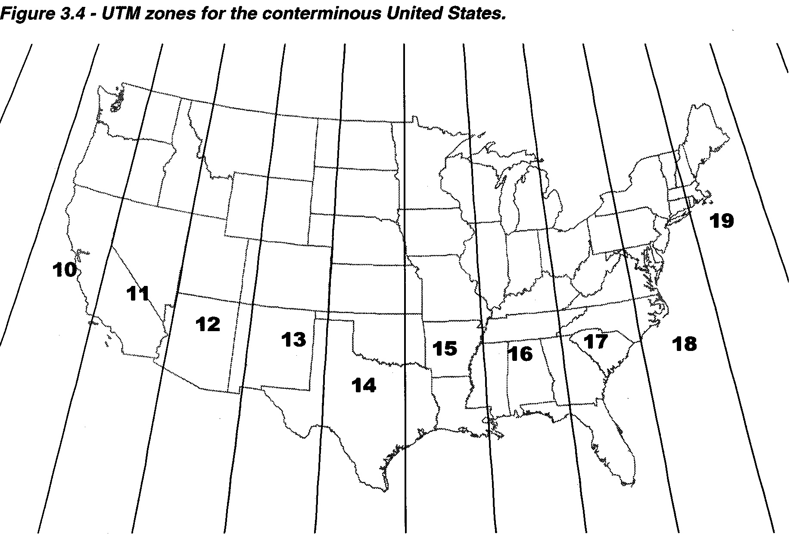

Projection Type: Transverse Mercator
Spheroid: GRS 80
Datum: NAD83
Units: meters
Zone (specific projection): 13N 14N 15N
Central Meridian: -105 -99 -93
Reference Latitude: 0 (Equator) 0 (Equator) 0 (Equator)
Western limit: -108 -102 -96
Eastern limit: -102 -96 -90
Scale Factor: 0.9996 0.9996 0.9996
False Easting: 500,000 (m) 500,000 (m) 500,000 (m)
False Northing: 0 (m) 0 (m) 0 (m)

Nomenclature: “UTM” is a projection family, not a specific projection. Only the UTM zone (e.g., “14N”) codes for a specific projection and coordinate scheme.

Usage: The UTM system was developed by the military to standardize the projection type on a worldwide basis. UTM projections are commonly used whenever a “default” projection is needed and state lines or other political boundaries are irrelevant. UTM is somewhat common for scientific applications and used to some extent by the federal government. UTM is seldom used by state and local governments.

Advantages: World-wide usage.

Disadvantages: The arbitrary zone boundaries every 6 degrees creates a serious problem for any study area that straddles one of these boundaries.

Variants: A pre-1983 version of the UTM system exists which uses the Clarke 1866 spheroid and NAD-27; all other parameters are identical. If you need to combine data with mixed datums, the datum difference can cause horizontal disparities on the order of 100 feet or so, which may not be a problem in many applications. I have never seen any UTM “foot” variants. For southern hemisphere latitudes, a false northing of 10,000,000 meters (the distance from the equator to the poles along any line of latitude) is applied.

Texas State Plane Family of Projections
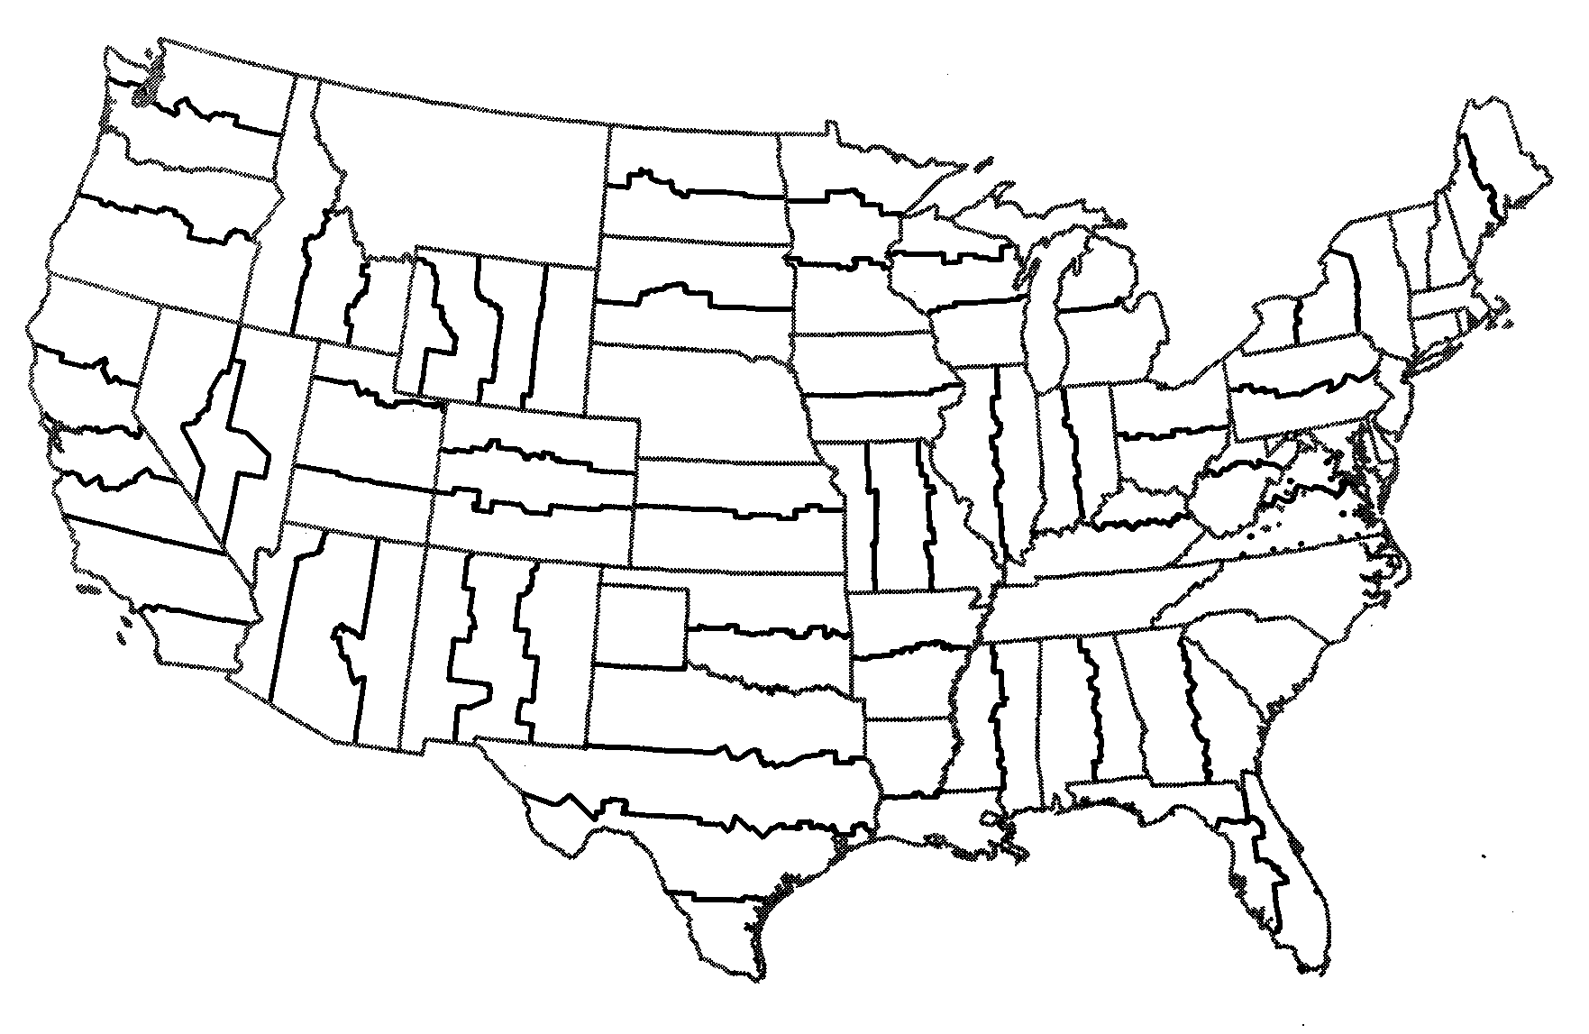

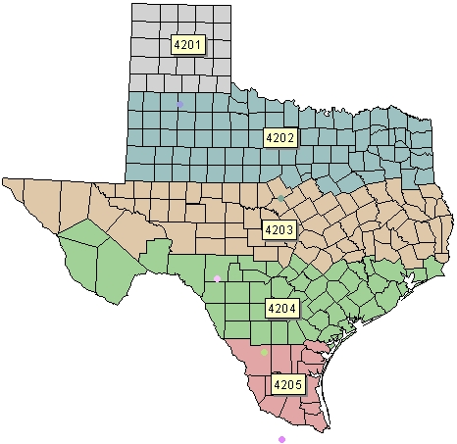
Code  Zone | Stand. Parallels | Origin | F. Easting  F. Northing
4201  North | 34.650  36.183 | -101.50  34.00 | 200,000  1,000,000
4202  N. Cent. | 32.133  33.967 | -98.50  31.67 | 600,000  2,000,000
4203  Central | 30.117  31.883 | -100.33  29.67 | 700,000  3,000,000
4204  S. Cent. | 28.383  30.283 | -99.00  27.83 | 600,000  4,000,000
4205  South | 26.167  27.833 | -98.50  25.67 | 500,000  5,000,000

Projection Type: Lambert Conformal Conic
Spheroid: GRS80
Datum: NAD83
Units: meters (see notes below)

Central Reference Standard Standard False False
Zone Meridian Latitude Parallel 1 Parallel 2 Easting Northing

North: -101 30 00 34 00 00 34 39 00 36 11 00 200,000 (m) 1,000,000 (m)
(4201) (-101.5) (34) (34.65) (36.183333)

North Central: -98 30 00* 31 40 00 32 08 00 33 58 00 600,000 (m) 2,000,000 (m)
(4202) (-98.5)* (31.666667) (32.133333) (33.966667)

Central: -100 20 00 29 40 00 30 07 00 31 53 00 700,000 (m) 3,000,000 (m)
(4203) (-100.333333) (29.666667) (30.116667) (31.883333)

South Central: -99 00 00 27 50 00 28 23 00 30 17 00 600,000 (m) 4,000,000 (m)
(4204) (-99) (27.833333) (28.383333) (30.283333)

South: -98 30 00 25 40 00 26 10 00 27 50 00 300,000 (m) 5,000,000 (m)
(4205) (-98.5) (25.666667) (26.166667) (27.833333)

*The NAD-27 version gives the central meridian as -97 30 00 (-97.5). One of these may be in error. All the State Plane parameters were obtained from the ArcView Projection Utility database and have not been independently verified.

Nomenclature: “Texas State Plane” is a projection family, not a specific projection. Only the zone (e.g., “Texas SP Central”) codes for a specific projection and coordinate scheme. Since there is no overlap between the zones, at any given location only one zone applies. Thus it is common (if incorrect) to simply refer to the projection as “State Plane” and leave determining the zone as an exercise for the user.

Usage: State Plane projections are commonly used by counties and cities. Also, TxDOT frequently uses it because TxDOT does most of its mapping on a county-by-county basis. The City of Austin has a tremendous amount of data available. It is all in Texas State Plane Central projection, but the units are converted to US survey feet. This conversion requires that the offsets also be converted. For clarity, the City of Austin data is in the following projection:

Texas State Plane Central Projection used by City of Austin
Projection Type: Lambert Conformal Conic
Spheroid: GRS80
Datum: NAD83
Central Meridian: -100 20 00 (-100.33333333)
Reference Latitude: 29 40 00 (29.66666667)
Standard Parallel 1: 30 07 00 (30.11666667)
Standard Parallel 2: 31 53 00 (31.88333333)
False Easting: 2,296,583.33333333 (US survey feet)
False Northing: 9,842,500.00000000 (US survey feet)
Units: US survey feet

Advantages: The main advantage of the State Plane zones is that their boundaries follow county lines so no county is split by a zone boundary. Note that the increase in the false northing from north to south allows one to easily check from which zone the data originate.

Disadvantages: Data from different zones cannot be combined without re-projection. Zone boundaries will cause a problem for a study area that straddles the boundary. It is likely that most counties convert the NAD-83 version of their State Plane zone to feet, causing confusion both to the data preparers and data users. The lines of secancy and the center of projection are defined in the deg-min-sec format, so their decimal equivalents are often awkward repeating decimals.

Variants: A pre-1983 version of the Texas State Plane system exists using the Clarke 1866 spheroid and NAD-27 and US survey feet as units. The center of projection is the same, as are the two lines of secancy. However, all five zones have the same offset, which is different from the above: false easting = 2,000,000 survey feet and false northing = 0 survey feet. These NAD-27 versions used today should not be confused with “feet” versions of the NAD-83 projections. In the later case, the offset from the NAD-83 version is simply converted to US survey feet (using 1 m = 3937/1200 survey feet) and all other parameters are identical to those in the above table.

