Stochastic Representation of Subgrid Snow Cover Variation in CLM and Its Influence on Land Surface Simulation:
Case Study in Sleepers River

1. Background
1.1 CLM introduction
Community Land Model (CLM) is a state-of-the-art land surface model developed in National Center of Atmosphere Research (NCAR) through efforts of scientists from several institutions and with different research backgrounds and serving as a prototype modular land model for weather forecasting and climate studies. It contains atmospheric coupling, surface dataset and adjustable parameters and physical constant. The energy cycle, hydrology cycle and ecology cycle are fully coupled and simulated in CLM which mainly include following physical processes and physical land surface variables: (1) surface albedos; (2) radiative fluxes; (3) momentum, sensible heat, and latent heat fluxes; (4) soil and snow temperatures; (5) canopy hydrology; (6) snow hydrology; (7) surface runoff and infiltration; (8) soil water; (9) sub-surface water; (10) runoff from glaciers, wetlands, and snow-capped surfaces; (11) stomatal resistance and photosynthesis; (12) lake; (13) river transport.

1.2 Snow cover representation in land surface model
In presence of snow precipitation in the grid domain of land surface model (like CLM), the model need to use variable named “snow cover fraction(SCF)” to describe how much area on ground within this particular grid is covered by snow. And SCF is a parameter to quantify the subgrid distribution status of snow state variable, ie., the snow water equivalent(SWE) or snow depth(SD). Since the area covered by snow has significantly different energy and water processes compared to those on snow-free area, the SCF is a very important parameter in simulating energy and water cycles in cold region. Different SCF parameterization scheme would produce different albedo and also different magnitude of absorbed incoming radiation. Thus the whole energy balance and hydrologic cycle(related with snow melting process) would be different. Regarding to this consideration the realistic quantification of SCF in each model step is desirable. Typically in land surface model the SCF is treated as a function of grid-mean SD or grid mean SWE, by assuming that the higher the mean SD, the higher the SCF. While this parameterization does not account for the subgrid SD or SWE distribution status and its influence on SCF during melting season. The physically based hypothesis is that given the same gird-mean SD, grids with different subgrid distributions would result in totally different snow cover area after same magnitude of spatially homogenous melting event. In this project we would explore alternative method to simulate the evolution of relationship between SCF and SD (or SWE) in CLM based on other people’s work and design sensitivity tests to investigate the performance of this new scheme, how the new parameterization influence the CLM’s capability of simulating land surface processes, and what is the optimal intrinsic parameter used in the scheme.

2. Stochastic representation of subgrid snow cover variation
In this project we would adapt the scheme of stochastic representation of subgrid snow cover variation proposed by Liston (2004) and couple it into CLM 2.0. This section summarizes the theoretical background of this scheme, how this scheme functions, and the key scheme parameter derivation.
  - Wind, topography and temperature influence on snow redistribution
There are several physical processes causing subgrid snow cover heterogeneity which means within same CLM grid the SD or SWE are larger somewhere than other places. There processes includes: spatially heterogeneous snow precipitation, spatially heterogeneous snow melting and snow redistribution by wind blowing. For simplification the stochastic scheme by Liston incorporate the mechanisms of snow redistribution and orographic snow precipitation to generate subgrid snow cover variation. Liston identify three prominent local land surface properties controlling this redistribution processes: wind, topography and temperature.
In natural world it is evident that wind blowing can remove snow in certain locations and bring them to other location, resulting spatially inhomogeneous SD (or SWE). Tall vegetation standing on ground is capable of hampering this wind bowling process by blocking the movement of snow. We can use different types of vegetation which are grouped in terms of their height to surrogate the role of wind in this snow redistribution simulation with the advantages that the vegetation dataset is easy to be derived from both ground survey and satellite remote sensing. The topography is another dominate source of subgrid snow heterogeneity by introducing orographic precipitation. And this influence is especially important in mountainous area such as Rocky Mountain and surrounding areas. Temperature also modify the snow relocation in a non-trivial extent. And the role of temperature in this modulation can be replaced by latitude ( supposing the higher of the latitude, the lower of the near surface temperature) without losing first-order accuracy.

  - Basic hypotheses for stochastic scheme
To facilitate the mathematical implementation of stochastic process of subgrid snow cover evolution and starting from physical analyses conduced in section 2.1, the following hypotheses are proposed in Liston(2004) regarding to subgrid snow distribution:
- The incoming snow precipitation is spatially homogenous in CLM gird;
- The melting rate at each time step is spatially homogenous in CLM gird;
(3) The snow distribution at snow accumulation season can be simulated using a Lognormal distribution function, with the mean of snow-water equivalent and coefficient of variation (CV) as two parameters;
(4) The snow distribution at melting season can be analyzed based on two effects: the snow accumulation distribution and the homogenous melting rate. The snow distribution curve is shifted towards negative direction;
(5) At time when new accumulation occur during the midterm of melting, the new snow precipitation would be used to remove the effect of accumulated melting and move the distribution curve towards fully cover direction.
Based on these hypotheses the SCF-SWE dynamic relationship can be illustrated in Figure 1. And the associated mathematical equations are given in Equation (1)-(6). In this example the CV is constant and different curve represents different value of accumulative snow precipitation.

$\begin{aligned}Γ(D_{m})=0\text{.}5∗\text{erfc}(\frac{z_{\text{Dm}}}{\sqrt{2}}) \\ D_{a}(D_{m})=0\text{.}5u∗\text{erfc}(\frac{z_{\text{Dm}}−ξ}{\sqrt{2}})−D_{m}Γ(D_{m}) \\ \text{erfc}(x)=\frac{2}{\sqrt{π}}\int_{x}^{∞}{e^{−t^{2}}\text{dt}} \\ z_{\text{Dm}}=\frac{\text{Ln}(D_{m})−λ}{ξ} \\ λ=\text{Ln}(u)−0\text{.}5∗ξ^{2} \\ ξ^{2}=\text{Ln}(1+{\text{CV}}^{2})\end{aligned}$ (1)
(2)
(3)
(4)
(5)
(6)
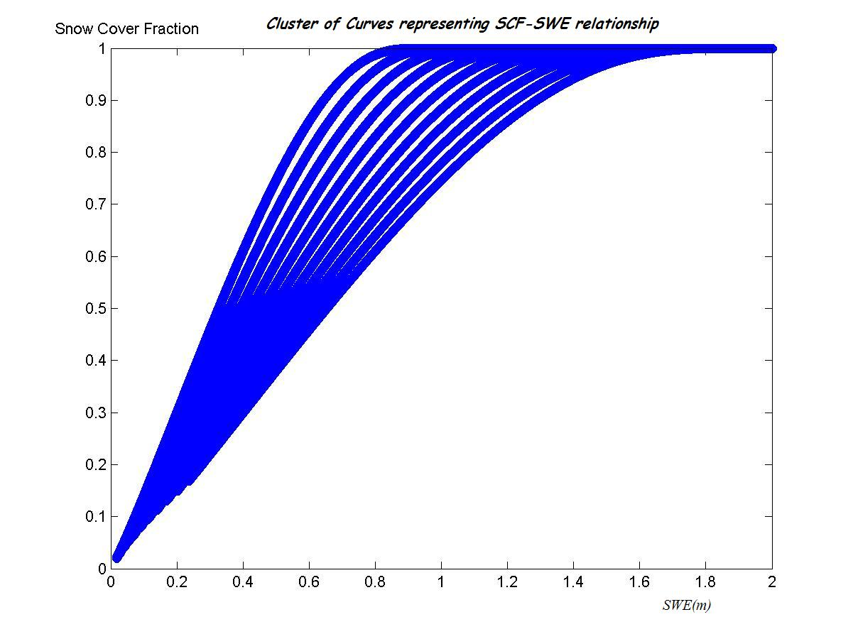

Figure 1. SCF-SWE relationship in melting season would evolve among the cluster of curves which has mathematical formulation described above, each curve with different value of accumulated snow precipitation--u

- Introduction of study site
To evaluate the performance of above stochastic snow variation model we used observational data obtained in subcatchment W-3 (8.4 km²) of the Sleepers River watershed (111 km²) in highlands of Vermont, USA. The land cover of these subcatchment mainly include grass (area fraction 80%) and bare soil (area fraction 20%). The dataset provide atmospheric forcing and hydrological data from 1969 to 1974 at half hour intervals. The W-3 topography is characterized by rollinghils and the soil are dominated by silty loams.
- Coupling subgrid snow variation module into CLM(offline, point scale) code
  - Adding stochastic snow variation process into Driver.F90 in CLM code
The code implementation of stochastic snow variation process is comprised of three parts. The first part is the initialization of two variable (accumulated snow precipitation and accumulated melting) in CLM organizing files and allocate memory for them. This is comparatively easy to achieve. The second part is to insert the program describing stochastic relationship of SWE and SCF expressed in Equation(1) and (2) into CLM Fortran module Driver.F90. This Fortran file controls and coordinates every physical subrountine involved in CLM. So when dynamic snow cover evolution scheme has been coupled in this module, it would be seamlessly linked to other related energy and water processes. The third part of code implementation is to put a Genetic Algorithm into Driver.F90 to resolve Dm from Equation (2) with knowing the value of average SWE.
The code implementation for the second part is given in Appendix A and the third part is discussed in more detail in next section.

  - Applying genetic algorithm into Driver.F90 in CLM code
At some situation when re-accumulation of snow occurs during the middle of melting season, we need to derive accumulative snow melting for this particular time step merely from Equation (2). In this equation the average SWE is known based on incorporation of current snow precipitation. Since analytic solution for Equation (2) is over complex, the genetic algorithm is used to optimize the result with favorable computational efficiency. The accuracy and computational complexity of this algorithm are validated and meets the requirement of running CLM.

- Simulation results and discussion
In this project our main purpose is to find out how the stochastic subgrid snow cover variation module performs when coupled into CLM. And CV is the important parameter representing effect of local land surface properties---vegetation type, topography and temperature. From this perspective we design the simulation test by defining CV as a adjustable parameter in previous coding implementation and vary CV in each simulation to investigate how the resulting time series of land surface water flux, snow state variable and energy flux change according to CV and calibrate the optimal CV for this catchment by comparing results with the observed dataset.
From Figure(2) to Figure (5) we can find that these simulated SWE and SD are quite sensitive to change of CV. Lower CV (0.6 and 0.8) generate early melting season and underestimate the SWE (or SD) compared to observed results. CV as 1.2 or 1.36 has good results and agree well with the observation. That imply that CV in range of (1.2-1.36) might be the intrinsic value for this particular catchment and would not vary with time given the time-invariant vegetation type, topography and latitude location.
Comparison of runoff simulated by different CV shown in Figure (6)- Figure(7) also demonstrates the importance of correct CV parameterization in reconstructing hydrologic flux in cold region when melting water from snow unit in spring is the substantial source for runoff production. Appropriate CV can bring more correct phase of snow melting and phase of runoff.

Figure 2. Time series of SWE and SD during 1969-1974 in W-3 catchment, blue is simulated result using CV=1.36, and red are observed data

Figure 3. Time series of SWE and SD during 1969-1974 in W-3 catchment, blue is simulated result using CV=1.2, and red are observed data

Figure 4. Time series of SWE and SD during 1969-1974 in W-3 catchment, blue is simulated result using CV=0.8, and red are observed data

Figure 5. Time series of SWE and SD during 1969-1974 in W-3 catchment, blue is simulated result using CV=0.6, and red are observed data

Figure 6 Simulated runoff (blue) using CV=1.36 and measured runoff (red)

Figure 7 Simulated runoff (blue) using CV=0.6 and measured runoff (red)

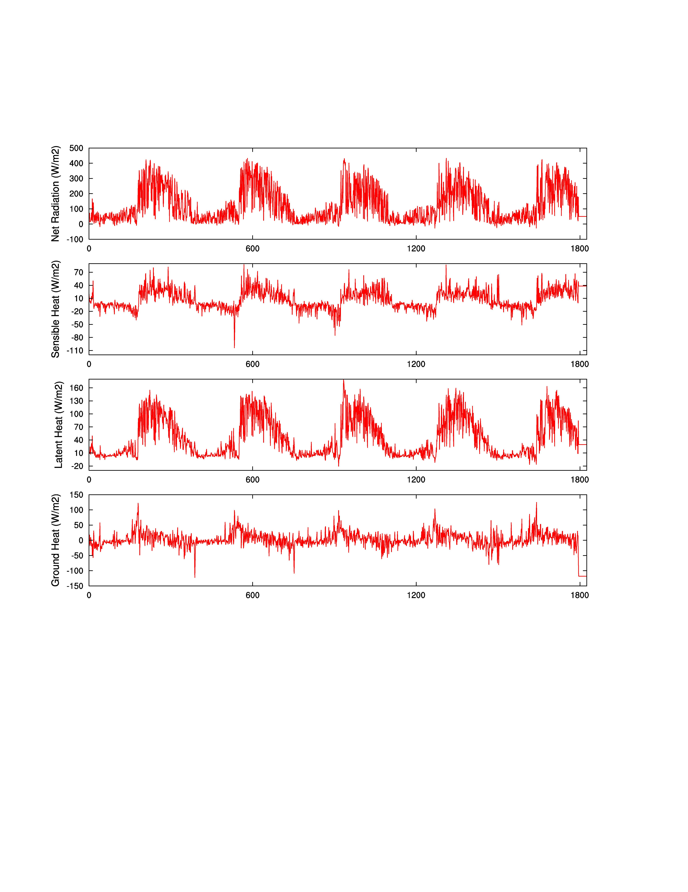

Figure 8. Simulated Energy Fluxes using CV=1.36

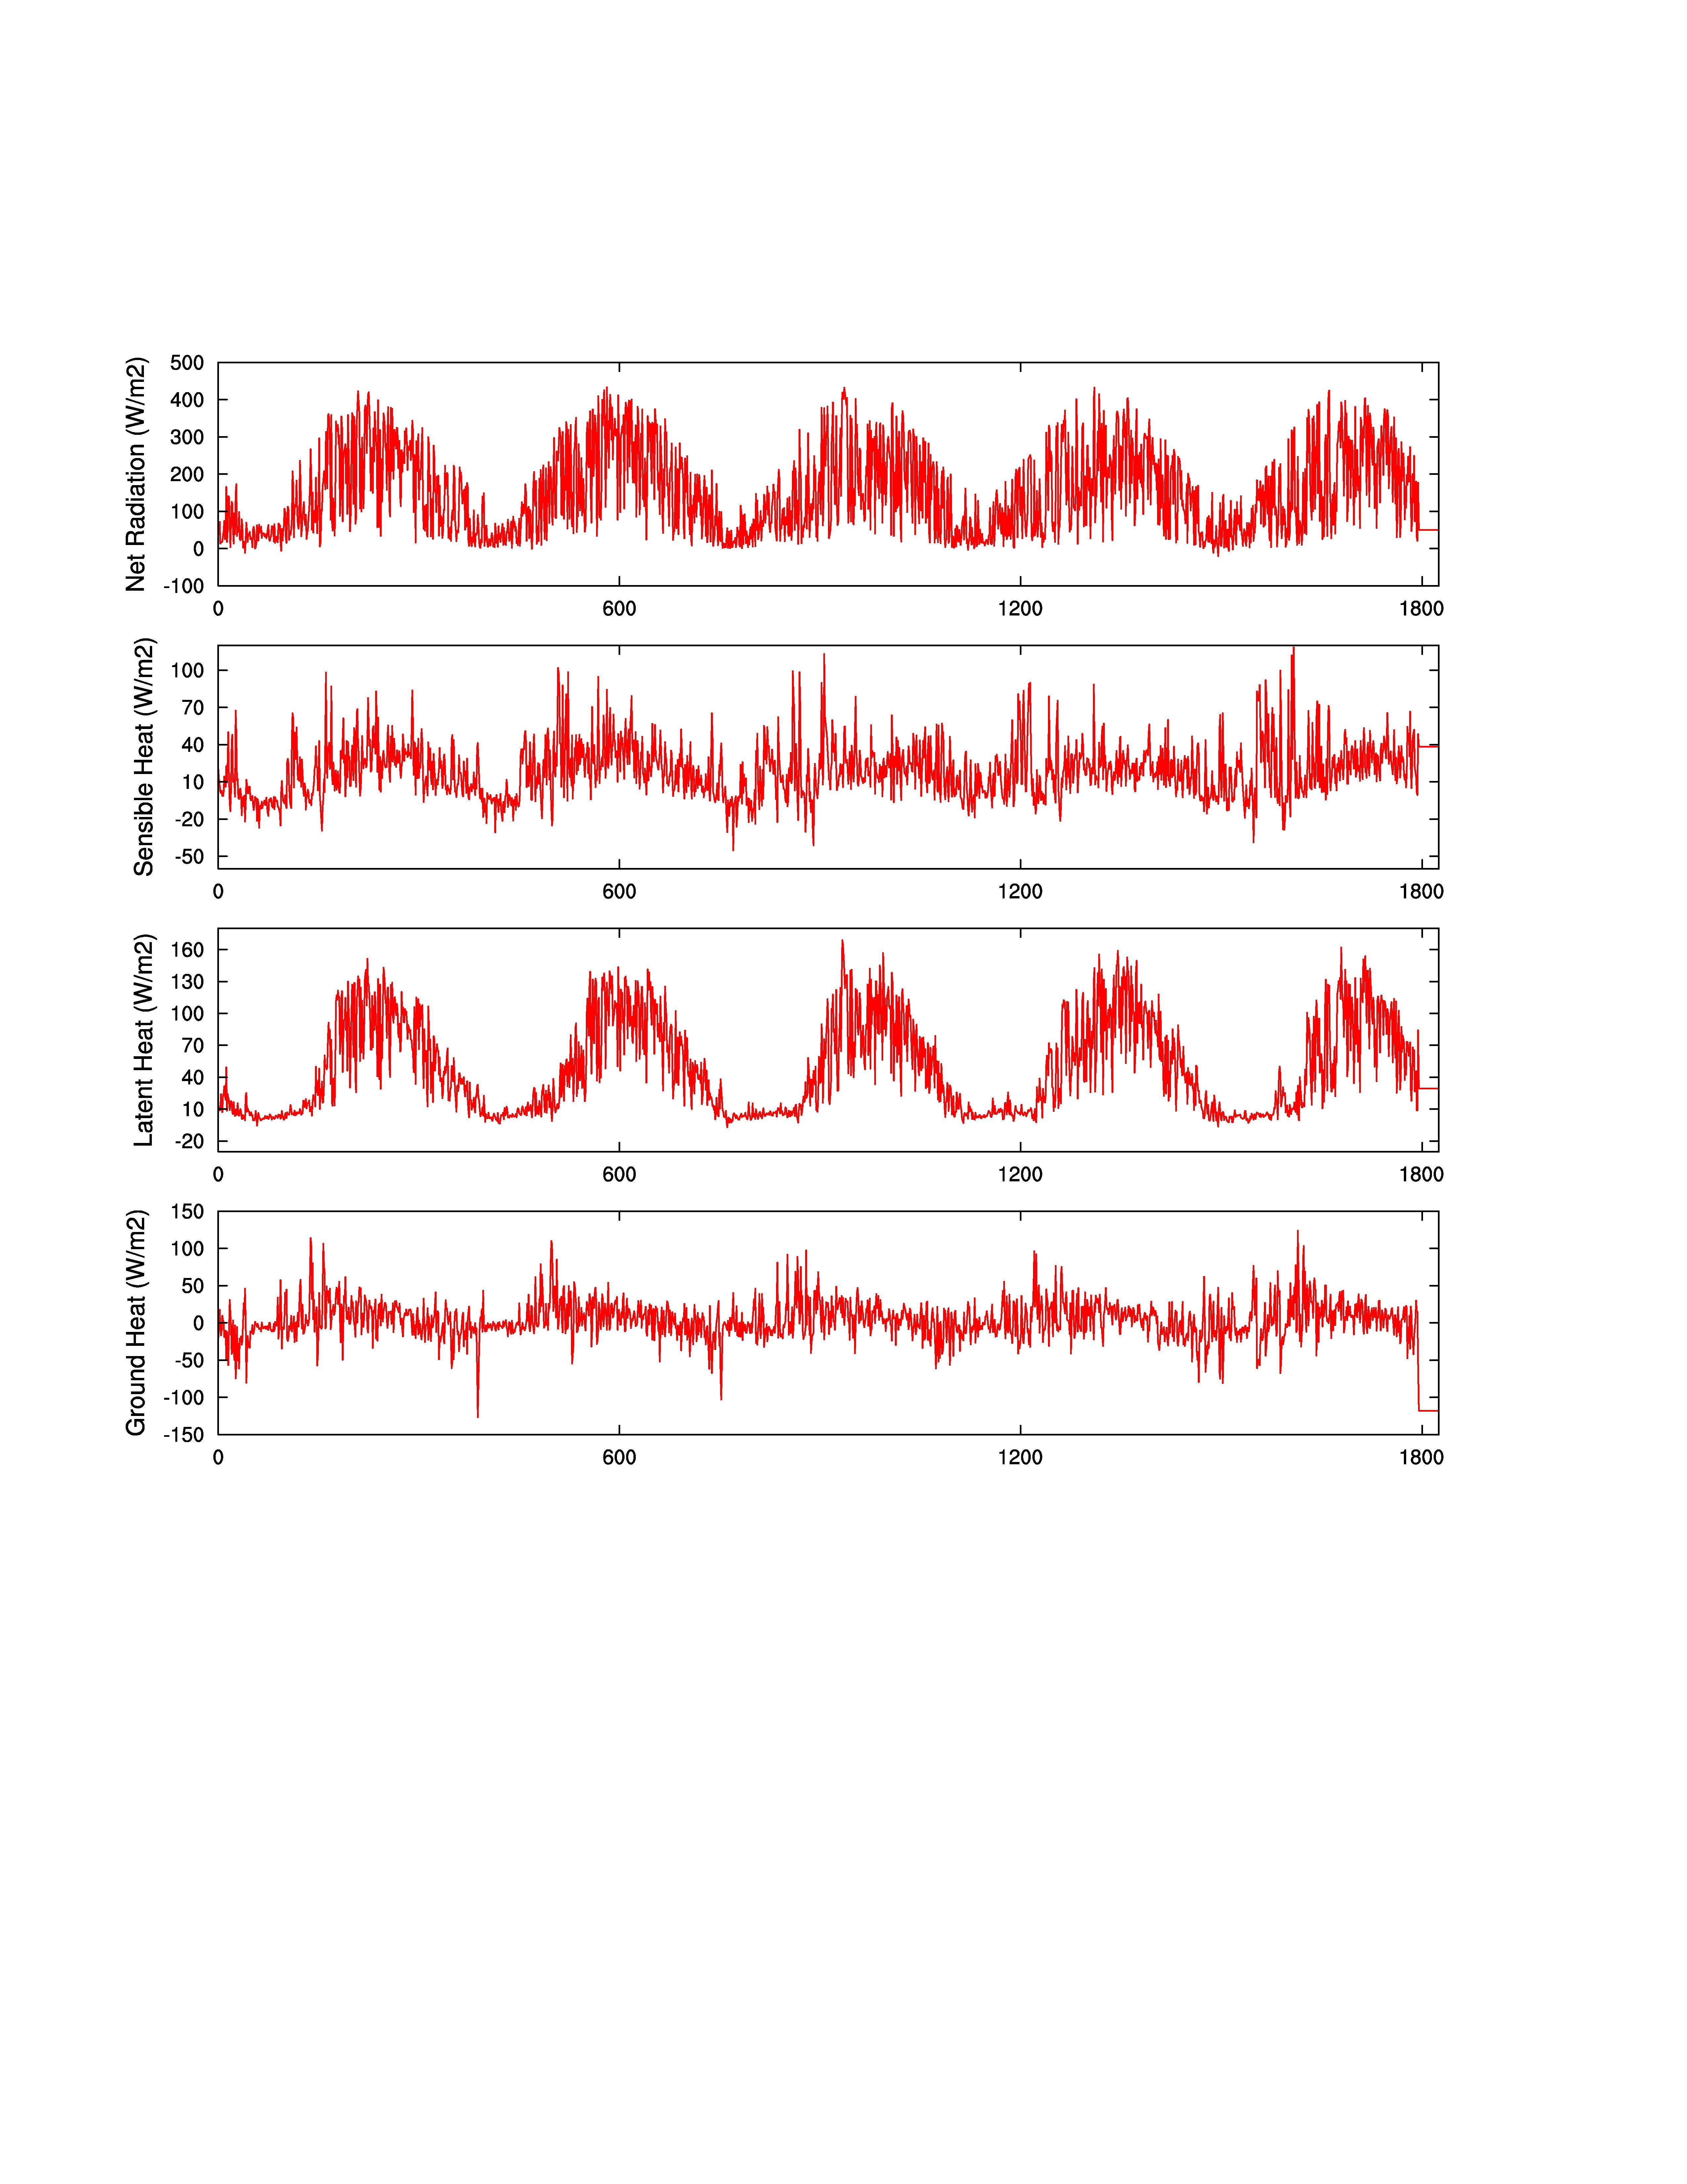

Figure 9. Simulated Energy Fluxes using CV=0.6

Appendix A: Program of subgrid snow cover variation

!StochasticSnowEvolutionProcess********************************************

snowcv = 1.6
lamd0 = 0.
zdmelt0 = 0.

if(clm(k)%h2osno.gt.0) then
if ((clm(k)%sumsno).le.0) then
clm(k)%sumsno = clm(k)%sumsno + clm(k)%qflx_snow_grnd*clm(k)%dtime + clm(k)%qflx_dew_snow*clm(k)%dtime
clm(k)%summelt = clm(k)%summelt + clm(k)%qflx_snomelt*clm(k)%dtime
if ((clm(k)%sumsno).gt.clm(k)%summelt) then
if ((clm(k)%summelt).le.0) then
clm(k)%frac_sno = 1.0
else
lamd0 = DLOG(clm(k)%sumsno)-0.5*(DLOG(1+snowcv**2))
zdmelt0 = (DLOG(clm(k)%summelt)-lamd0)/DSQRT(DLOG(1+snowcv**2))
clm(k)%frac_sno = 0.5*d_erfc(zdmelt0/(2**0.5))
endif
else
clm(k)%frac_sno = 0.
clm(k)%sumsno = 0.
clm(k)%summelt = 0.
endif
else
clm(k)%summelt = clm(k)%summelt + clm(k)%qflx_snomelt*clm(k)%dtime
if (clm(k)%summelt.le.0) then
clm(k)%frac_sno = 1.0
clm(k)%summelt = 0.
else
lamd0 = DLOG(clm(k)%sumsno)-0.5*(DLOG(1+snowcv**2))
zdmelt0 = (DLOG(clm(k)%summelt)-lamd0)/DSQRT(DLOG(1+snowcv**2))
averdep = 0.5*clm(k)%sumsno*d_erfc((zdmelt0-DSQRT(DLOG(1+snowcv**2)))/(2**0.5))-clm(k)%summelt*0.5*d_erfc(zdmelt0/(2**0.5))
totaldep=averdep + clm(k)%qflx_snow_grnd*clm(k)%dtime + clm(k)%qflx_dew_snow*clm(k)%dtime
if (totaldep.ge.clm(k)%sumsno) then
clm(k)%sumsno = totaldep
clm(k)%summelt = 0.
clm(k)%frac_sno = 1.0
else
totalsno = clm(k)%sumsno
newzdmelt = totaldep

call DE_Fortran90(FTN, Dim_XC, XCmin, XCmax, VTR, NP, itermax, F_XC,&
CR_XC, strategy, refresh, iwrite, bestmem_XC, &
bestval, nfeval, F_CR, method)

clm(k)%summelt = bestmem_XC(1)
if (bestmem_XC(1).le.0) then
clm(k)%summelt = abs(bestmem_XC(1))+0.000001
endif
lamd0 = DLOG(clm(k)%sumsno)-0.5*(DLOG(1+snowcv**2))
zdmelt0 = (DLOG(clm(k)%summelt)-lamd0)/DSQRT(DLOG(1+snowcv**2))
clm(k)%frac_sno = 0.5*d_erfc(zdmelt0/(2**0.5))
endif
endif
endif
else
clm(k)%sumsno = 0.
clm(k)%summelt = 0.
endif
! Stochastic Snow Evolution Process&&&&&&&&&&&&&&&&&&&&&&&&&&&&&&&&&&&&&&&&&&&&&&&&&&&&&&&&&&&&&&&&&&

Main Reference:

Liston G.E., 2004, Representing Subgrid Snow Cover Heterogeneities in Regional and Global Models, Journal of Climate, Vol. 17, P1381- P1397

