Community Land Model
By: Tiffany Katerndahl

Models are needed because they are able to give us an idea of what could happen in the future. However, no model is 100 percent accurate. They are able to tell use what is going to happen by analyzing data about what has happened in the past and what is currently happening. They also try to tell us why these changes are taking place, like whether it is natural or cause by man. One of these models is the Community Land Model.
The Community Land Model measures the effects of ecological climatology, which allows us to understand how changes in vegetation affect climate. This model has four components: biogeophysics, hydrologic cycle, biogeochemistry, and dynamic vegetation. However, the latter two have not been released yet. The current CLM includes the first two components.
Biogeophysics deals with the instantaneous exchanges with the atmosphere. These instantaneous exchanges can be of water, energy and momentum. It also deals with the surface influxes of these and how they influence surface climate. This can be used in many different fields such as: micrometeorology, soil physics, canopy physiology, radiative transfer and hydrology.
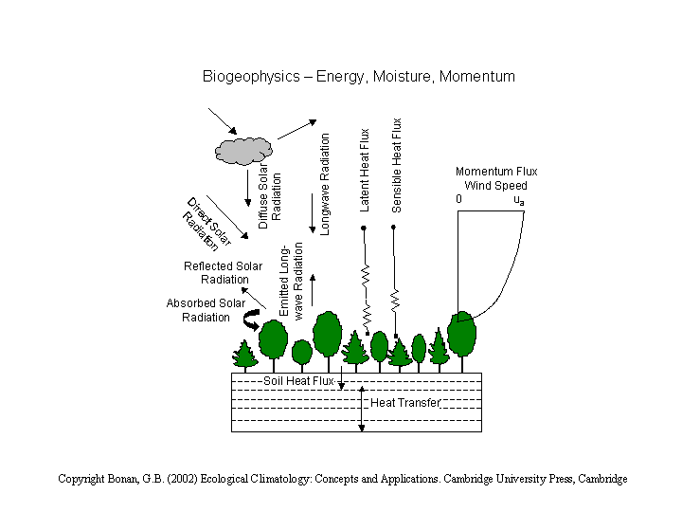picture: from www.cgd.ucar.edu/css/clm, shows how biogeophysics interacts with the atmosphere

The hydrologic cycle is linked to biogeophysics. This includes water infiltrating the ground, precipitation ( it could be either rainfall or snow), and soil moisture. These things affect temperature and other aspects of climate.
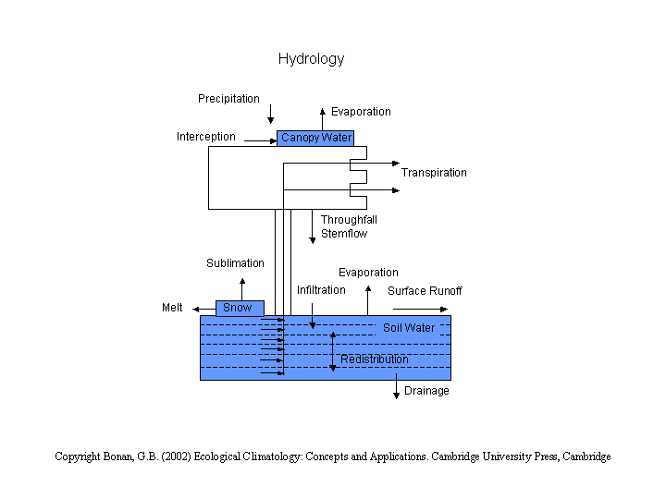
picture: from www.cgd.ucar.edu/css/clm

The main use of the Community Land Model when dealing with the hydrologic cycle is river routing, which is where the runoff is routed downstream to the oceans
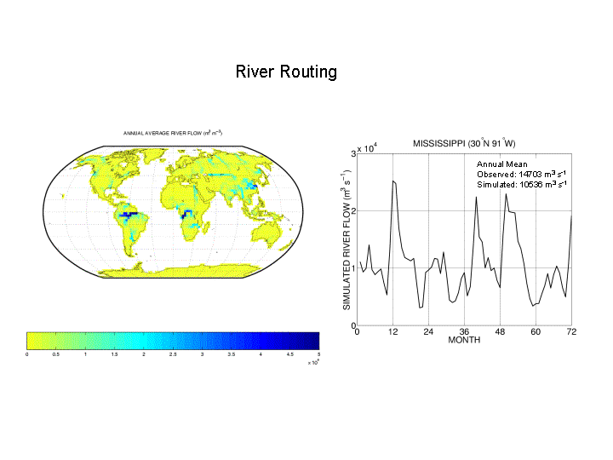
picture: from www.cgd.ucar.edu/css/clm

The Community Land Model is an important component in the NCAR Community System Model. The atmosphere is split into cells. There are 360x180x28 grid cells. It operates in two stages: dynamics and physics. Dynamics operates for the whole globe and solves conservation of energy, momentum, mass, and the ideal gas law simultaneously. Physics operates for each column, and it computes surface inputs and mass energy divergences, which is precipitation, clouds, and surface processes to name a few.

When you run the Community Land Model, you will get five sets of graphs. Graphs of the energy fluxes, water fluxes, state variables, SWE and snow depth in comparison with observations, and runoff in comparison with observations are all outputted. In the model you are able to change the type of vegetation, and the percent of that vegetation. The latitude, longitude, land fraction, sand and clay percentages in a ten layer system, and the percentage of wetland, glacier, lake, and urban areas are also able to be changed. There is even a way to control root distributions.

I am currently studying geophysics which deals with many different topics. Some of the topics includes in this is studying earthquakes, searching for hydrocarbons, plate tectonics, and studies of Arctic and Antarctic basins just to name a few. Some of these topics could use the Community Land Model and for some of these topics a different model would be better.
Since Biogeophysics is obviously a type of geophysics, the Community Land Model has at least a few applications in geophysics. However for most topics in geophysics other models would be better to use because these models are able to look into the Earth.
There are five generic types of geophysical models. These are depended upon the types of physical property distributions considered. The types of models are the uniform halfspace, buried object, the 1D model, the 2D model, and the 3D model.
In the uniform halfspace models, the Earth under the surface has the same physical properties well at least as far as the system can detect. These type of models are used for mapping shallow apparent conductivity and for other shallow investigation projects.
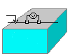picture: from http://www.eos.ubc.ca/research/ubcgif/tutorials/bkgr_3/modelytpes.htm
In the buried object models, there is a buried object within the Earth with the Earth uniform all around it. The buried object can be simple or complex. These types of models are used for finding and/or characterizing buried utilities, tanks, or any other objects.
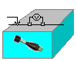 picture: from http://www.eos.ubc.ca/research/ubcgif/tutorials/bkgr_3/modelytpes.htm
In the 1D models, the physical property only varies in one direction. The Earth is divided into layers. There are two variants in this system: when you fix the thickness, you can find the values of the property, and when the number of layers is fixed, you can find the values of the property and the thickness of the layers. These models are used in layered Earth problems.
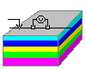 picture: from http://www.eos.ubc.ca/research/ubcgif/tutorials/bkgr_3/modelytpes.htm
In the 2D models, the physical property varies in two directions, which is usually depth and the direction parallel to the survey line. These are used for cross sections through regions, and the may be used to estimate 3D models.
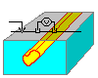 picture: from http://www.eos.ubc.ca/research/ubcgif/tutorials/bkgr_3/modelytpes.htm

In the 3D models, the physical property varies in all three directions. These are the more advanced models and are used for defining ore bodies or other geologic features.
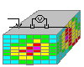 picture: from http://www.eos.ubc.ca/research/ubcgif/tutorials/bkgr_3/modelytpes.htm

Some better models for geophysical data are the Kelvin Voigt model, the Maxwell model and the linear solid model. These, along with many others, are used in exploration geophysics. These are all good in studying viscoelasticity. The linear solid model gives the best result.
The Kelvin Voigt model consists of a spring and damper in parallel. It is a good model for viscoelasticity and also 3-D wave simulation. This model is able to show us the stress strain relation. It does not require any additional field variables. This model is able to simulate 3-D waves by using the Chebychev method to compute the spatial derivatives in the vertical direction and the Fourier method to compute the spatial derivatives in the horizontal direction.
The Maxwell Model consists of a dashpot and a spring in a series. It allows you to study the effects of viscosity and loads on the stress-strain curve. There are two types of Maxwell models an elastic and an inelastic model. The elastic model deals with elastic collisions(i.e. g=v1-v2). The inelastic model deals with inelastic collisions(i.e. v1=EU1 + (1-E)U2). The Maxwell Model is good for measuring viscoelasticity and can be used for studying stress relaxation.
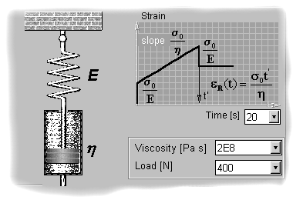picture: from deformation of polymers showing the Maxwell model
The Linear Solid model can be represented in two ways: can either be a spring in series with a Kelvin model or can be a spring in parallel with a Maxwell model. It is a good model for viscoelasticity like the other two.
The Community Land Model is a very good model for processes dealing with the land, ocean, and atmosphere. However, the other models discussed are good for looking into the interior of the Earth or for processing seismic data, which is needed for most topics in geophysics.

Bibloigraphy

Deformation of Polymers. Materials Science on CD Rom. Version 2.1.

Chen, Genmeng. Comparison of 2D numerical viscoelastic waveform modeling with ultrasonic physical modeling. Geophysics 61, 862 (1996).

http://www.cgd.ucar.edu/tss/clm/

http://hcgl.eng.ohio-state.edu/~ce552/3rdMat06_handout.pdf

http://www.eos.ubc.ca/research/ubcgif/tutorials/bkgr_3/modelytpes.htm

