Shiri Avnery
11/12/05
GEO 387H

The National Center for Atmospheric Research Community Land Model and its Dynamic Global Vegetation Model

Abstract

Terrestrial ecosystems affect climate through exchanging energy, water, momentum, gases, and aerosols with their surrounding environment. The modification of climate on multiple spatial and temporal scales in turn influences vegetation community compositions through time and space. Unlike other models, the Community Land Model’s Dynamic Global Vegetation Model (CLM-DGVM) is able to capture transient vegetation response to and affect on global climate. The CLM-DGVM represents spatial land surfaces as a grided and subgrided hierarchy, where grid cells are composed of multiple landunits, columns, and plant functional types (PFTs). While CLM-DGVM is generally successful in simulating many ecosystem processes and biogeographical distributions consistent with observations, specific ecosystems still require improvements in terms of physiological parameters and corresponding climate interactions. In addition to enabling more accurate predictions of future vegetation response to a globally warming world, combining CLM-DGVM simulations with high resolution paleoclimate proxies may provide insight into the historic relationship between terrestrial ecosystems and climate.

Introduction

Vegetation communities modify climate through the regulation of energy and water budgets, biogeochemical cycles, and trace gas emissions into the atmosphere. As climate conditions change, vegetation is in turn affected by feedback mechanisms that modify community compositions; new vegetation correspondingly affects moisture, nutrient, and energy balances according to species-specific physiological processes. The ability to model and predict global climate therefore depends on understanding the complex interaction between vegetation and climatic conditions, including identifying causal relationships and accurately quantifying the magnitude, timing, duration, and areal extent of climate modifications caused by terrestrial ecosystems. This data requirement has driven the development of models that can accurately simulate ecosystem dynamics during periods of global climate change.
The Community Land Model (CLM) is the land component of the Community Climate System Model (CCSM) and the Community Atmosphere Model (CAM) created by scientists at the National Center for Atmospheric Research (NCAR) (Oleson et al., 2004). The fully coupled CLM examines the physical, chemical, and biological processes of terrestrial ecosystems and demonstrates the importance of climate in determining vegetation compositions, as well as the ability of vegetation to regulate climate on multiple temporal and spatial scales. The overall CCSM is improved by the coupling of the land component CLM with a dynamic global vegetation model (DGVM) modified from the Lund-Potsdam-Jena (LPJ) DGVM (Levis et al., 2004). Dynamic vegetation models allow for vegetation compositions to change according to climate conditions, as opposed to “equilibrium” vegetation communities that simply serve as static model inputs. By accounting for the many interactions and feedbacks between the atmosphere, hydrosphere, cryosphere, and biosphere, DGVMs provide a more accurate illustration of ecosystem dynamics and their relationship to climatic conditions (Levis et al., 2004). Because my research focuses on vegetation disturbance—particularly due to fire—in Central America during the late Holocene, this study will examine the coupled CLM with its DGVM (hereafter referred to as the CLM-DGVM) and evaluate its potential applicability to my own research.

CLM Processes and Data Structure
The CLM is comprised of multiple components, as described by Oleson et al. (2004). The simulation of biogeochemical cycling accounts for the exchanges of carbon, biogenic volatile organic compounds (VOCs), dust, and other particles from the land with the atmosphere (Fig. 1a). Biogeophysical processes are also represented in CLM, including the fluxes of energy, water, and momentum associated with various micrometeorological, radiative, physiological, and hydrological parameters (Fig. 1b). The CLM additionally simulates the hydrologic cycle over land, which is affected by the interception of water by vegetation, the throughfall and stemflow of water, soil infiltration rates and soil water quantities, surface runoff (including rivers and streams), and the presence of snow cover (Fig. 1c). Finally, the CLM models multiple aspects of vegetation dynamics, including carbon and nitrogen cycling, ecological succession following fire and/or land use disturbance, as well as vegetation composition and modification over centuries or millennia due to climate change.
The CLM represents spatial land surfaces as a grided and subgrided hierarchy, where grid cells are composed of multiple landunits, snow/soil columns, and plant functional types (PFTs). The Technical Description of the Community Land Model (Oleson et al., 2004) details the CLM data structure summarized here. Each CLM grid cell can be divided into different landunits; each landunit may contain a different number of snow/soil columns, and each column can have multiple PFTs (Fig. 2). The landunit is the broadest subgrid level, representing the large-scale spatial distribution of different landscapes or environments. CLM classifies landunits into one of five categories: glacier, lake, wetland, urban, or vegetated. Physical soil properties are also defined at the landunit level, thereby allowing for variability in soil characteristics (such as color, texture, depth, and thermal conductivity) between landunits.
The snow/soil column is the second subgrid level and represents the evolving vertical profile of soil and/or snow within each landunit. This level defines the state variables for water and energy within the soil and snow, as well as their spatial and temporal fluctuations. Depending on depth, soil columns may be represented by up to 10 layers and snow columns by up to five layers in the CLM.
Vegetated landunit subgrids (as identified in the first-order landunit division) can be further divided into the final subgrid level: patches of plant functional types. Each PFT represents a unique leaf and stem area index and canopy height, intended to capture different biogeochemical and biogeophysical processes associated with various categories of plants and their unique physiologies (PFTs will be further discusses in the subsequent section). All energy and water fluxes to and from the surface are defined as vegetation state variables at this PFT level. CLM can incorporate up to 4 of 16 possible PFTs that may coexist within a single column for mixed vegetation landscapes; bare ground is represented as an unvegetated patch among the PFTs. In CLM, each PFT determines plant physiology, while vegetation composition, spatial distribution, and structure are direct inputs into grid cells for each PFT. CLM is thus able to interface with models that predict vegetation dynamics and response to climate change or disturbance, such as DGVMs.
The input surface data required to run CLM includes: the proportion of each landunit (glacier, lake, wetland, and urban, where vegetation occupies the remainder); the percentage cover of each PFT (up to 4 PFTs) within the vegetated landunit subgrid; the monthly leaf and stem area indices and the canopy top and bottom heights for each PFT in vegetated landunits; and the soil color, texture (fraction sand verses clay), and depth. These variables are determined from high-resolution datasets and combined into the model’s grid cells.

The NCAR Dynamic Global Vegetation Model

The NCAR DGVM is a modified version of the Lund-Potsdam-Jena DGVM (Sitch et al., 2003) that has since been coupled with CLM and integrated into the CCSM land model (Levis et al., 2004). As opposed to other types of models (e.g., forest-gap or asynchronous equilibrium models) that use climatic-biogeographical relationships to change vegetation composition by iterating until stable ecosystems are obtained, DGVMs can accurately depict transient vegetation response to climate change (Bonan et al., 2003). This section describes the various composition and structure of the CLM-DGVM as outlined by The Community Land Model’s Dynamic Global Vegetation Model (CLM-DGVM): Technical Description and User’s Guide (Levis et al., 2004).
Representation of Vegetation

In order to capture the complexities of the biogeochemical and biogeophysical processes associated with mixed vegetation communities, scientists classify vegetation by PFTs as opposed to single biomes. Multiple PFTs can coexist in a grid cell, such that a mixed forest can be represented by patches of needleleaf evergreens, broadleaf deciduous trees, and bare ground. PFTs also reduce the problem of species diversity to only key plant types with measurable physiological characteristics. Each PFT maintains a separate column for energy and water calculations, and is represented by an individual plant with average physical characteristics (e.g., biomass, height, stem diameter); by the number of individuals in the population; and by the percentage cover in each grid cell. The coupled CLM-DGVM uses a subset of the PFT categorizations (10 PFTs) embedded in the CLM, where woody vegetation is differentiated by bioclimatology, leaf form, phenology, and response to disturbance, and where grasses are distinguished by bioclimatology and C₃ verses C₄ photosynthetic pathways (Table 1 illustrates CLM-DGVM PFTs and PFT parameters). As previously mentioned, the uncoupled CLM only allows for four prescribed PFTs to coexist in a grid cell; the addition of the DGVM allows for all PFTs to exist depending on climate conditions, thereby predicting the response of a wider variety of vegetation communities to climate change.
Net Primary Production and Biomass Turnover

The CLM-DGVM has three timescales. Fluxes of energy, moisture, momentum, and CO₂ are calculated at a 20-minute time-step and update soil temperature and hydrologic cycle parameters accordingly. The accumulation of carbon is calculated annually and is used to update PFT mass, density, and fractional coverage in response to successional dynamics, resource competition, and disturbance. Leaf area indices are updated daily to a value determined by yearly vegetation characteristics. Figure 3 illustrates the order that individual processes are performed in all gird cells during one year of simulation (Sitch et al., 2003).
Biomass accumulation, calculated every 20 minutes, of the average PFT individual is represented as the difference between carbon uptake during gross primary production and carbon loss during maintenance and respiration. The CLM-DGVM scales photosynthesis from the leaf to the canopy by calculating the process separately for sunlit and shaded leaves and using a weighted sum to express the photosynthesis produced by each. Respiration is calculated using a base rate of maintenance respiration (6.3426×10⁻⁷ g C g N⁻¹ s⁻¹) adjusted to unique tissue carbon to nitrogen ratios for each PFT; this ratio represents the acclimation of vegetation to climate. After accounting for maintenance respiration, 25 percent of the remaining carbon pool is subtracted to simulate growth respiration.
Net primary production is summed annually to update two litter carbon pools (above- and belowground) and two soil organic carbon pools (fast and slow) for each PFT. The CLM-DGVM subtracts 10 percent of net primary production as a reproductive cost and transfers this carbon to the aboveground litter pool to ensure conservation of mass; remaining carbon is added to individual plant biomass. Establishment of new individuals occurs annually and is manifested as an increase in population density. Carbon pools are derived from initial leaf area indices in woody vegetation, whereas the establishment of herbaceous PFTs increases leaf and root carbon quantities; establishment these PFTs is limited to only the fraction of grid cells not occupied by woody vegetation (e.g., gaps in the canopy). Regeneration is further limited to those PFTs that are able to survive during existing climate conditions, to climates where precipitation is greater than 100 mm, and to locations where the 20-year running average of minimum monthly temperature falls within vegetation growth thresholds.
Mortality and Disturbance

Mortality is defined by a negative biomass increment and is inversely proportional to growth efficiency up to a maximum mortality rate; mortality is calculated annually and relocates biomass to carbon litter pools. Various factors contribute to vegetation mortality. Competition for light is calculated based on each PFT’s foliage projective cover (FPC) (which depends on leaf area indices updated daily) multiplied by the species crown area and population density. Fire disturbance also contributes to mortality, where fire occurrence is calculated annually as a function of fuel load and the annual sum of daily fire probability. The probability of an annual fire is defined by:
p = e^{− π(m/me)^2}

where:
m represents soil and fuel moisture values; and
me is a threshold moisture value unique to each PFT and above which fire cannot propagate. This threshold simulates fuel flammability, and is currently defined as 30 percent of the available water holding capacity of the PFT.
Annual fire season length is defined as the yearly sum of daily fire probabilities expressed as the fraction of a year:
s = N/365

Fire will occur only when a minimum fuel load of 200 g C m⁻² exists. When fuel load is greater than 200 g C m⁻², the fractional area burned in each PFT is a function of the length of the fire season given by the following equation:

A(s) = s • e [ (s-1) / (-0.13(s-1)^3 + 0.6(s-1)^2 + 0.8(s-1) + 0.45)]

Fire removes a fraction of trees in a PFT, where those that remain standing are governed by a PFT-dependent resistance to fire. Fires do not affect herbaceous PFTs because they are assumed to have annual life cycles. The CLM-DGVM also calculates the added carbon flux to the atmosphere due to biomass burning, which is subtracted from the aboveground litter carbon pool.

Discussion

CLM-DGVM Simulations

Bonan et al. (2003) demonstrate the success of the CLM-DGVM in simulating vegetation dynamics without explicit representation of individual plants, age and size structure, gap dynamics, or mosaic representations of landscapes. The authors used the following surface datasets (from Bonan et al., 2002) as inputs to model global biogeography on a 3° by 3° spatial grid integrated for 200 years from initial bare ground conditions:
- 0.5° by 0.5° maps of PFT distributions derived from 1-km IGBP DISCover data of natural and anthropogenic landcover, as well as the University of Maryland tree cover dataset of evergreen, deciduous, broadleaf, and needleleaf tree cover. In these datasets, the percentages of the tree covers were determined for each 1-km pixel. The 1-km data were then converted to grid data by finding the latitude and longitude of each 1-km cell, where PFT percentages were normalized per grid cell.
- Thirty-six global images of 1-km AVHRR red and nearinfrared reflectances over the period of study (1979-1998) to derive the seasonal progression of leaf area indices for every PFT in a 200-km by 200-km grid.
- A global, 3-hour atmospheric forcing dataset at 1.875° longitude by 1.915° latitude from the National Center for Environmental Prediction for the period 1979-1998.
The global biogeography generated by the CLM-DGVM is generally consistent with the spatial distribution of vegetation observed today (Fig. 4). Overall, the model also successfully simulated tundra, boreal forest, northern hardwood forest, and tropical rainforest establishment, succession, and post-disturbance recovery (see Bonan et al., 2002 for detailed results per individual ecosystem). Model simulations additionally demonstrate the importance of precipitation fluctuations and fire events in maintaining a mixture of trees and herbaceous species in savanna ecosystems.
Applicability to Fire Research
The success of the model in predicting savannah dynamics has implications for my own research, which aims to understand neotropical ecosystems of Central America (containing numerous savanna-dominated biomes) where anthropogenically induced fires over the last few thousand years have potentially altered natural fire regimes and thereby vegetation communities. Dull (2004) attributes the longevity of a neotropical savanna in El Salvador to anthropogenic burning between 2500-500 cal yr B.P., which benefited grasses at the expense of woody taxa: tree and shrub encroachment into the grassy savanna was shown to occur following a major 16th century population decline in the region. However, Dull (2004) cautions that deciphering the fire history of an area in which humans inhabit is difficult due to the complexities of separating anthropogenic fires from climate-induced signals in proxy data.
The CLM-DGVM simulations of Bonan et al. (2003) in the African sahel illustrate this affect of climate on savanna ecosystems and fire dynamics over two centuries. According to model results, grass-dominated communities exist in dry years and maintain annual fires of low intensity and high propagation potential. Trees dominate during wet years characterized by infrequent fires of increased intensity. Mixed tree-shrub vegetation is therefore maintained in the African sahel only during periods of interannual precipitation variability typified by fires of intermediate frequency and intensity. Bonan et al. (2003) argue that the domination of grasses during drought conditions depletes the top 30 cm of soil from water and prevents the encroachment of trees, providing ideal conditions for fire occurrence and propagation limited by biomass fuel load. As trees become established during slightly wetter conditions, leaf area indices increase and soil becomes less moisture depleted during the year; increased moisture and decreased grass (fuel) leads to suppression of fires. Finally, the maturation of trees leads to an ecosystem dominated by higher leaf area indices than can be supported by climate conditions. After a period of slightly decreased precipitation, the desiccation of large trees provides ample fuel for fire; the natural incidence of lightning therefore generates a major fire event (18 percent burn in one grid cell of the sahel), thereby reestablishing vegetation of lower leaf area indices and a more equal distribution of trees and grasses.
Given the important affect of climate in determining vegetation communities and fire behavior, the CLM-DGVM could help determine whether observed changes in vegetation and fire dynamics are climatically or anthropogenically induced in my own research. By simulating community compositions given initial vegetation abundances (as determined by pollen in lake sediment cores) and changing climatic conditions (as determined by multiple paleoclimatic proxies such as stable isotopes), the geographic distribution of modeled vegetation can be compared to that derived from the pollen record. If significant differences exist, one could argue for the potential role of humans in altering vegetation communities in the region—potentially by fire practices. Comparison to a high-resolution charcoal record derived from the same lake sediment core could evidence an anthropogenic fire regime, particularly if fire behavior is found to be different from that which would be naturally sustained by climate conditions.
The difficulty in using the CLM-DGVM for my research lies in the different spatial and temporal scales required by the model verses those inferred from paleoproxy evidence. CLM-DGVM inputs occur at 100-300 km by 100-300 km grid cells obtained from 1-km satellite data (Bonan et al., 2002). While the areal scale of my analysis has yet to be determined, an area less than the model’s resolution would render results irrelevant, as they would fail to capture vegetation dynamics on a more localized scale. Further, because the reliability of proxy evidence in accurately determining the climate and soil conditions needed to run CLM-DGVM simulations is much lower than modern (instrumental) datasets, the model’s output of past vegetation communities would maintain much higher degrees of uncertainty. Finally, while the model is generally successful in simulating many post-disturbance ecosystem processes, various ecosystems (such as tropical rainforest characterized by only one broadleaf evergreen PFT) require improvements in model simulations of biological, physiological, and successional processes (Bonan et al., 2002). In order to more accurately predict future vegetation response to climate change and the interaction between vegetation, fire, and climate, the CLM-DGVM must be continually enhanced by incorporating more detailed data related to disturbance, establishment, and succession of multiple vegetation communities.

Conclusions
Despite its limitations, the CLM-DGVM has been successful in modeling biogeography consistent with observations as well as the dynamics of multiple ecosystems. As technology and methodologies continues to improve to provide more accurate spatial resolution of modern and proxy datasets, the CLM-DGVM presents tremendous potential in studying the biogeochemical and biogeophysical processes of vegetation communities and their response to climate forcing as well as human-induced disturbance. In addition to enabling more accurate predictions of the feedbacks between vegetation and global climate in the future, the combined study of simulations from CLM-DGVM with high resolution paleoclimate proxies may provide insight into terrestrial ecosystem response to and affect on abrupt climate change events in the past.
References

Bonan, G. B., S. Levis, *S. Sitch, M. Vertenstein, and K. W. Oleson, 2003: A dynamic global vegetation model for use with climate models: Concepts and description of simulated vegetation dynamics. Global Change Biology 9: 1543-1566.
Bonan, G. B. 2002. Ecological climatology: concepts and applications. Cambridge University Press: Cambridge, U.K. 691 pp.
Bonan, G. B, S. Levis, L. Kergoat, and K. W. Oleson, 2002: Landscapes as patches of plant functional types: An integrating concept for climate and ecosystem models. Global Biogeochemical Cycles 16(2): 1021, doi:10.10292000GB001360.
Dull, R.A. 2004. A Holocene record of Neotropical savanna dynamics from El Salvador. Journal of Paleolimnology 32: 219-231.

Oleson, K. W., Dai, Y., Bonan, G., Bosilovich, M., Dickinson, R., Dirmeyer, P., Hoffman, F., Levis, S., Niu, G. Y., Thornton, P., Vertenstein, M., Yang, Z. L., Zeng, X. 2004. Technical Description of the Community Land Model (CLM). NCAR Technical Note (NCAR/TN-461+STR). Available from the National Center for Atmospheric Research publications at:
<http://www.cgd.ucar.edu/tss/clm/distribution/clm3.0/TechNote/CLM_Tech_Note.pdf#search='technical%20description%20of%20the%20community%20land%20models'>
Accessed 11/1/2005.

Levis, S., Bonan G. B., Vertenstein, M., and Oleson, K. W. 2004. The Community Land Model’s Dynamic Global Vegetation Model (CLM-DGVM): Technical Description and User’s Guide. NCAR Technical Note (NCAR/TN-459+IA). Available from the National Center for Atmospheric Research publications at:
<http://www.cgd.ucar.edu/tss/clm/distribution/clm3.0/DGVMDoc/TN-459+IA.pdf#search='the%20community%20land%20model%27s%20dynamic%20global%20vegetation'>
Accessed 11/1/2005.

Sitch, S., Smith, B., Prentice, I. C., Arneth, A., Bondeau, A., Cramer, W., Kaplan, J., Levis, S., Lucht, W., Sykes, M., Thonicke, K., and Venevski, S. 2003. Evaluation of ecosystem dynamics, plant geography and terrestrial carbon cycling in the LPJ Dynamic Vegetation Model. Global Change Biology 9: 161-185.

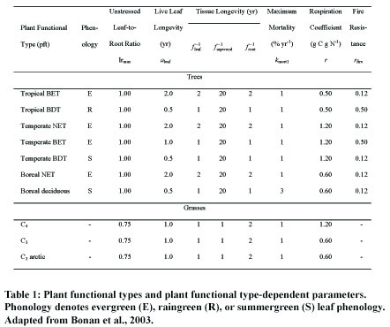
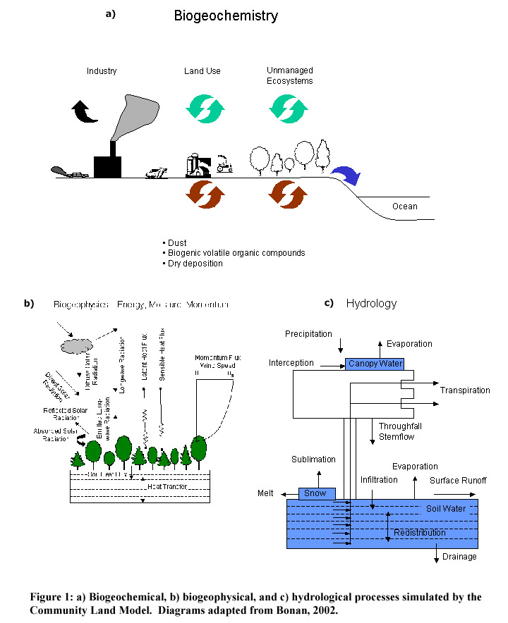
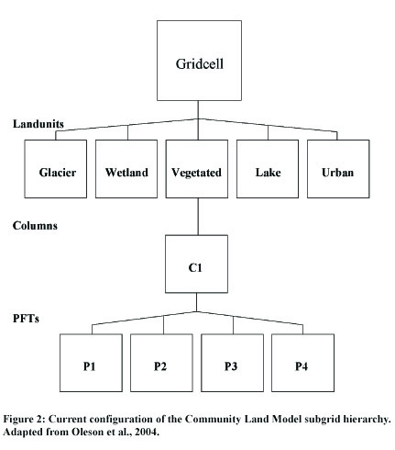
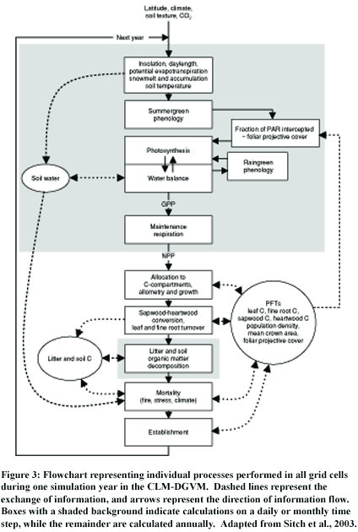
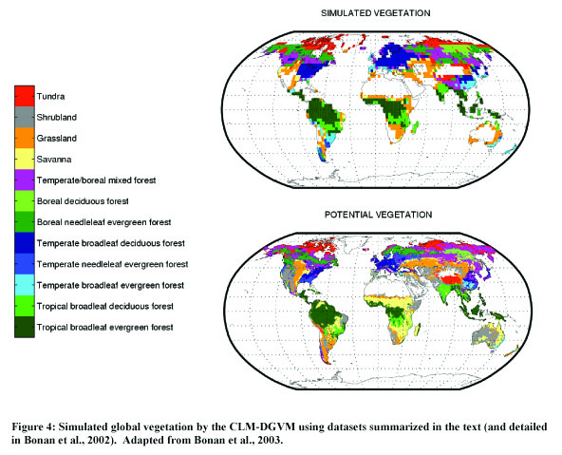

The urban land cover is included for future versions of the model, but currently urban landunits are not employed by CLM and represent zero percent of any grid cell (Olsen et al., 2004).

