I. Introduction
For this experiment I wanted to examine the effects that changes in groundcover have on various climatic factors. I wanted to look at changes in vegetation as well as changes from natural landscapes to urban landscapes. For centuries we have been altering our environment by changing the groundcover. Originally we did this by simply cutting down trees to make more farmland, but more recently we have been building cities and putting in impervious cover. This is all bound to have an effect on the climate of our region, and perhaps globally. I expect that changes in the type and amount of vegetation should have an effect on evaporation and precipitation, as well as surface runoff. These changes should also have an impact on the heat fluxes and the temperatures of the ground and canopy.
Many experiments have been done to look at similar effects. Foley, et al., looked at the Global effects of land use in 2005. Foley, et al. asked “are land-use activities degrading the global environment in ways that may ultimately undermine ecosystem services, human welfare, and the long-term sustainability of human societies?” What they found is that may be undermining our land in the long-term on regional and global scales by our current land-use practices (Foley, et al., 2005) Also in 2005, Lepers, et al., worked on putting together an assortment of information on rapid land-cover change from 1981-2000 (Lepers, et al., 2005). Costa, et al., examined how the discharge of the Tocantins river is affected by large-scale changes in land cover (2003). They found that while they did not see significant changes in precipitation, they did see an increase in the annual mean discharge (Costa et al., 2003).
For this experiment I used the Community Land Model developed by the National Center for Atmospheric Research. This model is part of the Community Climate System Model. The CLM version used in this study has a primary land cover and up to five plant functional type (PFT) patches (Bonan et al., 2002). The primary land cover can be composed of glacier, lake, wet-land, urban, or vegetated. The vegetated can then be split in up to 5 different PFTs. In the version used for this study there are sixteen PFTs available. This study only uses ten types: not vegetated, needleleaf evergreen temperate tree, broadleaf evergreen temperate tree, broadleaf deciduous temperate tree, broadleaf evergreen shrub, broadleaf deciduous temperate shrub, c3 non-arctic grass, c4 grass, corn, and wheat.

II. Methods
For this study, I ran a series of thirteen tests. These tests separate easily into two groups. In the first group I have 9 tests where I altered the plant functional types (PFTs) to see how different PFTs affect different climatic factors. The remaining four tests make up the second group. For this I chose one PFT and changed the percentage of coverage, assuming that the uncovered portion was not vegetated. For these tests, I left most of the defaults as is, however I changed the latitude and longitude to be near central Texas at 30N, 100W. I was not successful in getting the model to work for changes in the primary land cover, so I wasn’t able to do any experiments looking at urban changes in the environment. Therefore, this experiment looks only at what effects changes in vegetation have.
Table 1 provides a detailed summary of the conditions used in my thirteen tests. Looking at the PFTs of the first nine, we see that they can be divided into 4 sub-categories: trees, shrubs, grass, and crops (as denoted in column 8, above). To be able to easily see the variations of different types of vegetation, I took an average of the values computed for each of the PFTs in each category, and that gave me the general value for that category.

Case Number | PFT1 | % of PFT1 | PFT2 | % of PFT2 | PFT3 | % of PFT3 | Sub-cat
1 | Needleleaf evergreen temperate tree | 80 | c3 non-arctic grass | 2 | Not vegetated | 18 | Tree
2 | Broadleaf evergreen temperate tree | 80 | c3 non-arctic grass | 2 | Not vegetated | 18 | Tree
3 | Broadleaf deciduous temperate tree | 80 | c3 non-arctic grass | 2 | Not vegetated | 18 | Tree
4 | Broadleaf evergreen shrub | 80 | c3 non-arctic grass | 2 | Not vegetated | 18 | Shrub
5 | Broadleaf deciduous temperate shrub | 80 | c3 non-arctic grass | 2 | Not vegetated | 18 | Shrub
6 | c3 non-arctic grass | 98 | c4 grass | 2 | N/A | 0 | Grass
7 | c4 grass | 98 | c3 non-arctic grass | 2 | N/A | 0 | Grass
8 | Corn | 60 | c3 non-arctic grass | 2 | Not vegetated | 18 | Crop
9 | Wheat | 60 | c3 non-arctic grass | 2 | Not vegetated | 18 | Crop
10 | Broadleaf deciduous temperate shrub | 10 | c3 non-arctic grass | 2 | Not vegetated | 88 | N/A
11 | Broadleaf deciduous temperate shrub | 40 | c3 non-arctic grass | 2 | Not vegetated | 58 | N/A
12 | Broadleaf deciduous temperate shrub | 70 | c3 non-arctic grass | 2 | Not vegetated | 28 | N/A
13 | Broadleaf deciduous temperate shrub | 96 | c3 non-arctic grass | 2 | Not vegetated | 2 | N/A
Table 1. Summary of tests run.

III. Results
a. Changes in plant functional type
First, we will look at the effects of groundcover changes on precipitation and runoff. Looking at figures 1 and 2 we see that there is no variation in the rainfall, but there is a little variation in the runoff amount. Overall, however, there are not drastic differences in the precipitation and runoff between the different types of vegetation. This is not what I expected. According to Costa, et al., changes in vegetation alters the balance between rainfall, evaporation, and runoff because it changes the hydrological cycle of the drainage basin (Costa, et al., 2003). So, what I expected was that even if there was no change in the precipitation, that we would see a pattern in the change of runoff, however, upon careful examination, there is no pattern apparent to me.

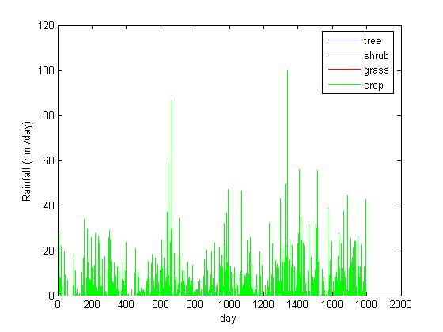
Figure 1. Rainfall amount/day.

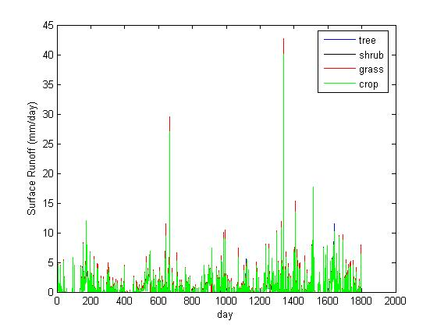
Figure 2. Runoff amount/day.

Next let’s look at the changes in heat fluxes. Figure 3 shows the ground heat flux, there doesn’t seem to be a large difference between the different types of vegetation. Looking at figure 4, the latent heat flux, there seems to be some difference between the vegetation types. The most obvious difference is that the grass overall has less latent heat flux than the crops. We see the opposite when looking at the sensible heat flux, figure 5; the crop has the least sensible heat flux, then grass, then shrubs. Upon closer examination, shrubs and trees have similar values for sensible heat flux. This makes sense to me because shrubs seem like little trees.
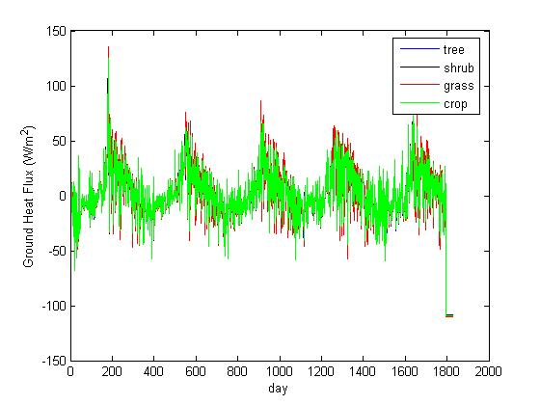
Figure 3. Ground heat flux (W/m²)

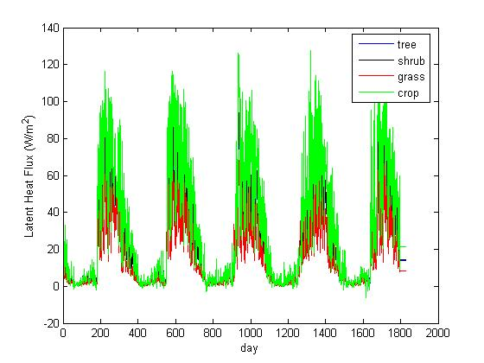
Figure 4. Latent heat flux (W/m²).

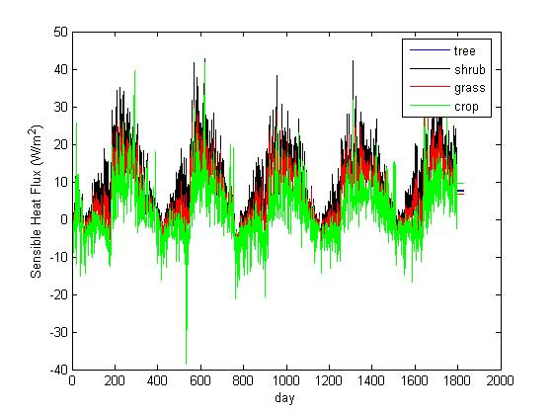
Figure 5. Sensible heat flux (W/m²).

Finally, lets look at changes in ground temperature and canopy temperatures. We see results that are similar to the heat fluxes. Figure 6 shows the temperature of the ground, looking at it we can see that grasses have the highest temperatures, then shrubs, and crops have the lowest ground temperature. Looking at the temperature of the vegetation canopy temperature (figure 7) we see some variation, but a pattern is not as clear. It does appear that crops have a slightly lower temperature than the other types of vegetation.
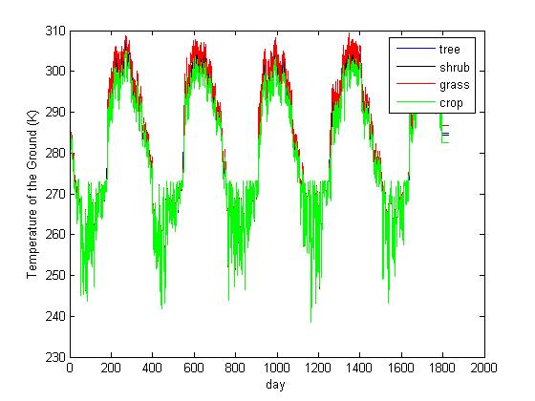
Figure 6. Temperature of the ground (K).

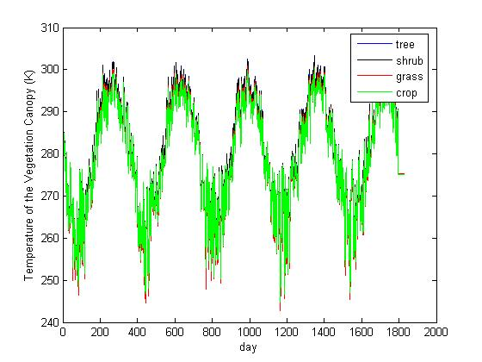
Figure 7. Temperature of the vegetation canopy (K).

Something interesting to be noted in the heat fluxes and the temperatures is the seasonal variations of these values. We notice that all of these values decrease during the spring, then start to increase during the summer sometime, reaching a maximum sometime during the fall, and then decreasing back until the spring. Looking at the variations of these values with the PFT it seems that the PFT has the greatest effect on these values during the fall (when these values are at their highest).
b. Changes in vegetation coverage
For my final four tests I varied the percentage of coverage for one PFT from 10% to 100% (10,40,70,96). The PFT used for this experiment was arbitrarily chosen to be broadleaf deciduous temperate shrub. The portion of the land that wasn’t covered by this specific vegetation was assumed to be not vegetated. Reference table 1 for the exact configurations of the PFTs.. In this experiment I found similar variations as the previous experiment. It seems that the same variables that were sensitive to the type of vegetation are also sensitive to the amount of vegetation.
As before, looking at the precipitation (figure 8) and runoff (figure 9), we see no variation in precipitation with the amount of cover, and we see some variation of runoff, but no definite pattern.
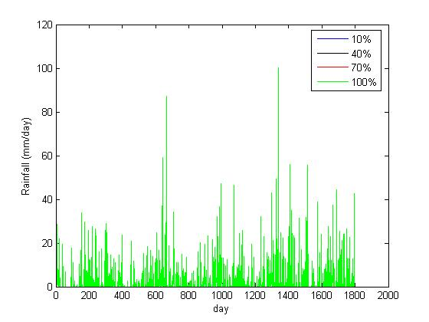
Figure 8. Rainfall (mm/day).

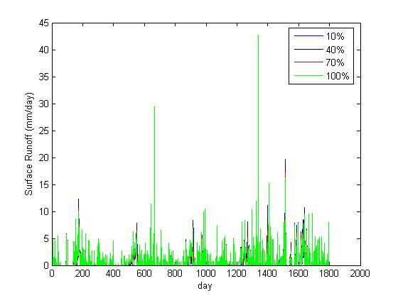
Figure 9. Surface runoff (mm/day).

Next lets look at the heat fluxes. Again, we don’t see a pattern in the ground heat flux (figure 10), but we have definite patterns in the latent heat flux (figure 11) and the sensible heat flux (figure 12). As the percentage of groundcover increases, the latent heat flux decreases, and as we increase the percentage of groundcover the sensible heat flux increases.
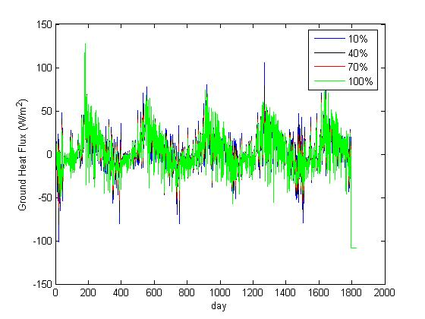
Figure 10. Ground heat flux (W/m2).

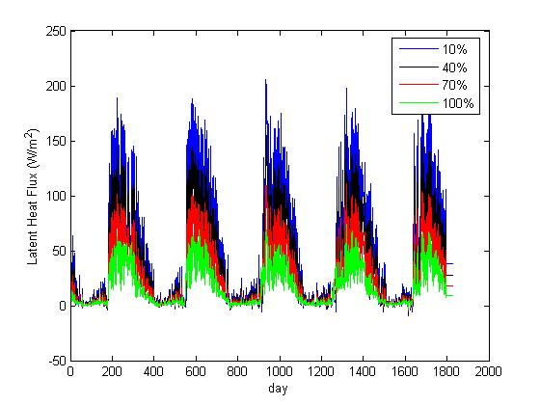
Figure 11. Latent heat flux (W/m2).

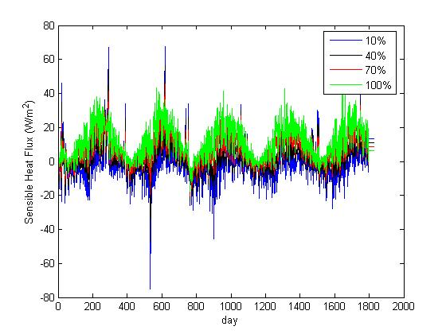
Figure 12. Sensible heat flux (W/m2).

Finally, let’s look at the temperatures of the ground (figure 13) and of the vegetation canopy (figure 14). Looking at figure 13, we see that as we increase the percentage of vegetation cover, the temperature of the ground decreases. There doesn’t seem to be a definite pattern to the changes in the temperature of the canopy, but there appears to be a small decrease in temperature with a decrease in vegetation cover, especially during the late fall.
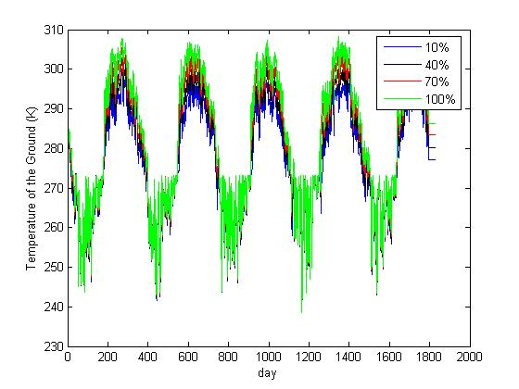
Figure 13. Temperature of the ground (K).

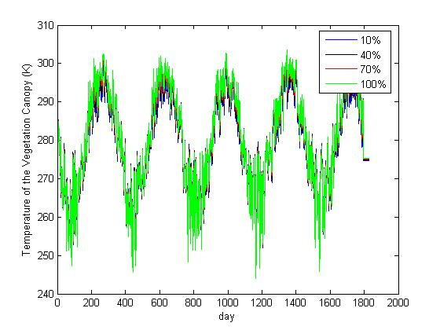
Figure 14. Temperature of the vegetation canopy (K).

As noted in the previous experiment, the percentage of ground cover seems to have the largest effect on the heat flux and the surface and vegetation canopy temperatures during the fall.

IV. Conclusions
This experiment examined what effect changes in the type and amount of plant functional type had on rainfall and runoff; ground, sensible, and latent heat fluxes; and the temperatures of the ground and canopy. What I found is that the same variables that are affected by the type of vegetation are also affected by the amount of vegetation. The seasonal cycle noted in the heat flux and temperature values is very interesting. These values decrease during the spring, then they increase starting in the summer, reaching their maximum in late fall, then they decrease again until the summer. The biggest effect that PFT had on these values was during the maximums that occurred in late fall. I’m unsure as to why this is the case.
This was just an introductory look into how the model treated changes in PFT. To further expand on this experiment, I would like to look at the impacts of urban cover on all of these factors, especially rainfall and runoff. I would also like to find some real world examples of rainfall and runoff variations with the different PFTs and compare them to the results of the community land model.

V. Works Cited

Bonan, G.B, K.W. Oleson, M. Vertenstein, S. Levins, X. Zeng, Y. Dai, R.E. Dickinson, Z-L.
Yang, 2002: The Land Surface Climatology of the Community Land Model Coupled to the NCAR Community Climate Model. Journal of Climate, 15, 3123-3149.

Costa, M.H., A. Botta, J.A. Cardille, 2003: Effects of large-scale changes in land cover on the
discharge of the Tocantins River, Southeastern Amazonia. Journal of Hydrology, 283, 206-217.

Foley, J.A., R. DeFries, G.P. Asner, C. Barford, G. Bonan, S.R. Carpenter, F.S. Chapin, M.T.
Coe, C. Monfreda, J.A. Patz, I.C. Prentice, N. Ramankutty, P.K. Snyder, 2005: Global Consequences of Land Use. Science, 309, 570-574.

Lepers, E., E.F. Lambin, A.C., Janetos, R. DeFries, F. Achard, N. Ramankutty, R.J. Scholes,
2005: A Synthesis of Information on Rapid Land-cover Change for the Period 1981-2000. BioScience, 55, 115-124.

