Theresa Diehl Physical Climatology Project 11/22/05

The Community Land Model (CLM): Studying its Treatment of Snow and Glaciers

1. Introduction
The Community Land Model (CLM) was developed by the National Center for Atmospheric Research (NCAR) and has been adapted by the University of Texas at Austin (CLM2.0). The CLM allows users to change surface features of an area on the earth in order to investigate the resultant changes in climate. The parameterization of the CLM is complex and the boundary conditions input by users cover a range of land surface types, soil and snow properties, and vegetation varieties.
Using CLM2.0, I studied extreme changes in the land cover of the Sleepers River Watershed of Vermont. I hypothesized that it may be possible cover the watershed with snow all year round by making changes to the land cover of the area. This, in effect, was an attempt to simulate the conditions that would have been present at edge of the incipient Laurentide Ice Sheet at the beginning of the last glacial period, except using modern climate forcing data for the model. To determine if this scenario was possible, I did sensitivity tests on the CLM2.0 model parameters that could lead to changes in the snow cover of the area. Based on the results of the sensitivity tests, I put forth a theory on whether the Sleepers River Watershed could become snow covered year round given the forcing data of today’s climate. I conclude with a critical look at the CLM2.0’s treatment of snow cover and propositions for further tests on CLM2.0.
2. The Sleepers River Watershed
The Sleepers River Watershed of Vermont is a 111 km² cold region watershed that has been monitored continuously since 1958 (“Water Resources…”, 2005). Land use in the watershed is 2/3 forest and 1/3 pastures and the elevation of the area is fairly low, between 200 m and 780 m (“Water Resources…”, 2005). Most importantly for this study, the watershed currently receives 275 mm/yr of precipitation as snow and remains snow covered from late November into April (“Water Resources…”, 2005).
Despite its low elevation, this region is already covered by snow for almost half of the year. I hypothesize that, by altering the land use coverage and other surface boundary conditions, the Sleepers River watershed could become “glaciated”, or snow covered all year round. To do this, the sensitivity of the model boundary conditions must be determined and values identified that will allow snow cover to be continuous.
3. Description of the CLM2.0 and Relevant Parameters / Boundary Conditions
The CLM2.0 is a complex model of land use/land coverage that includes realistic parameterizations of vegetation, soil, snow, water, energy transfer, and other properties of the Earth’s surface. A comprehensive explanation of the model is given in Oleson et al. (2004) and a summary of the details pertinent to this study is given here. The model is broken into a 3-level hierarchy of boundary conditions that are applied to grid cells across a surface area (Figure 1). The first level of user defined boundary conditions is the “landunit”, which is either vegetated, glacier, lake, wetland, or urban. The two treated in this study are glacier and vegetated. The former landunit is much more simple that the latter. A glacier landunit is inherently non-vegetated and many of its boundary conditions’ values are fixed: temperature= 250K; the snow water equivalent (W_{SNO})= 1000mm; snow depth is simply the snow water equivalent divided by the density of the snow; density of the snow= 250 kg/m³; albedo=1; and the snow layers’ structure is determined by the snow depth and set in the next sub-level of the hierarchy. The vegetated landunit is more complex and requires several sub-levels in the hierarchy of boundary conditions for a full parameterization, all of which are described below.
Figure 1: The levels of the boundary conditions hierarchy used in CLM2.05
The next level in the hierarchy is the “column” level. This level allows for spatial variations in the vertical layer structure of soil and snow. Soil structure is represented by 10 layers and snow by up to 5 layers, depending on snow depth. The user can specify the percentages of sand and clay in each of the 10 soil layers, which determines the thermal and water conductivity of the soil. This level of the hierarchy thus determines the boundary conditions for surface energy fluxes. For the glacier landunit, there is no parameterization of the soil because the surface is assumed to be frozen and always covered by at least a small thickness of snow. The vegetated landunit requires user defined values for the soil. Both landunits have a default treatment of the snow layers.
The lowest level is the PFT level, or the plant functional type level. This level allows the user to designate up to 4 types of vegetation cover out of a possible 15 types (Table 1). The user also determines what percentages of the land are covered by each PFT, the height of the canopies (Table 1), the leaf area indices (LAI) (Figure 2), and the stem area indices (SAI) (Figure 3). The two indices are PFT specific and the values were taken from Bonan (1996). These two indices determine the optical properties of the vegetation, which in turn impact the hydrological fluxes (including runoff and infiltration), surface albedo, and energy fluxes.
Table 1: The 15 types of PFTs available in the CLM2.0 model and their canopy heights, where NET=Needleleaf evergreen tree; NDT=Needleleaf deciduous tree; BET=Broadleaf evergreen tree; BDT= Broadleaf deciduous tree; BES= Broadleaf evergreen shrub; BDS= Broadleaf deciduous shrub.
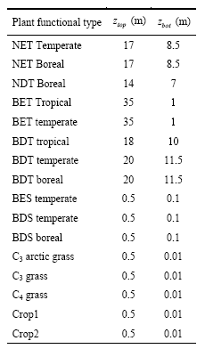
4. Method: Sensitivity Analyses
In order to determine if the Sleepers River Watershed could become snow covered year round, several sensitivity tests were performed. First, the benchmark model results were found for a 100% vegetated landunit grid of 2/3 forest and 1/3 pasture. The forest of Vermont is likely boreal (meaning: “of or belonging to the north”) rather than temperate (meaning: “free from extremes”). Thus, I characterized the forest as 1/3 NET Boreal and 1/3 BDT Boreal. The 1/3 pasture was characterized as C₃ non-arctic grass, which is more boreal than C₄ grass but more temperate than C₃ arctic grass. The soil is made of 10% sand and 10% clay in each layer.
Figure 2: Leaf Area Indices (LAIs) for 11 of the PFTs, where abbreviations are the same as Table 1 except TST=tropical seasonal tree, cg=cool C₃ grass, wg=warm C₄ grass, es=evergreen shrub, ds=deciduous shrub, ads=arctic deciduous shrub, ag=arctic grass, and c=crop (Bonan, 1996).

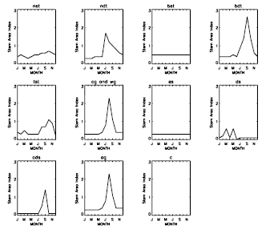
Figure 3: Stem Area Indices (SAIs) for 11 of the PFTs, see Figure 2 for abbreviations (Bonan, 1996).
Then, a variety of more extreme land cover scenarios were tested. The first set of scenarios fixed the landunit as 100% vegetated and varied the abundance of two PFTs. The model was run for the following scenarios: 100% C₃ arctic grass; 75% C₃ arctic grass and 25% not vegetated; 50% C₃ arctic grass and 50% not vegetated; 25% C₃ arctic grass and 75% not vegetated; and 100% not vegetated. In actuality, the model gives an error for 100% of a single PFT and so the PFT abundances were 99% and 1%, though I refer to the abundances as 100%. Next, I varied the landunit for the following scenarios: 75% vegetated (PFT: 100% not vegetated) and 25% glacier; 50% vegetated (PFT: 100% not vegetated) and 50% glacier; 25% vegetated (PFT: 100% not vegetated) and 75% glacier; and 100% glacier.
Originally I had decided to test the effects of soil composition on the snow pack thickness for the model with the most seasonal snow of the above set of scenarios. However, the glacier landunit is independent from changes in soil composition. Instead I altered a few of the model’s time constants, found in the file “iniTimeConst.F90”, and performed sensitivity tests on the model from the first tests that had the thickest snow pack. First I altered the roughness length of the snow from its default of 0.0024m to higher values, since this value was already a lower bound. Second I examined the irreducible water saturation of snow value, which sets the value to which surface water saturation will asymptotically approach as time goes to infinity for a column of draining snow (Denoth, 2003).
5. Results
In all, fourteen sets of model results will be presented here. Since the forcing data of net radiation, rainfall, and snowfall were never altered in any of the model scenarios, those graphs are neglected. The first set of results is for scenario 1, the one most like reality (forest and pasture), versus scenario 2, where the PFT is 100% arctic grass (Figures 4-8). Most of the results
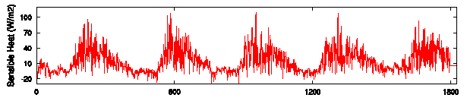
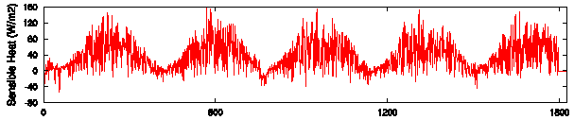
Figure 4: Sensible Heat Results for scenario 1 (top) versus scenario 2 (bottom).

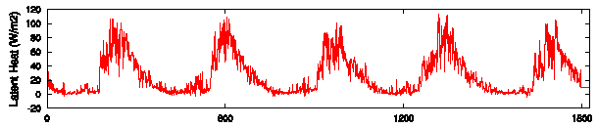
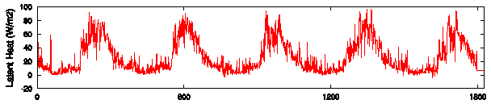
Figure 5: Latent Heat Results for scenario 1 (top) versus scenario 2 (bottom).

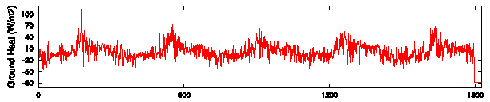
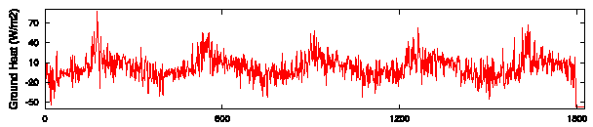
Figure 6: Ground Heat for scenario 1 (top) versus scenario 2 (bottom).
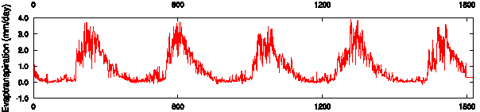
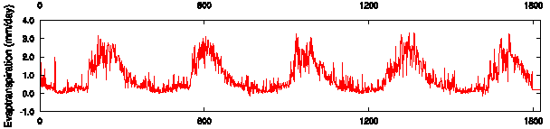
Figure 7: Evapotranspiration for scenario 1 (top) versus scenario 2 (bottom).
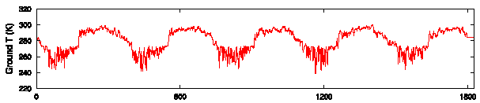
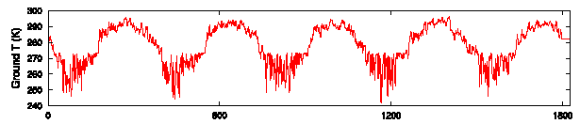
Figure 8: Ground temperature for scenario 1 (top) versus scenario 2 (bottom).

between the first two scenarios were not significantly different, including runoff, snow melt, vegetation T, snow depth, snow water, snow density, snow surface T, soil T, and soil moisture. However, there was an increase in sensible heat, decrease in latent heat, decrease in ground heat, decrease in evapotranspiration, and slight decrease in ground T. The decrease in ground heat may be due to the lack of downward longwave radiation from a high canopy like the 20-17 m canopy of scenario 1. This leads to a decreased ground T and thus decreased sensible heat, which is a function of ground temperature. The decrease in evapotranspiration leads to a decrease in sensible heat and is likely due to the fact that the transpiration of arctic grass is less than that of a boreal forest.
The next set of scenarios (3 to 6) examined the impact of decreasing the percentage of arctic grass from 100% to 0% and replacing it with bare ground. I will present only the results of scenario 3 (75% arctic grass) and scenario 6 (0% arctic grass) (Figures 9-12).
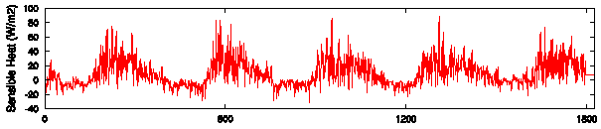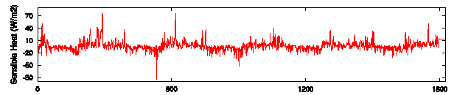
Figure 9: Sensible heat for scenario 3 (top) versus scenario 6 (bottom)

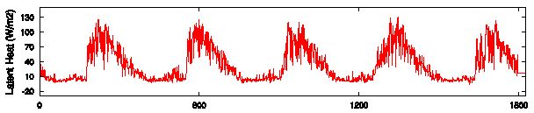
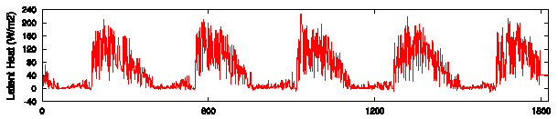
Figure 10: Latent Heat for scenario 3 (top) versus scenario 6 (bottom).

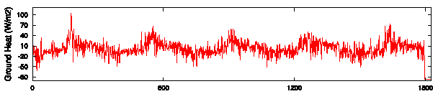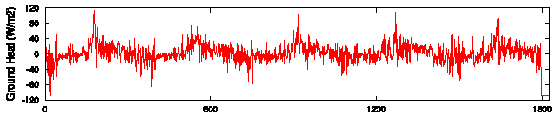
Figure 11: Ground heat for scenario 3 (top) versus scenario 6 (bottom).

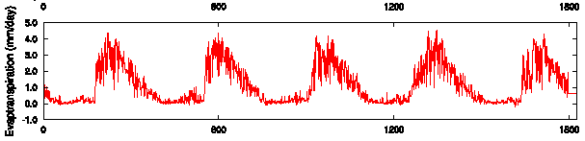
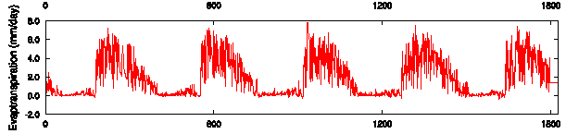
Figure 12: Evapotranspiration for scenario 3 (top) versus scenario 6 (bottom).
The results of this change from arctic grassland to bare ground yields no change in the snow pack. It does yield similar changes as those seen for the deforestation scenario examined previously. Most interesting is the 60 W/m² increase in latent heat and 2 mm/day increase in evapotranspiration for the 100% bare ground scenario, since there is less transpiration this indicates that much more of the precipitation is evaporating from the surface.
The next set of scenarios (7 to 10) progressively changed the landunit from bare ground to glacier. Here I show the results of scenario 7 (25% glacier) and scenario 10 (100% glacier) (Figures 13-22). The only parameters that did not change were rainfall, snowfall, vegetation T, and snow surface T. With the increased percentage of glacier landunit, the net radiation decreased by 50% (Figure 13). This is likely due to the high albedo of the glacier, which is unity. The sensible heat decreases and becomes nearly entirely negative (Figure 14). This could be the product of a temperature inversion where the ground surface temperature is lower than the air temperature over an increasing area of land. Latent heat (Figure 15) drops by 60% with increased glacier coverage, which again is due to a similar drop in evapotranspiration. Ground heat (Figure 16) and temperature (Figure 17) are higher in the first season then are the same for subsequent seasons despite the increased glacial coverage. Snow depth (Figure 18), water (Figure 19), and melt (Figure 20) respond similarly, where the first season sees a doubling in melt and a tripling in depth and water. The subsequent seasons see little change despite the increase in glacial cover. Runoff (Figure 21) approximately doubles, as would be expected for the impermeable glacier cover. Soil moisture (Figure 22) goes to the ground water value, as also would be expected due to the glacier boundary condition of being impermeable.
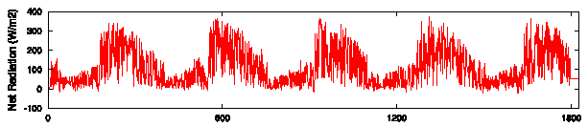
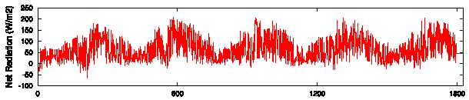
Figure 13: Net Radiation for scenario 7 (top) versus scenario 10 (bottom).

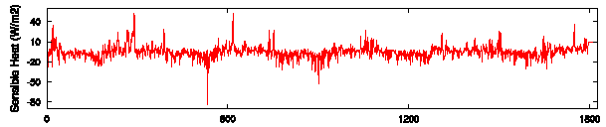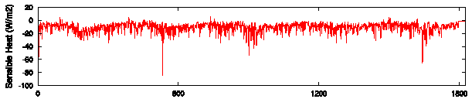
Figure 14: Sensible heat for scenario 7 (top) versus scenario 10 (bottom).

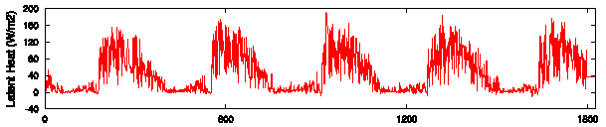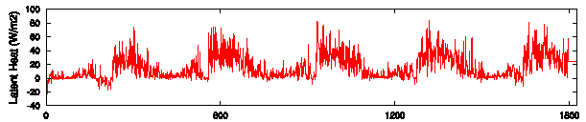
Figure 15: Latent heat for scenario 7 (top) versus scenario 10 (bottom).

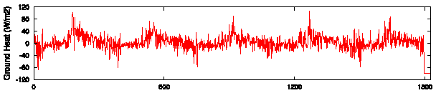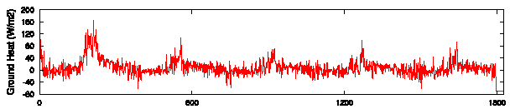
Figure 16: Ground heat for scenario 7 (top) versus scenario 10 (bottom).
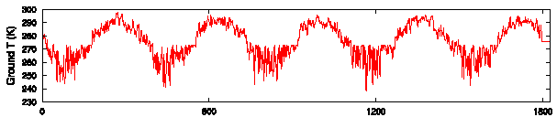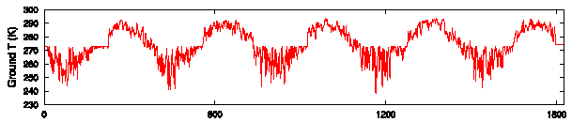
Figure 17: Ground temperature for scenario 7 (top) versus scenario 10 (bottom).

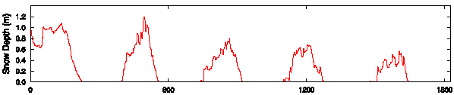
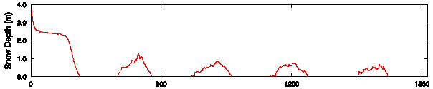
Figure 18: Snow depth for scenario 7 (top) versus scenario 10 (bottom).
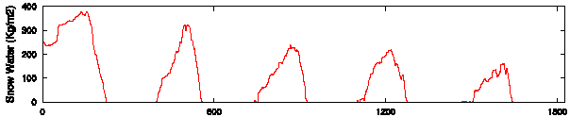
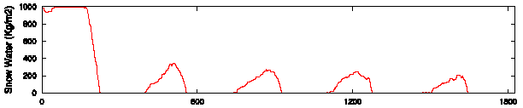
Figure 19: Snow water for scenario 7 (top) versus scenario 10 (bottom).

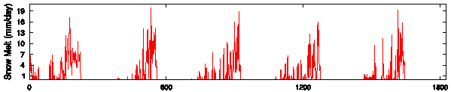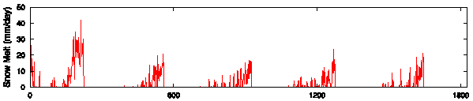
Figure 20: Snow melt for scenario 7 (top) versus scenario 10 (bottom).

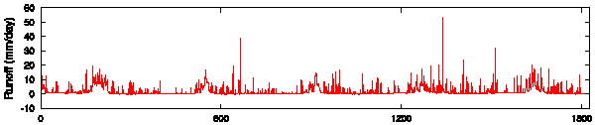
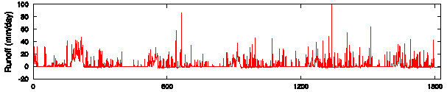
Figure 21: Runoff for scenario 7 (top) versus scenario 10 (bottom).

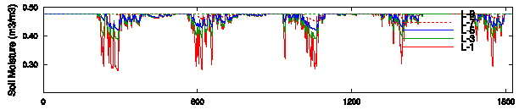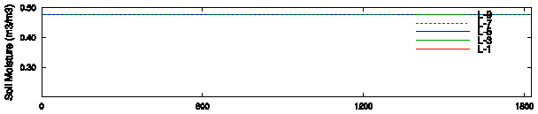
Figure 22: Soil moisture for scenario 7 (top) versus scenario 10 (bottom).

The next scenarios involved changing the roughness length of the snow and were performed on the 100% glacier scenario presented above. The value was set very low (0.024m) by default and small increases to 0.048m and 0.1m yielded no change in the model results. With larger changes to 0.15m, 0.25m, and 0.38m came more visible changes to the snow depth. Presented here are the snow depths for the 0.15m and 0.38m snow roughness lengths (Figure 23). As would be expected, the rougher the snow, the more easily melted it is and the smaller the snow packs can become. The change is significant, showing that the model is slighly sensitive to this parameter.
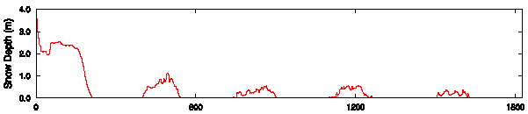
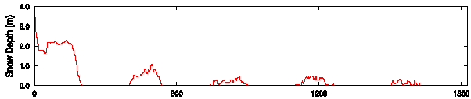
Figure 23: Snow depth for snow roughness lengths of 0.15m (top) and 0.38m (bottom).
The final sensitivity test was done for the irreducible water saturation of snow boundary condition. This parameter was set to 0.01 (1%) as a default and an order of magnitude change in the parameter to 0.1 (10%) made no change at all in the model results. This shows that CLM2.0 is not at all sensitive to the value of this parameter.
6. Conclusions
As is apparent from the results of the sensitivity tests on CLM2.0, one cannot produce year round snow coverage of the Sleepers River Watershed with modern climate forcing data. Although one can produce upwards of 3.5m of snow depth (scenario 10) where a realistic land cover model (scenario 1) produces only 1m, this change only lasts for approximately a season. It is likely that the modern climate forcings, which include air temperature, snowfall, downward solar radiation, downward longwave radiation, and humidity, are the reason for the model’s inability to create year round snow cover. These tests should be done again for an area of higher latitude where the climate forcing would be more likely to induce persistent snow pack. It is also probable that the treatment of snow is too simplistic in this model, which does not include horizontal conduction or advection of heat within the glacier landunit.

7. References
Bonan, G.B. 1996. “A land surface model (LSM version 1.0) for ecological, hydrological, and atmospheric studies: Technical description and user’s guide.” NCAR Technical Note NCAR/TN-417+STR, National Center for Atmospheric Research: Boulder, Colorado. 150pp.

Denoth, A. 2003. “Structural phase changes of the liquid water component in Alpine snow.” Cold Regions Science and Technology, 37, 227-232.

Oleson, Keith W., Yongjiu Dai, Gordon Bonan, Mike Bosilovich, Robert Dickinson, Paul Dirmeyer, Forrest Hoffman, Paul Houser, Samuel Levis, Guo-Yue Niu, Peter Thornton, Mariana Vertenstein, Zong-Liang Yang, and Xubin Zeng. 2004. “Technical Description of the Community Land Model.” NCAR Technical Note NCAR/TN-461+STR, National Center for Atmospheric Research, Terrestrial Sciences Section, Climate and Global Dynamics Division: Boulder, Colorado. 186pp.

“Water Resources of New Hampshire and Vermont.” 2005. New Hampshire/Vermont Water Science Center, US Geological Survey, Department of the Interior. Online: http://nh.water.usgs.gov/projects/sleepers/Site_Description.html. Available November, 2005.

