A REVIEW OF CLIMATIC FORCING FACTORS DURING
THE LATE NEOPROTEROZOIC SNOWBALL EARTH

Ryan C. Ewing
University of Texas-Austin, Jackson School of Geosciences, Department of Geological Sciences, C1100, 1 University Station, Austin, TX 78712-0254

Outline

I. Introduction

II. Climatic Forcing Factors
1. Necessary factors
a. Reduced solar luminosity
b. Variable atmospheric CO2
c. Favorable continental configuration

2. Other factors
a. Atmospheric dynamics
b. Ocean dynamics
c. Ice sheet dynamics
III. Conclusions

Introduction
The possibility that the Earth endured at least two global glaciations (snowball Earth) during the late Neoproterozoic (800-600 yBP) presents an intriguing conundrum for a broad community of earth and climate scientists (Kirschvink, 1992). From a geological perspective the snowball Earth hypothesis provides unique explanations for several anomalous geological and geochemical observations (Kirschvink, 1992, Hoffman et al., 1998) and from a climatological perspective the snowball Earth provides a unique opportunity to understand abrupt and radical climate changes driven by various forcing factors (Jenkins, 2004). Whether a snowball Earth ever existed or the precise nature of a snowball Earth is still far from resolved, yet it remains a highly explored topic in an effort to understand one of the most consequential events in Earth’s past (Pierrehumbert, 2005).
The snowball Earth hypothesis in its original conception postulates that a unique combination of forcing factors resulted in the growth of the polar ice caps to a point that breeched a critical threshold for an ice/albedo feedback and ice extended to the equator encasing the Earth in a ball of ice (Kirschvink, 1992). This type of ice/albedo feedback was recognized early by climate physicist (Budyko, 1969, Sellers, 1969), but they could not provide a mechanism for the Earth to recover from snowball conditions. Kirschvink (1992) recognized that without an ocean/atmosphere interaction the atmosphere would build-up CO2 and other greenhouse gasses through volcanic outgassing. This would lead to excessively high partial pressures of CO2 (~1.2 bar) that would result in global warming and recovery from a snowball scenario (Kirschvink, 1992, Caldeira and Kasting, 1992). While this seems plausible, Pierrehumbert (2004, 2005) suggests that a simple increase in greenhouse gasses is not sufficient to recover from a snowball Earth and that other factors must be considered. Hoffman et al. (1998) suggested that the recovery would be an extreme greenhouse scenario with global temperatures approaching 50C then back to pre-snowball conditions, setting the stage for another potential snowball scenario (Figure 1). The details of this highly simplified scenario remain controversial.
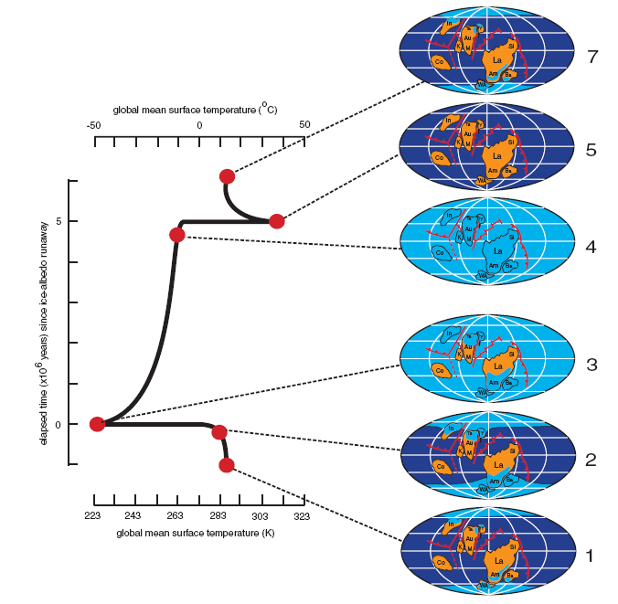
Figure 1. The snowball Earth to extreme green house cycle suggested by Hoffman and Schrag (2002). Note that time elapsed to enter the snowball is on the order of thousands of years and that the snowball persisted for almost five million years.

Subsequent to the inception of the snowball Earth hypothesis a torrent of climatological research has been directed towards verifying or disproving the possibility of an equatorial glaciation (Hoffman and Schrag, 2002; Jenkins, 2004). Although the conditions of early Earth are not well understood, climate modeling has been vital in forwarding the understanding of the possible extreme ice-house scenarios that took place in the late Neoproterozoic. Climate modeling can address the climatic forcing factors and boundary conditions needed to initiate, sustain, and recover from a global glaciation (Figure 2). The goal of this paper is to provide a review from a climatologist perspective of these factors.
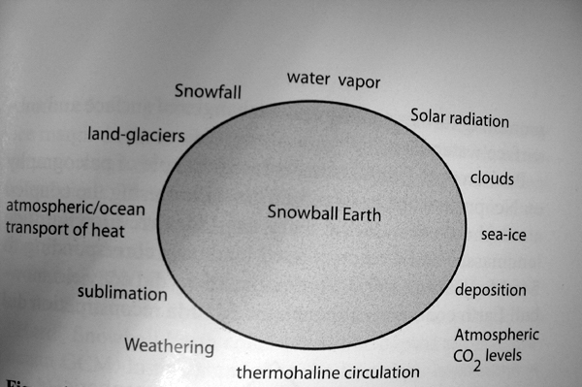
Figure 2. Schematic showing some climatic forcing factors of the snowball Eath

Climatic Forcing Factors and Boundary Conditions
Because the snowball Earth represents a unique climatic scenario not seen since the Precambrian there is substantial difficulty in creating realistic models. Further because there is limited data as to the conditions at the time it becomes difficult to determine what is “realistic”. Models simulating the snowball Earth have evolved from the 1-D energy balance models of Budyko (1969) and Sellers (1969) to sophisticated global climate models (GCMs) that attempt to paramterize many of the early Earth conditions. This review found that reduced solar luminosity, variable pCO2, and the continental configurations have consistently been treated in most climate models while the specific dynamical roles of the atmosphere, ocean, and ice during a snowball have been incorporated are not always adequately represented.

Reduced Solar Luminosity
One factor that must be considered for the initiation of a snowball Earth is a reduced solar luminosity (Chandler and Sohl, 2000, Schrag et al., 2002). Stellar evolution models suggest that the sun’s luminosity has increased by ~ 30% since the beginning of the Earth (Gough, 1981). At the time of the snowball Earth the sun’s energy output would have increased to ~94% of modern values (Gough, 1981) (Figure 3). This is a common value used in climate models and translates to a reduced solar flux of ~1285 Wm-2 (Caldeira and Kasting, 1992; Baum and Crowley, 2001; 2003; Chandler and Sohl, 2000; Donnadieu et al., 2004; Jenkins and Smith, 1999; Pierrehumbert, 2004, 2005; Poulsen et al., 2001, 2003). The simple energy balance models of Budyko (1969) and Sellers (1969) recognized that this is a driving factor in the Earth’s energy balance and if reduced enough could lead to a catastrophic ice covered Earth. Chandler and Sohl (2000) point out that because of the gradual decrease in luminosity (Figure 3) this alone cannot account for an abrupt climate change. Further, if reduced luminosity was the sole cause of glaciation then this would predict that there were multiple glaciations prior to the Neoproterozoic events and there is no evidence to suggest that these events were common during the early Earth.
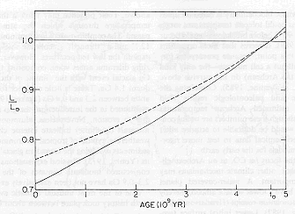
94% of current, ~ 6% less
Figure 3. The increased luminosity of the sun over time. Red arrows point to the Late Neoproterozoic at 6% less luminosity than current values. From Yang (2005) from Endal (1981).

Variable Atmospheric CO2
One of the most studied factors in simulations of the snowball Earth is the variability of atmospheric CO2 (Calderia and Kasting, 1992; Chandler and Sohl, 2003; Donnadieu et al., 2004; Jenkins and Smith; 1999). The reasoning behind these studies is that as a significant greenhouse gas, the reduction in the partial pressures of CO2 would lead to global cooling which could trigger a runaway ice/albedo feedback resulting in a snowball Earth (Calderia and Kasting 1992). The cause of a CO2 depletion stems from fluxes between the atmosphere, ocean and rock reservoir (Donnadieu et al., 2004; Schrag et al., 2002). Volcanic outgassing, mid-ocean ridge processes, and carbonate metamorphism act as sources for CO2, while the weathering of silicates and deposition of carbonate rocks act as the sinks (Donnadieu et al., 2004; Schrag et al., 2002). The negative feedback between these processes contributes to the maintenance of a stable climate (Calderia and Kasting, 1992). A simple energy balance model by Calderia and Kasting (1992) show that given the lower solar luminosity during the Late Neoproterozic a perturbation that decreased the CO2 could initiate a global glaciation (Figure 4). The dominant reason cited for a possible draw down of CO2 during the Late Neoproterozoic is the paleo-configuration of the continents (Hoffman et al., 1998). This will be discussed in the following section.
Figure 4. Steady state ice lines shown as a function of solar luminosity for three pCO2 scenarios. In this EBM by Calderia and Casting an ice covered Earth occurs at modern values of pCO2
modern

The amount of CO2 necessary to initiate a snowball Earth is controversial and highly dependent on the model used and the parameterizations (Jenkins, 2004). Energy balance models have required lower pCO2 to generate a snowball Earth. Crowley and Baum (1993) simulated an equatorial glaciation at <120ppmv and Calderia and Casting (1992) were able to simulate it at < 300ppmv. GCMs that use slab ocean models have been able to simulate snowball conditions at ~140ppmv (modern values) (Baum and Crowley, 2001, 2003, Chandler and Sohl, 2000, Donnadieu et al., 2004). Differences among these studies arise from the oceanic heat transfer. Reductions in the heat transfer enhance the effects of reduced CO2 (Chandler and Sohl, 2000) (Figure 5). GCM studies that have incorporated dynamical oceanic processes (wind-driven oceanic currents, transient eddies, vertical mixing) have required not been able to generate snowball conditions at the threshold 140ppmv that slab models do, suggesting that the GCMs with slab ocean models inadequately represent oceanic processes (Poulsen et al. 2001, 2003; Poulsen and Jacob, 2004).

Figure 5. A plate from Chandler and Sohl (2000) showing the effects of ocean heat transfer (OHT) and variable pCO2. Note that with reduced OHT the surface temperature is significantly reduced.

Favorable Continental Configuration
The configuration of the continents during the Late Neoproterozoic has been hypothesized to be one of the most critical forcing factors influencing the initiation of a snowball Earth (Donnadieu et al., 2004; Kirschvink, 1992; Hoffman et al., 1998; Poulsen et al., 2002). During this period there was a low-latitude distribution of continents (Dalziel, 1997) (Figure 6).
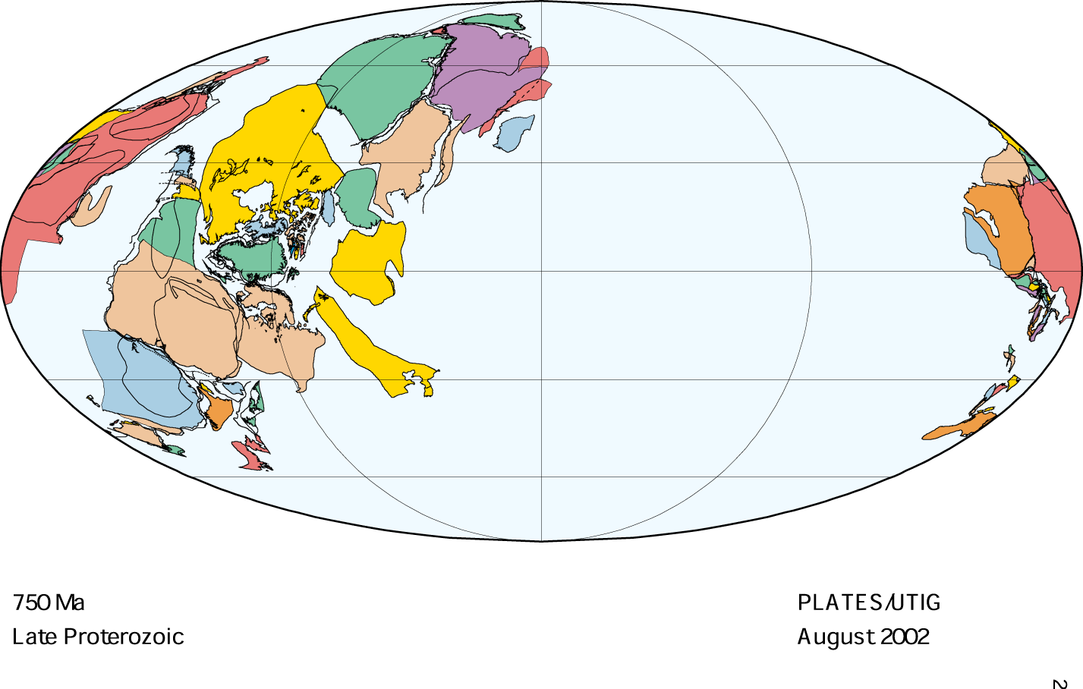
Figure 6. Reconstructions of the paleoconfiguration of continents from the University of Texas-Austin Institute for Geophysics

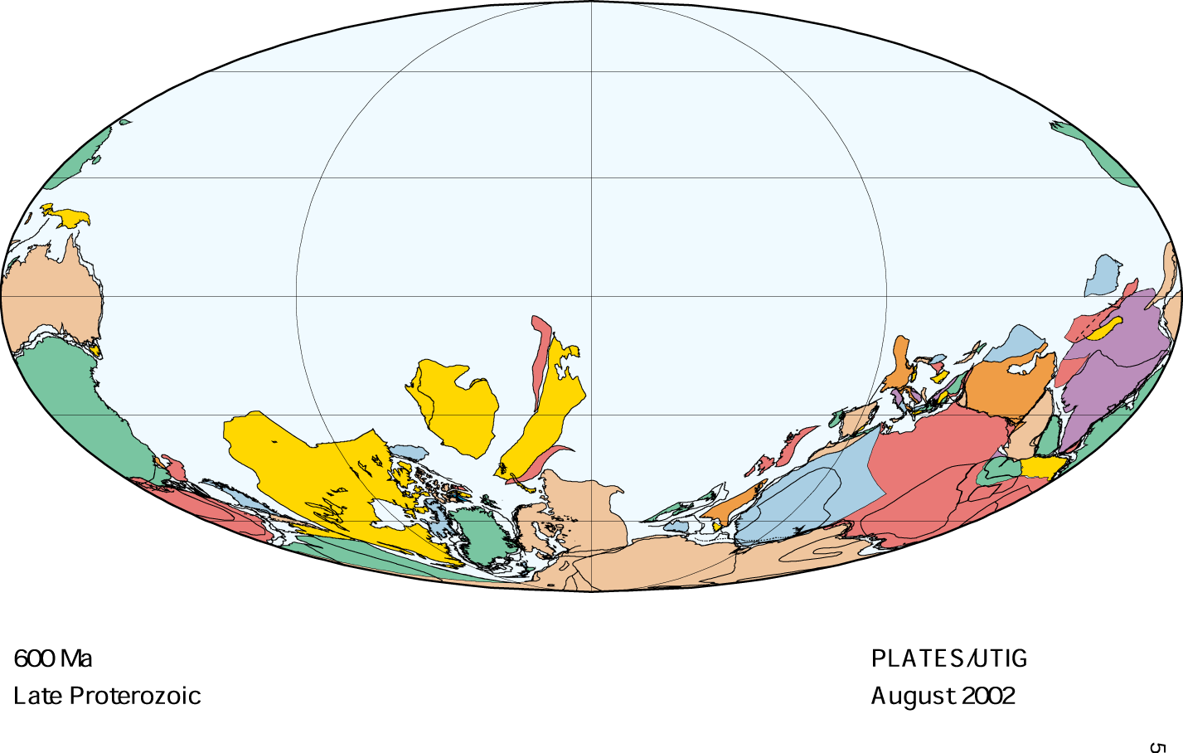

The impact of this distribution is three fold. With substantial continental area in the low-latitudes more tropical shortwave radiation would be reflected back to space enhancing glaciation. The land surface albedo during the Precambrian can be estimated to be that of a desert (~0.5) due to the lack of plant vegetation is substantially higher than that of water (.1) ( (Poulsen, 2002). More importantly the weathering rates would have been dramatically increased due to tropical moisture (Hoffman and Schrag, 2000). This could have a potentially profound impact by dramatically reducing the partial pressure of atmospheric CO2 and triggering the initiation of an equatorial glaciation as described above (Hoffman and Schrag, 2000, Schrag et al., 2002). Further enhancing the draw down of pCO2 is the break up of the supercontinent at this time (Hoffman et al., 1998). The break-up would increase the surface area at the margins of the continents, enhancing weathering rates and provide more sinks for the CO2 (Hoffman and Schrag, 2000).
Poulsen et al. (2002) addressed the issue of paleogeographic controls on the iniation of a snowball Earth by running simulations with an idealized low-latitude super continent, a low-latitude three continent scenario, and a configuration based on plate reconstructions (Figure 7). The runs used the 6% reduced solar luminosity and the 140ppmv CO2 used in other models and a coupled ocean/atmosphere model. Poulsen et al., 2002 show that there is a reduction in tropical temperatures due to the predicted reduced receipt of shortwave radiation, but that the high latitudes and sea ice are minimally affected. Despite the continental configuration they did not succeed in generating snowball Earth conditions suggesting that continental configuration alone is not sufficient to initiate a snowball Earth.

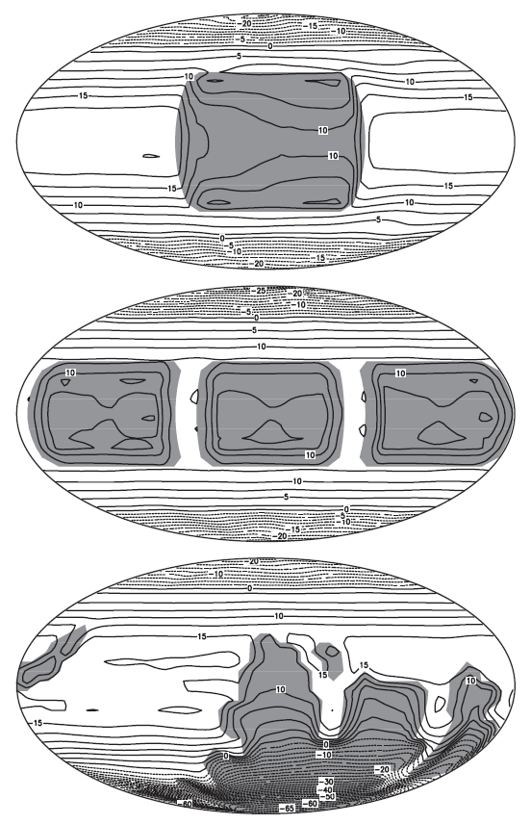
Figure 7. The continental configurations used in simulations by Poulsen et al. (2001) to test how paleogeography may influence the initiation of a snowball Earth.

Atmospheric Dynamics
Investigating the dynamics of a snowball Earth atmosphere yields some insights as to the possibility and nature of an ice covered Earth (Pierrehumbert, 2004, 2005; Poulsen and Jacob, 2004). Poulsen and Jacob (2004) point out that because of the magnitude of climatic change occurring during a snowball scenario the details of the climate system seem unimportant and have received little attention. Further, because most studies to date have focused on the delimiting the amount of atmospheric CO2 necessary to drive a snowball the atmospheric components of the models are parameterized to modern values. However, because there is wide disagreement among the climate modeling community regarding the snowball Earth recent studies have focused on these components and their impact on a ice covered Earth (Poulsen and Jacob, 2004; Pierrehumbert, 2004, 2005). Factors that are to be considered here are the effects of clouds, Hadley Cell circulation, and diurnal forcing.
The parameterization of clouds has not been yet adequately treated in Neoproterozoic climate studies (Poulsen and Jacob, 2004), however the gross effects may be rendered from some simulations. Poulsen and Jacob (2004) did a sensitivity test by removing the cloud component from their coupled ocean/atmospheric model, eliminating the cloud albedo and greenhouse effects. Pierrehumber (2004) points out that the albedo effect of clouds over an ice covered ocean would be negligible given the high albedo of ice. The Poulsen and Jacob (2004) experiment found that due to the reduced greenhouse effects (30Wm-2) the air temperatures over the sea-ice were lower than in their control run. The result was an enhanced sensible heat loss at the sea-ice margins that enhanced cooling and increased the ice/albedo feedback (Figure 8).

Figure 8. Shows the difference in temperatures between a control simulation and a simulation without clouds run by Poulsen and Jacob (2004). Note that there is substantial cooling because of the lack of clouds.

Pierrehumbert (2005) suggests that the Hadley Cell circulation of a snowball Earth may be dramatically different given the weaker solar forcing, low thermal inertia of a snow covered surface and the minimal latent heat flux in a cold, dry atmosphere. Pierrehumbert (2005) points out that the most dramatic difference in the Hadley Cell of a snowball is that it cannon homogenize the tropical temperature gradients like the modern day cell. The experiments of Poulsen and Jacob (2004) show that as ice approaches the domain of the Hadley cell it abruptly intensifies, acting to lessen the tropical temperature gradient, but collapses prior to full glaciation (Figure 9).

Figure 9. Poulsen and Jacob (2004) show that the Hadley Cell intensifies as the Earth approaches the snowball conditions due to the enhanced thermal gradient from equator to pole. Note the collapse in the intensity just prior to full glaciation.
Because of the low thermal inertia of a snowball Earth the effects of diurnal forcing are strong, much like that of Mars (Pierrehumbert, 2005). Daytime temperatures during a snowball are up to 10K warmer than air temperatures, driving an upward transfer of heat (Pierrehumbert, 2005). The night time atmosphere becomes completely stably stratified, eliminating the transfer of heat through turbulence.

Ocean Dynamics
In current GCM simulations of the Neoproterozoic climate the treatment of ocean dynamics determines the fate of the snowball Earth hypothesis (Jenkins, 2004). GCM simulations that use a simplified slab ocean model with no heat transport or diffusive heat transport consistently can produce snowball Earth conditions (Baum and Crowley, 2001, 2003; Donnadieu et al., 2004; Hyde et al., 2000; Jenkins and Smith, 1999) while GCMs that use coupled ocean-atmospheric models with dynamic ocean processes cannot (Poulsen et al., 2001; Poulsen and Jacob, 2004).
Chandler and Sohl (2000) first addressed the issue of ocean heat transport (OHT) by running sensitivity simulations with snowball Earth boundary conditions (reduced solar luminosity and variable pCO2) and varying the (OHT) relative to modern values. They found tropical cooling occurs when the OHT is increased and that overall global cooling occurred both at reduced and enhanced OHT values. The cooling at increased OHT values is unexpected and they attribute this to the parameterization of the zonal distributions of OHT.
Poulsen et al. (2001) used an ocean-atmosphere GCM fully coupled and in mixed-layer mode to test the sensitivity of a snowball Earth to OHT. Their mixed layer experiments parameterized heat transfer through diffusion and also to no heat transport. They used two coupled simulations with initial ocean temperatures set to present-day and colder. Both mixed layer experiments resulted in a relatively quick advance of ice to the equator, while the sea-ice margins never reached the equator in the coupled experiments (Figure 10). The physical processes accounted for by the coupled model are ocean currents, transient eddies and vertical mixing. Of these vertical mixing was found to be the most significant contributor of heat to the sea-ice margins, stopping the advance of ice.

Figure 10. Experiements by Poulsen et al. (2001) show that coupled ocean atmosphere models are unable to simulate snowball conditions due to the parameterization of dynamic ocean processes.
Poulsen and Jacob (2004) ran similar sensitivity experiments using a fully coupled GCM and found that in addition to vertical mixing, wind-driven ocean circulation is a major mechanism for heat transport that is inadequately represented in slab ocean models. They found that without wind-driven circulation snowball conditions could be simulated using a coupled model, however with wind-driven circulation the large sensible heat loss at the sea surface is balanced by the OHT and the sea-ice line is stabilized. All these experiments show that if dynamical ocean processes are adequately represented other factors must be invoked to initiate a snowball Earth.

Ice Dynamics
The role of ice in a global glaciation is clearly very important, yet is another underrepresented factor in many Late Neoproterozoic models (Lewis et al., 2003). Further, as Pierrehumbert (2005) points out how the variability in a sea-ice/snow surface affects the energy balance of a system is a challenging problem, not unlike that of clouds. Two studies point out the important role of ice dynamics. Accurately modeling ice surfaces is not only important in predicting the existence of a snowball Earth, but also has implications for the persistence of life through such an event.
Lewis et al. (2003) uses a moderately complex GCM coupled with a sophisticated thermodynamic/dynamic ice model to show that even at higher pCO2 levels (up to 1800 ppmv) a snowball Earth can exist, suggesting that in experiments by Poulsen et al. (2001) the ice dynamic component of the coupled oceanic-atmosphere models is limiting the formation of equatorial ice. The sea-ice dynamics incorporated in Lewis et al. (2003) are ice rheology and variable ice thickness.
Warren et al. (2002) address the possibility of thin ice during a snowball Earth by using different models to test the radiative transfer of shortwave radiation through ice. They incorporate different estimates of the surface albedo of the sea ice in their models and suggest that thin ice would not likely have existed during a snowball and that photosynthetic life could not have persisted through the snowball Earth.

Conclusions
This review highlighted the significant efforts that have gone into climatically modeling a snowball Earth. Global glaciation was once thought to be the simple result of an ice/albedo feedback system, but as the more sophisticated models and understanding of forcing factors reviewed above show there are many aspects of the Late Neoproterozoic climate that are not yet properly parameterized. Most importantly the role of a dynamical ocean in the initiation of the snowball Earth has not been resolved. Also there is a need for better understanding of the impact of clouds and the role of ice in triggering a equatorial glaciation.

References
Baum, S.K. and Crowley, T.J. 2001. GCM response to late Precambrian (~590Ma) ice- covered continents. Geophysical Research Letters. v. 28, n. 4, p. 583-586.

Baum, S.K. and Crowley, T.J. 2003. The snow/ice instability as a mechanism for rapid climate change: A Neoproterozoic snowball Earth model example. Geophysical Research Letters. v. 30, n. 20, 2030.

Budyko, M.I. 1969. The effect of solar radiation variations on the climate of the
Earth. Tellus, v. 21, p. 611-619.

Caldeira, K. and Kasting, J.F. 1992. Susceptibility of the early Earth to irreversible
glaciation caused by carbon dioxide clouds. Nature, v. 359, p. 226-228.

Chandler, M.A. and Sohl, L.E. 2000. Climate forcings and the initiation of low-latitude ice sheets during the Neoproterozoic Varanger glacial interval. J. Geophysical Research, v. 105, n. D16, p. 20,737-20,756.
Dalziel, I.W.D. 1997. Neoproterozoic-Paleozoic geography and tectonics: Review, hypothesis, environmental speculation. GSA Bulletin, v. 109, n. 1, p. 16-42.

Donnadieu, Y., Ramstein, G., Fluteau, F., Roche, D., Ganopolski, A. 2004. The impact
of atmospheric and oceanic heat transports on the sea-ice-albedo instability during the Neoproterozoic. Climate Dynamics, v. 22, p. 293-306.

Hyde, W.T., Crowley, T.J., Baum, S.K., Peltier, R. 2000. Neoproterozoic ‘snowball Earth’ simulations with a coupled climated/ice-sheet model.

Jenkins, G.S. 2003. GCM greenhouse and high-obliquity solutions for early Proterozoic glaciation and middle Proterozoic warmth. J. of Geophysical Research, v. 108, n. D3, p. 4118.

Jenkins, G.S. and Smith, S.R. 1999. GCM simulations of snowball Earth conditions during the late Proterozoic. Geophysical Research Letters, v. 26, n. 15, p. 2263- 2266.

Kirschivink, J. 1992. Late Proterozoic low-latitude global glaciation: the snow-ball earth.
In: The Proterozoic Biosphere (J.W. Schopf and c. Klein, eds), p.51-52. Cambridge University Press, Cambridge.

Pierrehumbert, R.T. 2005. Climate dynamics of a hard snowball Earth. J. Geophysical Research. V. 110, D01111.

Pierrehumbert, R.T. 2004. High levels of Atmospheric carbon dioxide necessary for the termination of a global glaciation. Nature, v. 429, p. 646-649.

Poulsen, C.J. and Jacob, R.L. 2004. Factors that inhibit snowball Earth simulation. Paleoceanography, v. 19, PA4021

Poulsen, C.J., Jacob, R.L., Pierrehumbert, R.T., Huynh, T.T. 2002. Testing paleogeographic controls on a Neoproterozoic snowball Earth. Geophysical Research Letters, v. 29, n. 11, 10-1.

Poulsen, C.J., Pierrehumbert, R.T., Jacob, R.L. 2001. Impact of ocean dynamics on the simulation of the Neoproterozoic “snowball Earth”. Geophysical Research Letters, v. 28, n. 8, p. 1575-1578.

Sellers, W.D. 1969. A Global climatic model based on the energy balance of the Earth- atmosphere system. Journal of Applied Meterology, v. 8, p. 392-400.

Scotese, C.R., Boucot, A.J., McKerrow, W.S. 1999. Gondwanan paleogeography and paleoclimatology. Journal of African Earth Science. V. 28, p. 99-114.

