The role of uncertainty in the simulation of biogenic volatile organic compound emissions in the Community Land Model.

Lindsey Gulden
Physical Climatology, GEO 387h
November 22, 2005
Abstract

We use an offline land-surface model to simulate biogenic volatile organic compound (BVOC) emissions at 0.1º resolution on a regional scale. We analyze the sensitivity of modeled biogenic emissions to the vegetation dataset used in the land-surface model. The Community Land Model version 3.0 (CLM3) is driven from 1979 to 2004 using bilinearly interpolated North American Regional Reanalysis (NARR) meteorological forcing data. We use as our starting points a Moderate Resolution Imaging Spectroradiometer (MODIS)-derived vegetation and soil color database and a plant vegetation-type distribution dataset developed with ground survey data. We systematically vary both datasets to examine how distinct specifications of percent vegetated area, vegetation-type distribution, and phenological parameters directly and indirectly alter biogenic emission flux.
The relative magnitude of the variation in the runs’ biogenic emissions estimates is assessed, and the underlying reasons for the discrepancies between the two datasets are analyzed. In most locations, the ground-referenced dataset contains a higher density of trees than the satellite-derived dataset. Consequently, for a specific location, the inherent BVOC flux rate (defined as the product of the BVOC emission capacity and the leaf biomass density) of the ground-referenced dataset tends to be higher than the inherent BVOC flux rate of the satellite-derived dataset. In both datasets, BVOC flux increases west-to-east, coincident with the general trend of west-to-east increase in tree biomass density that is observed in Texas.
Consistent with the work of other researchers, when forced with the same meteorological input data, using two different vegetation datasets in CLM results in modeled environments that have distinct state variables (e.g., soil moisture, leaf-surface temperature) and surface-to-atmosphere fluxes. Differences in the specified vegetation type distribution of the ground-referenced and satellite-derived dataset cause very significant changes in biogenic emission flux, but only a small portion of these differences result from vegetation-composition-driven changes in model state variables (1–3% of inherent BVOC emission capacity). Uniformly scaling LAI by factors of 0.5 or 1.5 has an approximately linear effect on total emission flux, with very slight differences in total emissions resulting from LAI-driven changes in model state variables (<1% of inherent BVOC emission capacity). Changing the bare soil fraction from the ground-referenced values to the lower satellite-derived values causes direct increases in BVOC emissions resulting from increased vegetation mass; decreasing the bare soil fraction also results in a significant (0–16% of inherent BVOC emission capacity) increase in BVOC flux directly attributable to changes in modeled state variables.

Introduction
The representation of the land surface is one of the largest sources of uncertainty in the ability of land-surface models to simulate biogenic emissions. Although uncertainty in land-cover datasets is difficult to quantify (e.g., Wiedinmyer et al., 2001), cursory examination of various input datasets highlights the wide range of land-surface parameters that are deemed reasonably realistic by the modeling community. Uncertainty pervades the parameters that determine the vegetation characteristics that control the modeled rate of biogenic volatile organic compound (BVOC) emissions. In most models, simulated BVOC flux is a function of the amount of biomass covering the modeled land surface, the types of vegetation that compose the landscape, and the biogenic emission capacity attributed to each vegetation type. These characteristics are determined by the initial land-cover dataset’s specification of the percent vegetated area, the type of vegetation that covers the land surface, and the phenology of each vegetation type.
This study examines how different representations of vegetated land alter the simulation of biogenic emissions within the National Center for Atmospheric Research’s Community Land Model version 3 (CLM3) (Oleson et al., 2004; Bonan et al., 2002). CLM3 is a widely used land-surface model (LSM) that incorporates a biogenic emissions module (Levis et al., 2003) based on the work of Guenther et al. (1995). CLM3 is representative of the type of model used as the lower bound to global climate system models; the Guenther et al. algorithm used to simulate biogenic emissions is a standard method to represent biogenic emissions. Results presented here comprise the first use of an LSM to simulate biogenic emissions on a regional scale.
CLM3 represents emission of isoprene and four types of nonisoprene BVOCs from the model landscape For a given PFT, CLM3 parameterizes the emission of BVOC type i (isoprene, monoterpene, other volatile organic compounds [OVOCs], other reactive volatile organic compounds [ORVOCs], or CO) as:
$F_{i}=ε_{i}{Dγ}_{i}$ (1)
where F_{i} is the flux to the atmosphere of BVOC type i (units: μg C m⁻² h⁻¹); D is the foliar density (units: g dry leaf matter [gdlm] m⁻² of ground covered by the PFT); ε_{i} is a PFT-specific emission capacity for BVOC type i (units: μg C gdlm⁻¹ h⁻¹); γ_{i} is a dimensionless factor that modulates BVOC emissions in response to variation in canopy temperature and, in the case of isoprene, photosynthetically active radiation. Figure 1 shows graphs of the components of the γ function for isoprene and nonisoprene BVOCs.
Variations in land-surface dataset parameters contribute directly and indirectly to differences in the CLM3-simulated biogenic emission flux. There are three ways for the land-surface dataset to directly control the modeled landscape’s inherent BVOC flux (defined as PFT-area-fraction–weighted sum of εD in Equation 1 above): (1) The fraction of each grid cell covered by vegetation (as opposed to bare soil) directly determines the biomass present and the inherent BVOC flux of a modeled landscape. (2) Each plant functional type (PFT) has a unique BVOC emission capacity; consequently, the percentage of vegetated area covered by each PFT controls the area-weighted sum of inherent BVOC flux from each PFT for each grid cell within the dataset. (3) CLM3 calculates BVOC flux as a linear function of biomass density, which is a scalar multiple the PFT’s leaf area index (LAI). A dataset’s spatial and temporal distribution of LAI controls the magnitude and seasonal variation in the inherent BVOC flux of the modeled landscape. All three of these direct mechanisms for variation in a dataset’s inherent BVOC flux also exert indirect control on the actual CLM3-simulated BVOC flux. Because CLM3 represents BVOC fluxes as a nonlinear function of leaf-surface temperature, a dataset’s PFT fractional coverage and its LAI specification indirectly alter BVOC flux by creating deviations in model state variables that control vegetation temperature (e.g., soil moisture, surface temperature). The results presented here examine the relative magnitude and importance of the direct and indirect means by which divergent land-cover representations alter the simulation of biogenic emissions.

Summary of relevant past work
Gulden and Yang (2005) derived region-specific PFT emission capacities using a ground-referenced, species-based dataset (Wiedinmyer et al., 2001), its CLM3-compatible counterpart (Gulden and Yang, 2005), and species-specific BVOC emissions capacities originally compiled for MS Access–based BVOC emissions module, GLOBEIS (http://www.globeis.com; Yarwood et al., 1999). The spatial distribution of the grid-cell–averaged inherent BVOC flux calculated using the PFT database and the Texas-specific PFT emission capacities compared favorably with the inherent BVOC emission rates calculated directly from the species-based dataset (the mean absolute error was an order of magnitude lower than the statewide range of inherent fluxes). Additional information regarding the methods used to derive region-specific PFT emissions capacities can be found in Gulden and Yang (2005). For all experiments presented in this paper, we used the PFT-specific BVOC emission capacities derived for the state of Texas.

Data and Experimental Design
We conducted offline six model simulations over the state of Texas, U.S.A., using CLM3. All land-cover datasets used in our experiments were derived from one of two “raw” datasets: (1) A 1-km PFT-distribution dataset based on a ground-referenced dataset describing the land-surface in terms of species area fraction. (Henceforth we refer to the original ground-referenced dataset as the “Wiedinmyer dataset.” See Wiedinmyer et al. [2001] for a detailed description of the original species-based dataset; see Gulden and Yang [2005] for an in-depth description of the methods used to convert the dataset to CLM3-compatible format.) (2) A 5-km land-cover dataset containing PFT distribution, plant parameters (LAI, SAI, height of canopy top and bottom), and soil-color information derived from Moderate Resolution Imaging Spectroradiometer (MODIS) satellite images (Lawrence and Chase, 2005) (hereafter the “Lawrence dataset”). Both datasets were interpolated and regridded to a 0.1º ×0.1º grid.
For all model runs, North American Regional Reanalysis (NARR) data provided meteorological input forcing (air pressure, specific humidity, wind speed, temperature, precipitation, incident longwave radiation, and incident shortwave radiation). We used bilinear interpolation to convert the NARR data from its original 32-km grid to a 0.1º × 0.1º grid coincident with the land-surface datasets used.
In all six simulations, we ran the model from midnight January 1, 1993, to midnight January 1, 1999, and analyzed data from the last four years of the simulations. All model runs employed static ecosystem dynamics: for each PFT, CLM3 calculated daily LAI and SAI by interpolating between monthly phenology values defined in the land-cover dataset. For all simulations, we used CLM3-standard values of the height of the top and bottom of the canopy. The Lawrence dataset provided soil color for all simulations; soil texture was defined using the 5-minute CLM-standard soil texture data.
Vegetation parameters (LAI, SAI, height of canopy top, and height of canopy bottom) remained constant from year to year. Interannual environmental variation in precipitation, temperature, and incident photosynthetically active radiation directly affected biogenic emissions by changing vegetation temperature, but because the model runs did not employ dynamic vegetation, environmental changes did not indirectly influence emissions by altering vegetation composition or density. Consequently, we felt that a four-year analysis period (January 1, 1995–January 1, 1999) spanning both a weak La Nina and a strong El Nino event was sufficient to assess interannual variation in BVOC flux.

To appraise different types of uncertainty in land-cover datasets, we compared the results from model simulations using three groups of datasets:

- Evaluation of the effect of uncertain bare soil fraction on simulated biogenic emissions
When compared to the satellite-derived Lawrence dataset, the unmodified Wiedinmyer dataset (WIED) consistently identifies more of the land surface as being covered by bare soil, especially in central and eastern Texas (Figure 2). To investigate the effect that differences in the specified percent bare soil fraction has on the simulation of BVOCs, we compared model output from a simulation using the original Wiedinmyer database with model output from a run empoloying a second, modified Wiedinmyer dataset (WEID-MOD). The modified Wiedinmyer dataset contains the same PFT fraction of total vegetated area as the original Wiedinmyer dataset; however, the modified version shares its total vegetated fraction and total bare soil fraction with the Lawrence dataset. As a result, the modified Wiedinmyer dataset is more densely vegetated than is its unchanged counterpart, especially in central and eastern Texas.
The original Wiedinmyer dataset specifies only PFT fraction; it contains no vegetation parameter information. To ensure that LAI and SAI were defined at all model grid points, we used the Lawrence vegetation parameters to derive area-weighted longitudinal average parameters for each PFT. Because the Lawrence dataset does not identify any broadleaf evergreen trees (BETs) or broadleaf evergreen shrubs (BESs) in Texas, it contains LAI or SAI information for neither. We defined the LAI and SAI of BET for all months as the June–July–August (JJA) average of the longitudinally averaged LAI and SAI for broadleaf deciduous trees. We defined LAI and SAI for BES for all months as the JJA average of broadleaf deciduous shrubs. Needleleaf evergreen shrubs (NESs) and temperate needleleaf deciduous trees (NDTs) do not exist in the standard version of CLM3, but they do exist in the Wiedinmyer database (Gulden and Yang, 2005). We defined the LAI and SAI of NES as identical to those of BES. LAI and SAI for NDT were defined using the LAI and SAI of needleleaf evergreen tree; because there are so few NDTs in Texas, we considered any error caused by additional biomass in the wintertime to be negligible. The longitudinally averaged LAI and SAI values were used for both the WIED and the WIED-MOD datasets.

- Experiments to evaluate the effect of uncertain PFT fractional coverage on simulated biogenic emissions
In nature, trees emit BVOCs at a rate that is an order of magnitude greater than the emission rate of grasses and crops. (The Texas-specific PFT emission capacities used here reflect this natural variation.) Model simulations using land-cover datasets that specify a greater percentage of tree cover are consequently expected to model BVOC fluxes that are greater than simulations using land-cover datasets dominated by grasses and crops. Trees compose a much greater percentage of the land cover in the Wiedinmyer dataset than in the raw Lawrence dataset (Figure 3).
To ensure a completely fair comparison between the Wiedinmyer dataset (WIED) and the Lawrence dataset, we created a modified Lawrence dataset (LAWR-LA) that used the PFT area fraction from the original Lawrence dataset and the longitudinally averaged (Lawrence-derived) vegetation parameters used in WIED and WIED-MOD. (It is interesting to note that the difference in the modeled statewide monthly average emission flux from the LAWR run and the LAWR-LA run was negligible. See Figure 4.) All comparisons between the Wiedinmyer dataset and the Lawrence dataset described in this paper are between the original Wiedinmyer dataset (WIED) and the Lawrence dataset with longitudinally averaged LAI and SAI (LAWR-LA).

- Experiments to evaluate the effect of uncertain LAI on simulated biogenic emissions
To simulate uncertainty in the magnitude of phenological parameters, we modified the LAI and SAI values in the original LAWR dataset to create artificial datasets with “underestimated” and “overestimated” LAI and SAI values. We scaled the LAI and SAI values used in LAWR by a uniform factor of 0.5 to create dataset “LAWR-0.5.” We multiplied the LAI and SAI values used LAWR by uniform factor of 1.5 to create “LAWR-1.5.” Note that in all three datasets, LAI and SAI varied in both the nortt–south and east–west direction. Only the magnitude of LAI and SAI varied between LAWR, LAWR-0.5, and LAWR-1.5; total vegetated area, PFT distribution, and bare soil fraction remained the same in all three. This study did not examine the effect of uncertainty in the seasonality of phenological parameters; future papers will report results from model runs that employ dynamic vegetation modules.

Results and Discussion
Comparison of model outputs
WEID and WEID-MOD simulations
Figures 5, 6, and 7 summarize the differences in the emissions simulated using the WEID and WEID-MOD datasets. Of particular interest is the difference in the modeled canopy-temperature modulation factors (Fig. 7); the different canopy temperature resulting from the divergent state variables in the model run using the WIED dataset and the model run using the WIED-MOD dataset lead to differences in the total isoprene flux of up to 5% of the inherent BVOC flux and differences in the total non-isoprene flux of up to 16% of the inherent BVOC flux. This is particularly important in the needleleaf evergreen forests of eastern Texas, where BVOC emissions are, in the model, dominated by nonisoprene hydrocarbons.

LAWR-LA and WEID-MOD simulations
The LAWR-LA dataset and the WIED-MOD dataset lead to vastly divergent estimates of BVOC flux (Figures 8, 9). Because it is ground-referenced, the PFT distribution in the WIED-MOD dataset is likely closer to reality than is the PFT distribution in the LAWR-LA; however, the “truth” probably lies somewhere in between. Figure 9 shows that the estimates of BVOC flux provided in the simulation using the WIED-MOD dataset are consistently a factor of three greater than those from the simulations using the LAWR-LA dataset. When BVOCs are incorporated into the atmospheric processes of coupled climate system models, this uncertainty will alter land-surface–atmosphere feedbacks initiated by biogenic emissions, which serve as messengers between the land surface and the atmosphere.

LAWR, LAWR-0.5, LAWR-1.5 simulations
As expected, increasing the LAI causes a coincident, nearly linear increase in model-simulated BVOC flux. Figure 11 shows the JJA average flux for 1995–1998 for all three LAI-variation runs. The LAWR-0.5 run likely approximates the lower bound of estimated LAI, while LAWR-1.5 approximates a reasonable upper bound for estimated LAI. The rough range of uncertainty in the simulated mass of BVOCs emitted in LSMs can be approximated by the difference between the LAWR-0.5 and the LAWR-1.5 runs (Figure 12.) Note that the difference in the canopy-temperature environmental modulation factors is in most cases less than 1%; a corresponding diagram is thus not shown.

This study examines variation in the monthly mean biogenic emissions, emission modulation factors, and model state variables. It is possible—perhaps likely—that different representations of the land surface result in significant variation in the modeled diurnal cycles in BVOC emissions, emission modulation factors, and state variables. Examination of uncertainty at a finer temporal resolution is warranted.
In nature, considerable seasonal interannual variability in LAI in response to short-term environmental variation causes significant variation in the actual mass of BVOCs emitted from a landscape. Use of static ecosystem dynamics as is done in this study considerably underestimates the true variation in biogenic emissions. When employing a dynamic vegetation module that updates changes in maximum LAI once a year and allows daily variation in the fraction of the maximum LAI in response to environmental conditions, Levis et al. (2003) found that interannual variation in total BVOC flux exceeded 29% during a 10-year fully coupled climate simulation. Gulden et al. (2006) employed a short-term dynamic vegetation module that allowed LAI to vary in response to short-term changes in environmental conditions. They found that interannual variability in the maximum monthly statewide BVOC flux reached [imagine I’ve written that paper already and mentally insert a reasonable value here (40%?)]. Although modules employing dynamic vegetation are expected to produce simulated BVOC fluxes that more realistically track interannual variability in actual BVOC flux, the accuracy of the models’ parameterizations is not readily quantifiable.

Conclusions
From this study, we can conclude the following: (1) The dominant vegetation-related controls on biogenic emissions are the land-cover dataset’s specified PFT distribution, specified LAI, and specified vegetated and bare soil land-cover fraction. (2) When examined on a monthly time scale, variation in model state variables resulting from different specifications of fractional vegetation coverage and different specification of the magnitudes of LAI and SAI causes negligible modulation of actual BVOC emissions. However, different specification of vegetated vs. bare soil fractions can have a significant indirect effect on modeled actual BVOC flux through modification of state variables. (3) Use of the MODIS-derived land-cover dataset employed here results in BVOC flux estimations that are one third of those estimated using the modified ground-referenced database. Urban planners and air quality managers making use of LSM-based model predictions of BVOC emissions should be aware of the significant uncertainty in modeled BVOC flux estimates depending on the dataset used. When LSMs are used as lower bounds for climate models, the uncertainty in BVOC emissions derived from uncertainty in the land-cover dataset will increase the uncertainty of all BVOC-related radiative, carbon-cycle, and atmospheric-chemistry feedbacks within the model.

References
Please imagine that I actually included these. I will for the actual paper…

Figures

Figure 1. The top panel shows the isoprene light dependence factor as a function of photosynthetic active radiation for various fractions of the canopy that are exposed to sun. The bottom panel shows the isoprene and nonisoprene BVOC canopy-temperature dependence emission factors. The isoprene environmental modulation factor is the product of the isoprene light dependence emission factor and the isoprene canopy-temperature dependence emission factor (bottom panel). The non-isoprene BVOC environmental modulation factor is the nonisoprene light dependence modulation factor (always = 1) multiplied by the nonisoprene canopy-temperature dependence emission factor.
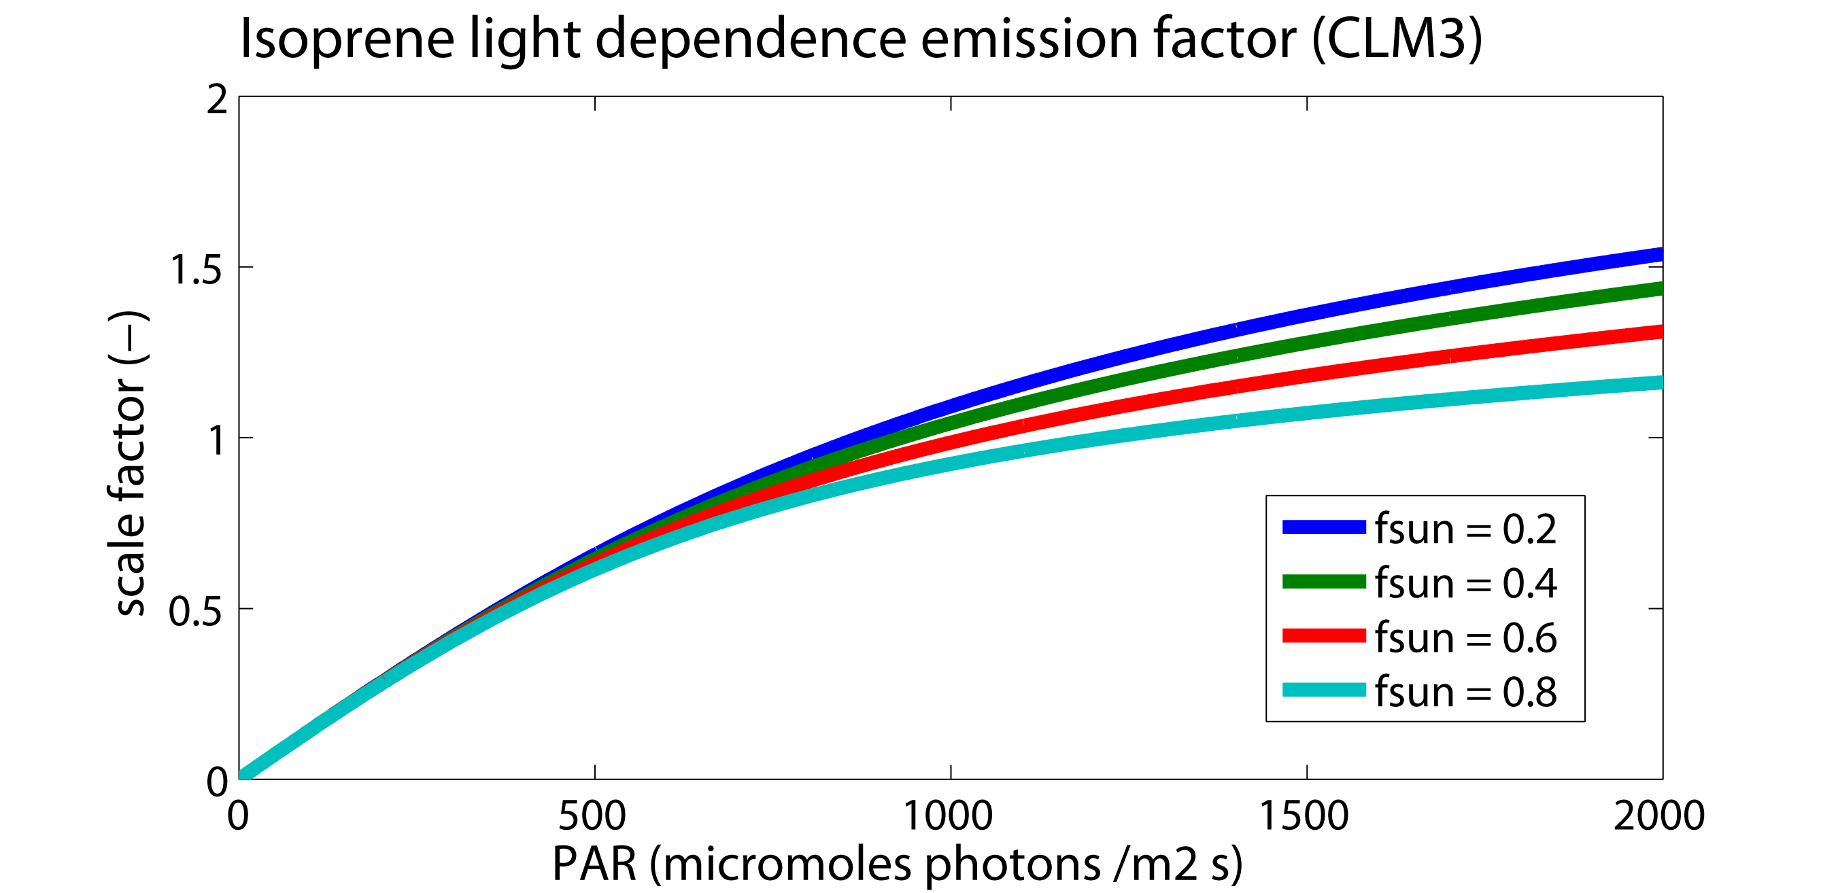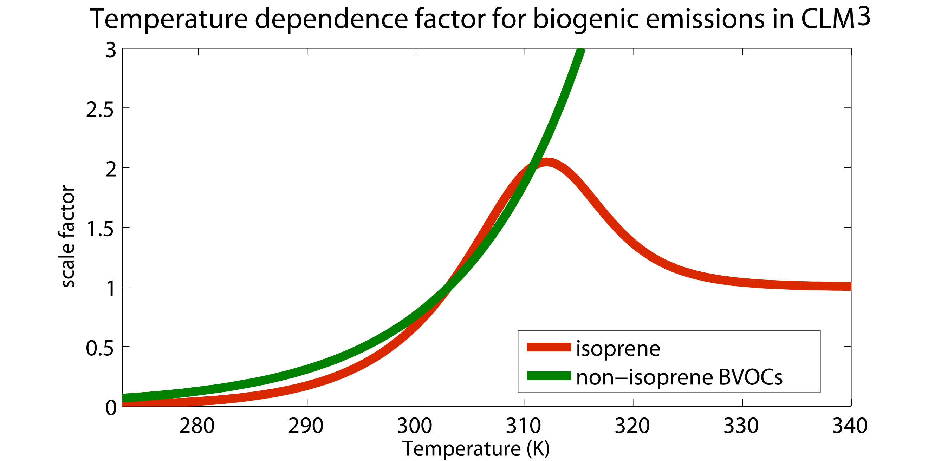
Figure 2. Bare soil fraction in the original Lawrence and Weidinmyer datasets.

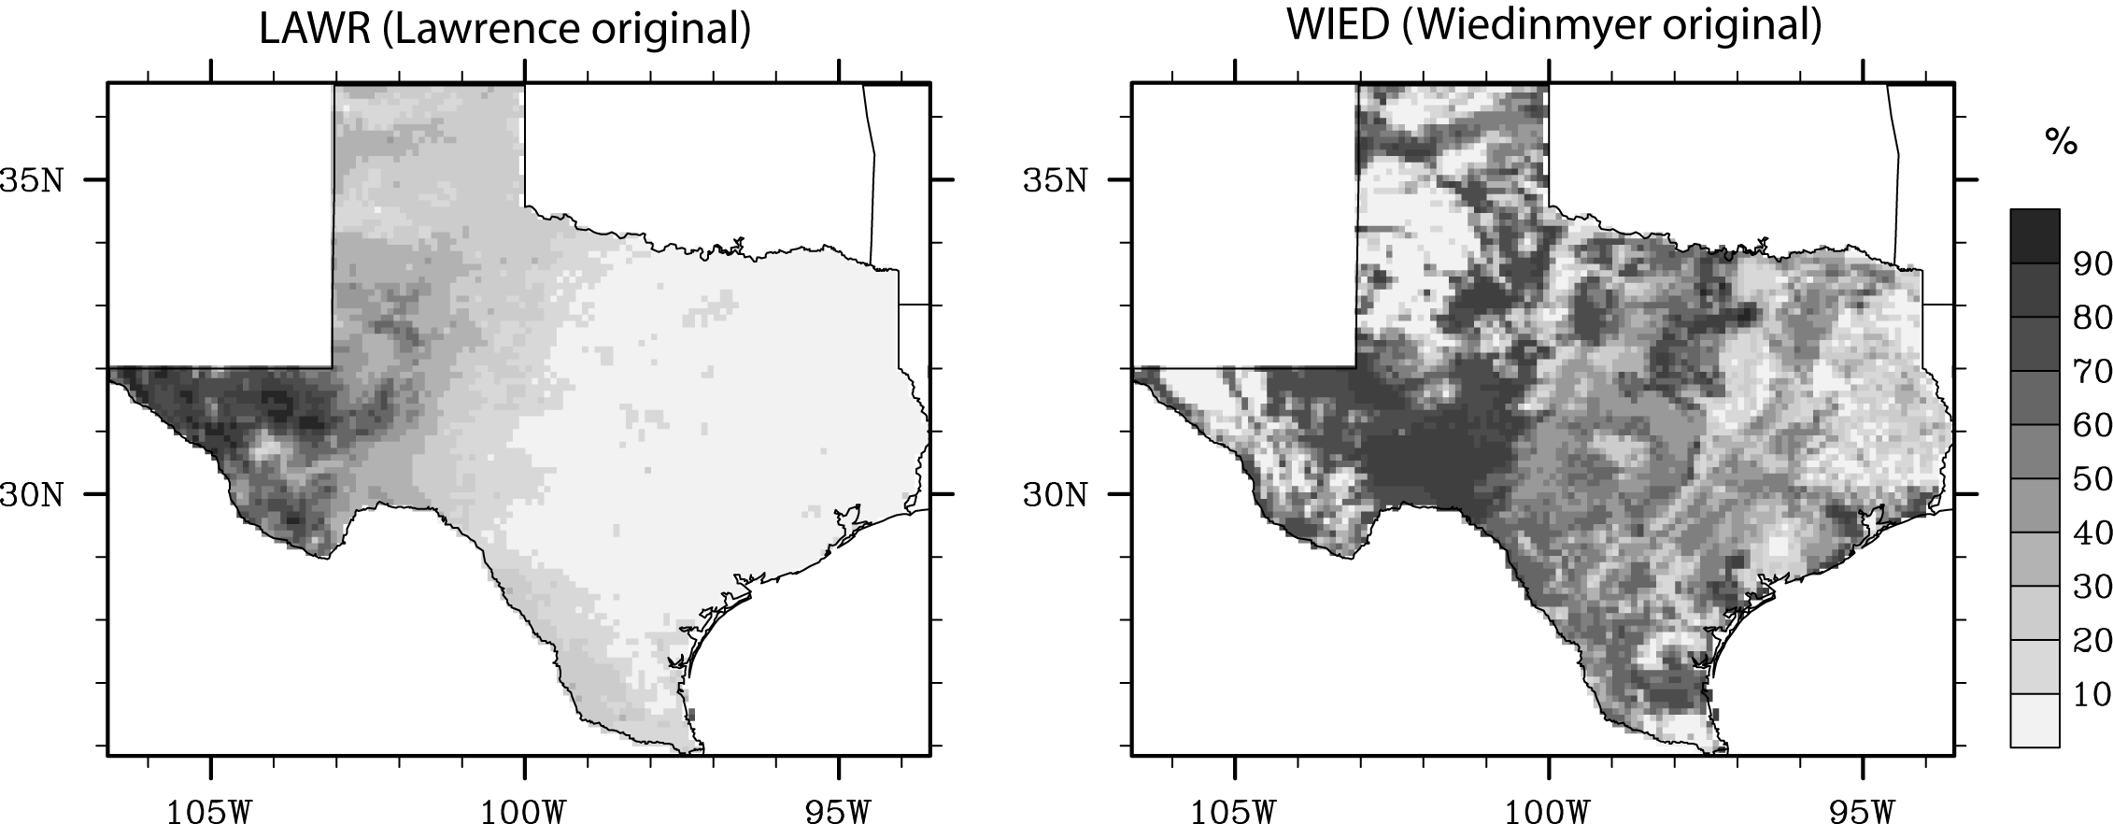
Figure 3. Sum of all tree PFTs in Texas in the Lawrence dataset and the Modified Wiedinmyer dataset.
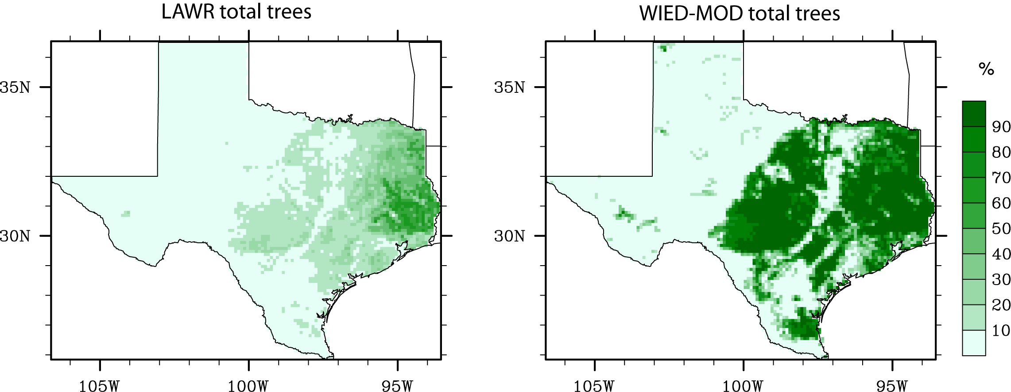
Figure 4. Difference in the statewide monthly average flux between model run using the original Lawrence dataset LAI and SAI parameters (LAWR) and the Lawrence-based dataset with longitudinally averaged vegetation parameters (LAWR-LA). Figure shows LAWR–LAWR-LA. Note the units of the vertical axis.
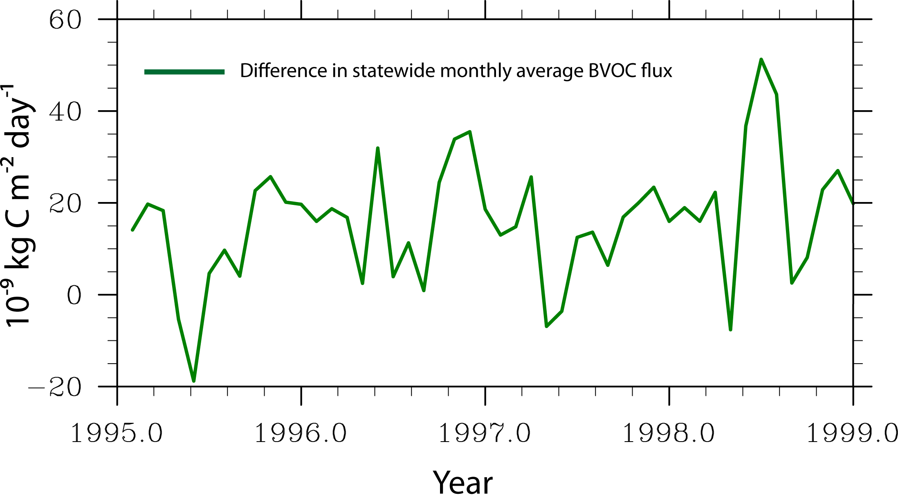
Figure 5. JJA Average daily BVOC flux rate (units are in μg C m⁻² h⁻¹) despite what the legend label says) for the period 1995–1998 for the original Wiedinmyer dataset (more bare soil) and for the modified Wiedinmyer dataset (less bare soil).

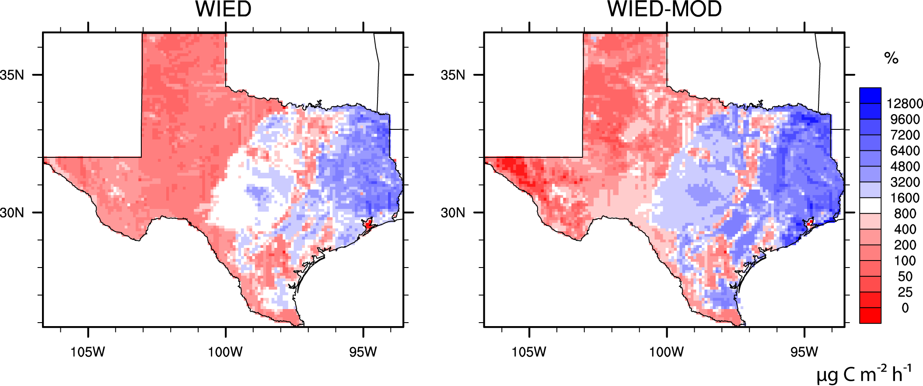
Figure 6. Statewide, monthly average total BVOC flux rate for 1995–1998 for the original Wiedinmyer dataset (more bare soil) and for the modified Wiedinmyer dataset (less bare soil).

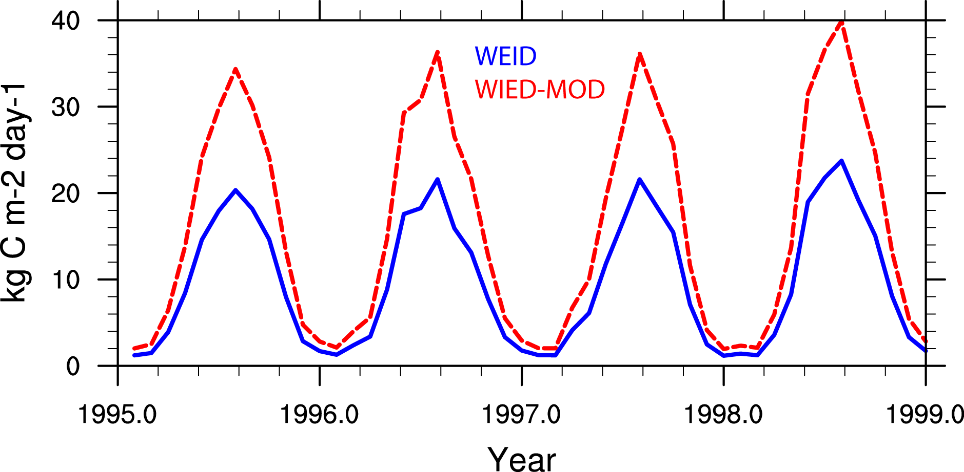
Figure 7. Difference between the monthly average BVOC canopy-temperature dependence modulation factors between the runs using the original Wiedinmyer dataset (less bare soil) and the modified Wiedinmyer dataset (more bare soil). The top panel shows the nonisoprene BVOC canopy-temperature emission dependence factor; the bottom panel shows the isoprene canopy-temperature emission dependence factor.

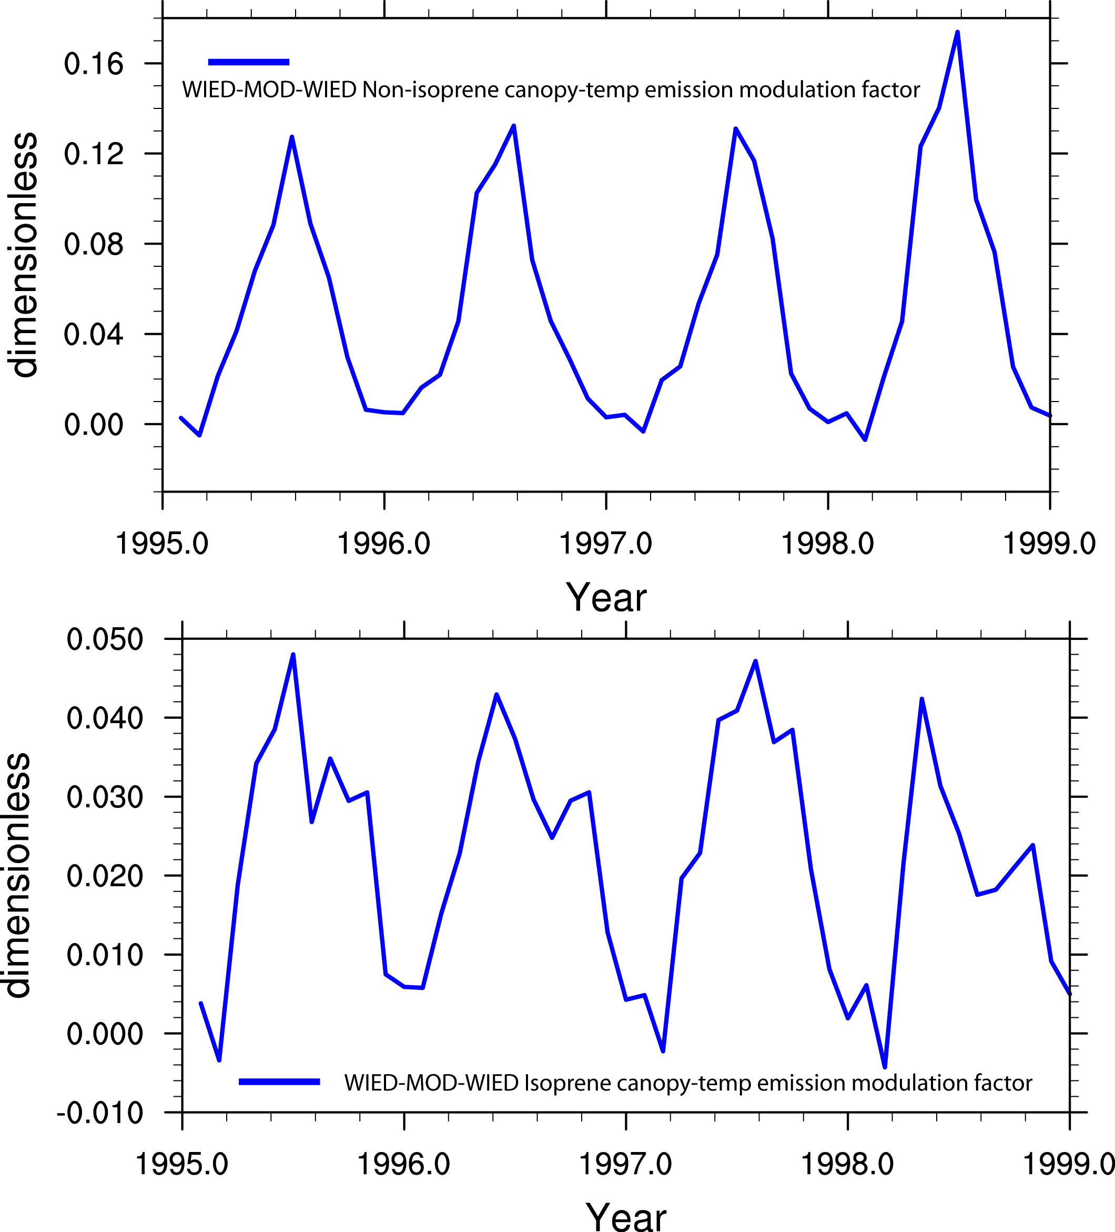

Figure 8. JJA Average daily BVOC flux rate for the period 1995–1998 for the modified Wiedinmyer dataset (WIED-MOD, despite what the figure says) and the Lawrence dataset with longitudinally averaged plant parameters.
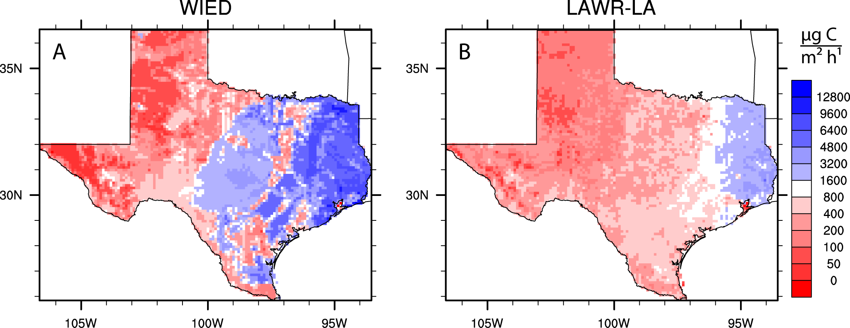

Figure 9. Statewide, monthly average total BVOC flux rate for 1995–1998 for the modified Wiedinmyer dataset (WIED-MOD; less bare soil than original; bare soil fraction equal to that in Lawrence dataset) and for the the Lawrence dataset with longitudinally averaged plant parameters.
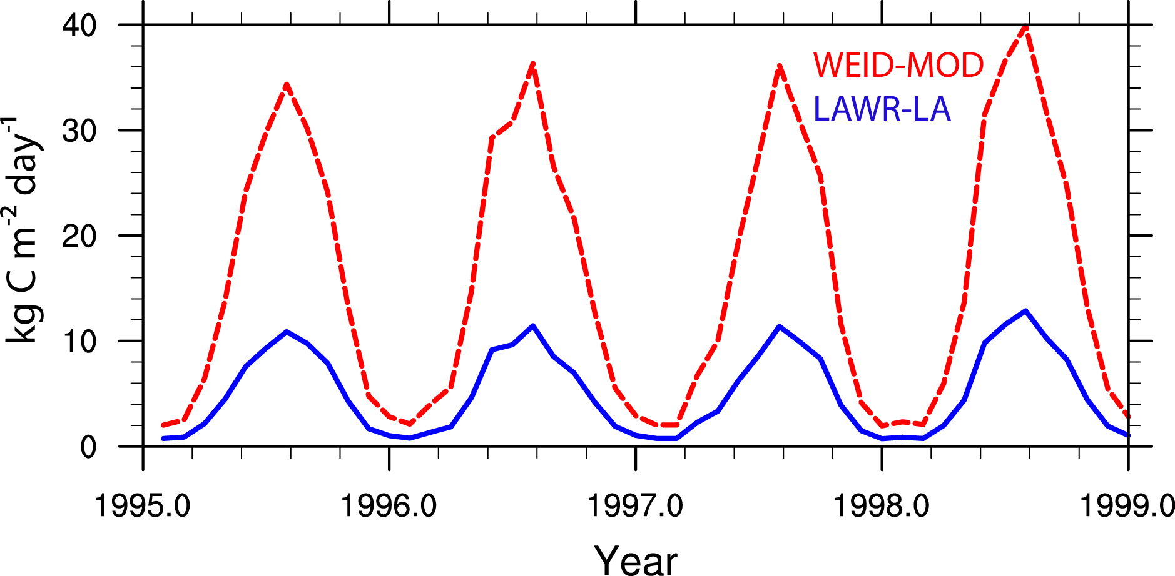
Figure 10. Difference between the monthly average BVOC canopy-temperature dependence modulation factors between the runs using the modified Wiedinmyer dataset (WIED-MOD, not WIED as shown, incorrectly, in figure) and the Lawrence dataset with longitudinally averaged plant parameters (LAWR-LA).
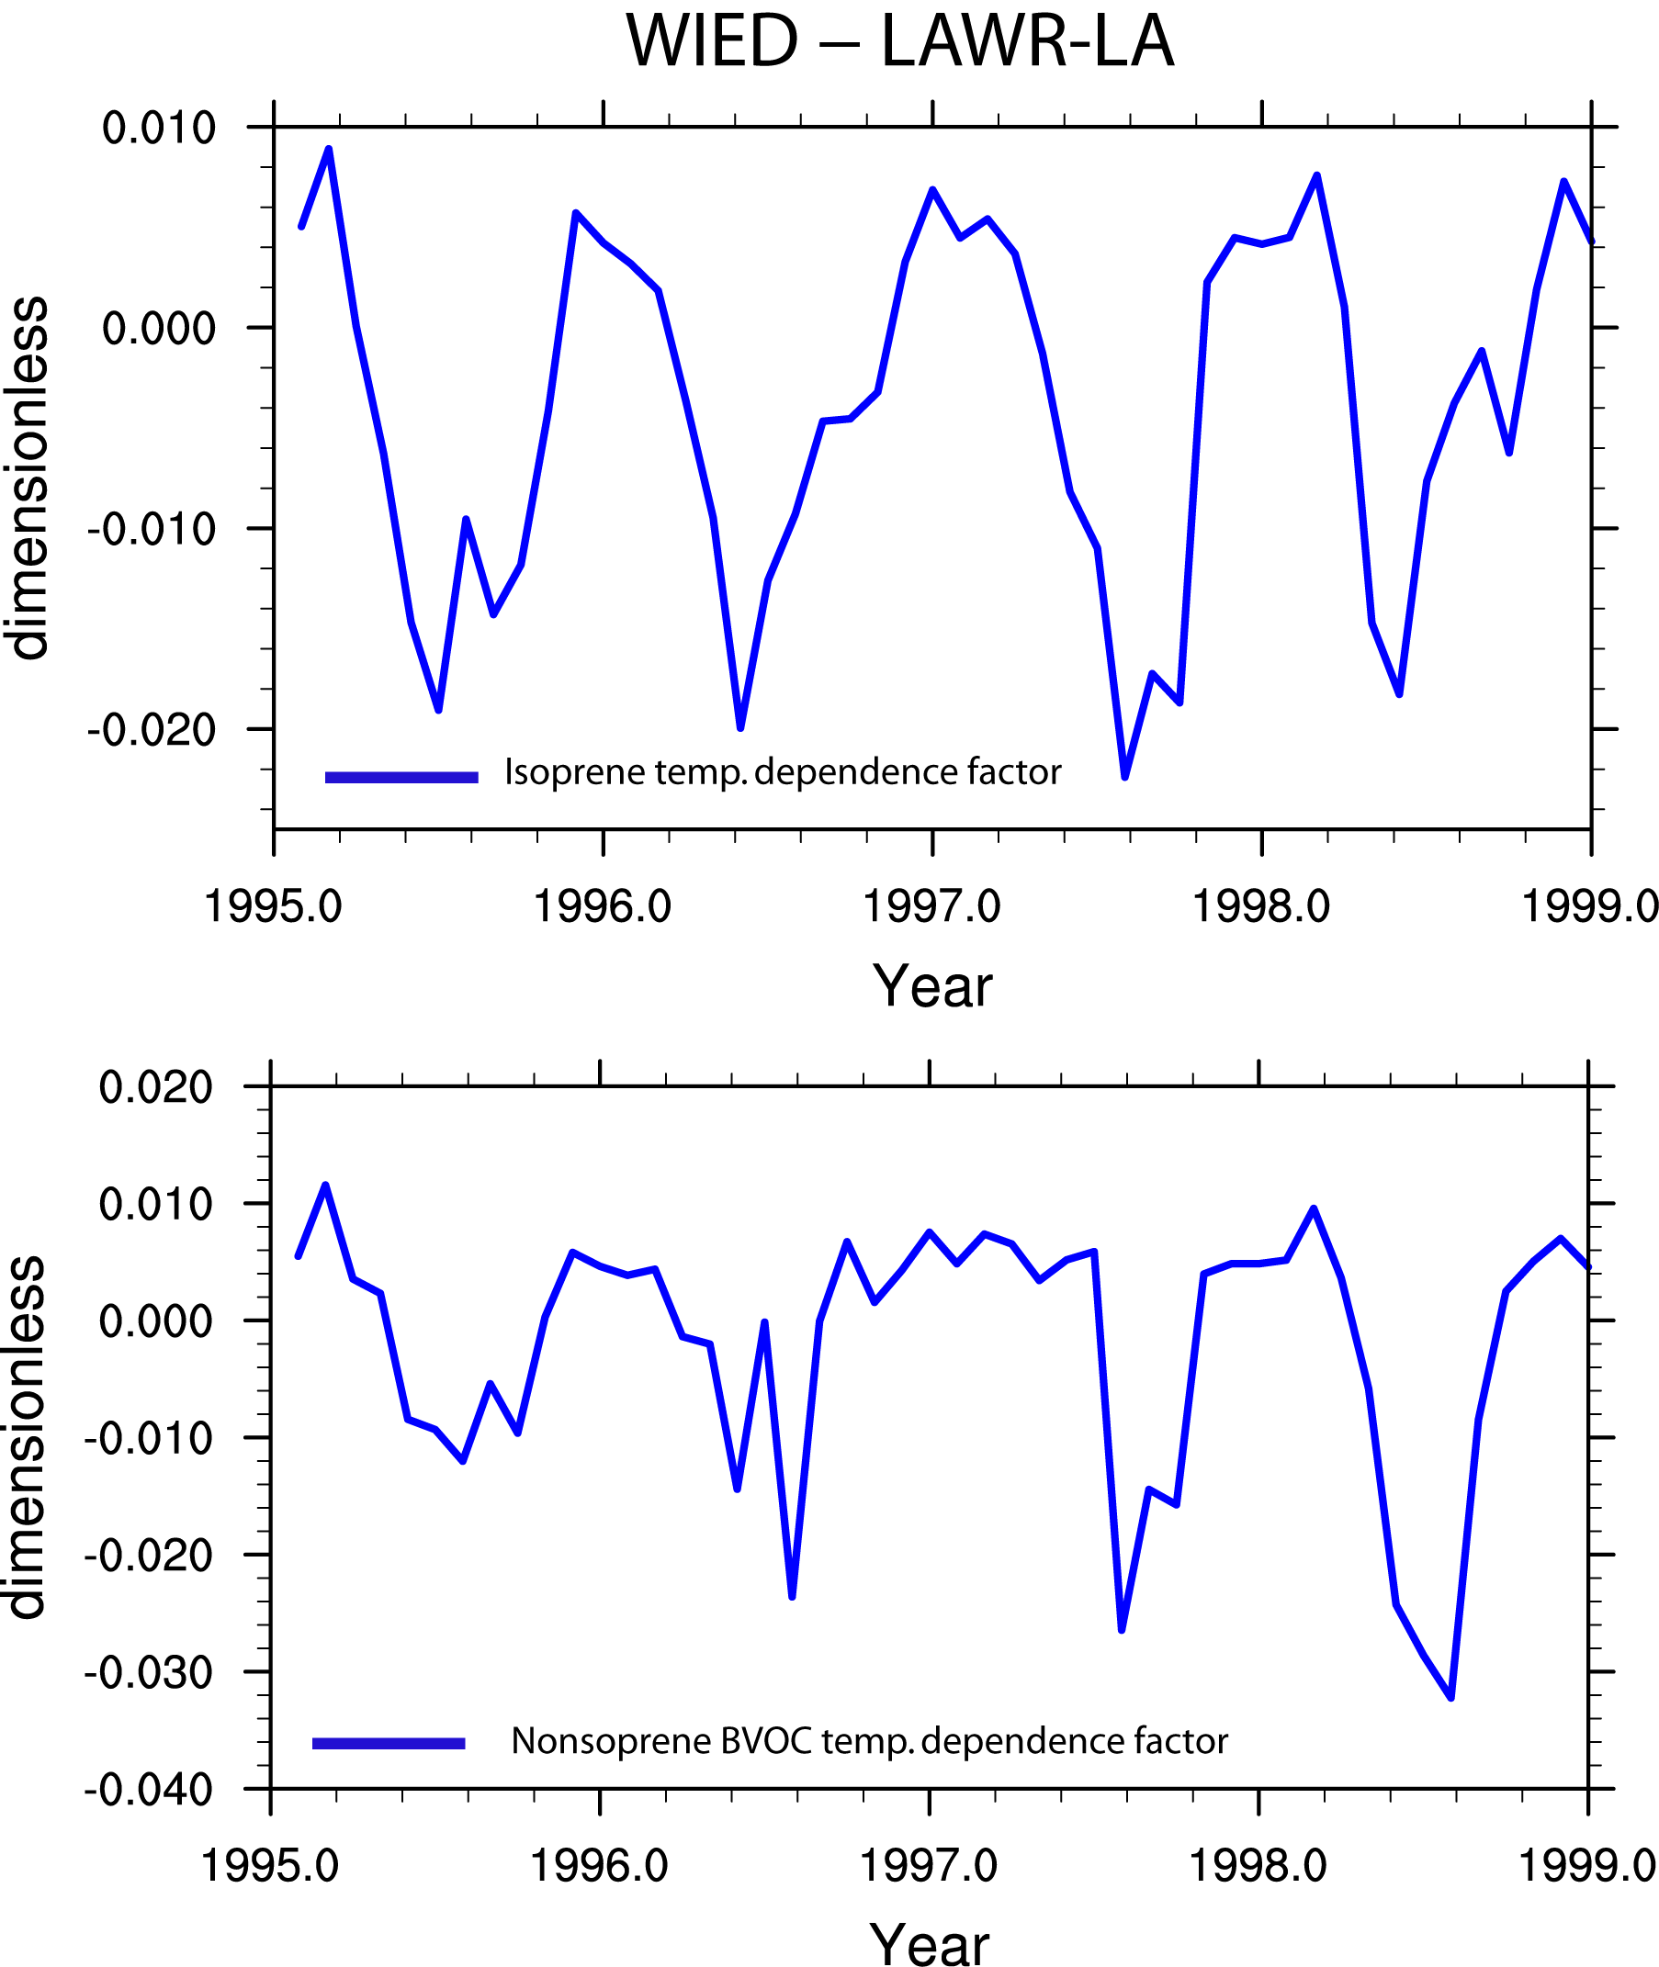

Figure 11 JJA Average daily BVOC flux rate for the period 1995–1998 for model runs using the LAWR, LAWR-1.5, and LAWR-0.5 datasets as described in the text.
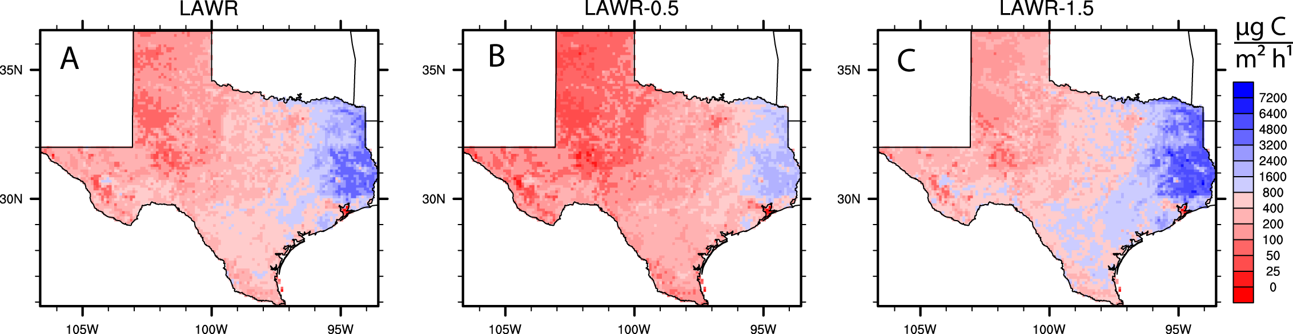

Figure 12. Statewide, monthly average total BVOC flux rate for 1995–1998 for model runs using the LAWR, LAWR-1.5, and LAWR-0.5 datasets as described in the text.

