GROUNDWATER RECHARGE THE TEXAS-MEXICO BORDER REGION AND ASSOCIATED REGIONAL GROUNDWATER FLOW SYSTEMS

ABSTRACT
Population growth in the United States (U.S.) and Mexico is focused in the arid southwest. One such region is the Texas-Mexico border region. However, groundwater resource extraction to meet human water needs often exacts deleterious environmental consequences, such as spring flow reduction or groundwater capture of surface water bodies. In the arid basins of this study, the evaluation of groundwater recharge to regional flow systems is critical for understanding groundwater resource extraction sustainability. As the climate has experienced a general drying trend in the southwest U.S. and northeastern Mexico since the Pleistocene Epoch, current recharge to these regional groundwater flow systems may be much less than historic values. Thus, prior to the initiation of groundwater development projects in the arid portions of Texas and Mexico, it is critical to ascertain the extent of regional groundwater systems.
This Literature Review will integrate the findings of three papers dealing with groundwater flow systems of the arid Texas-Mexico border region. In particular, one flow system from will be described from recharge area (Ryan, Lobo, Southeast Eagle, and Wildhorse Flats) to discharge location (San Solomon Springs). While the Texas-Mexico border region is the geographic focus of this report, aquifers of this region are analogous to the less-studied aquifers in neighboring regions. In fact, my Ph.D. research focuses on understanding regional groundwater flow in northeastern Mexico, an area with similar groundwater resource management challenges and future research will present a novel method of delineating regions groundwater systems from recharge source to discharge area.
1.0 PROBLEM STATEMENT
The Texas-Mexico border region is a locus for population growth in an arid climate. In fact, average precipitation in El Paso is approximately 22 cm/yr (or approximately 9 in/yr, BBC, 2005). As surface water resources are limited, population centers often exploit groundwater resources to satisfy unmet need. Unfortunately, unsustainable groundwater resource development often exerts undesirable environmental consequences, such as occurred at Comanche Springs of Ft. Stockton, Texas, where surrounding groundwater irrigation projects intercepted groundwater flow from the spring’s recharge area and caused the spring to dry up within 20 years of the initiation of pumping, drying a 2,500-hectare irrigation district which relied on spring discharge and eliminating the only habitat for the Comanche Springs pupfish (Brune, 2002). Further up the Rio Grande, water resource managers in the Middle Rio Grande basin of New Mexico fear that unbridled groundwater extraction for municipal uses in Albuquerque will capture Rio Grande surface flow and jeopardize the State’s mandated water deliveries to downstream Texas water users (Tidwell, 2005), a situation that western Texas may also face in the future without aggressive groundwater resource management.

2.0 SOLUTION: AQUIFER MANAGEMENT
Thus, in order to balance economic growth with preservation of groundwater-dependent ecosystems, it is critical to actively manage groundwater resources. Tantamount to this goal is the delineation of regional groundwater flow systems in arid regions such as the Texas-Mexico border. The goal of this Literature Review is to present an integrated assessment of hydrogeologic methods used to delineate groundwater flow systems from recharge to discharge in a selected series of aquifers along the Texas-Mexico border region.
3.0 GROUNDWATER RESOURCES ON THE TEXAS-MEXICO BORDER
The following section will discuss the results of several studies that have delineated regional groundwater flow systems along the Texas-Mexico border. Regional aquifers on the northern portion of the Texas-Mexico border have been well characterized by EPA and NSF-funded hydrogeologic investigations and include Hibbs and Darling’s (2005) characterization of basin-fill (alluvial) aquifers and of west Texas and Northern Chihuahua based on hydrogeologic techniques developed in analogous aquifers of the Great Basin of Nevada. Further to the east, Uliana and Sharp (2001) traced regional groundwater flow paths using geochemistry and isotopic analyses from dozens of wells. One of the first works that assessed the hydrogeology of the westernmost portion of Texas is Gates and others, 1980.

3.1 Groundwater of Westernmost Texas
The following section discusses Gates and others’ (1980) evaluation of the fresh and slightly saline groundwater resources of westernmost Texas (Figure 1). This work delineates the groundwater resources of westernmost Texas to determine sustainable production levels in order to satisfy growing demands in spite of groundwater head declines of as much as 95 feet in the El Paso vicinity from 1903-1976 and approximately 150 feet in Lobo Flat for irrigation (south of the City of Van Horn).

3.1.1 Background
In order to assess available groundwater resources in westernmost Texas, the study is accomplished in three phases. Phase 1 pertains to the collection of hydrogeologic data, including an inventory of wells, springs, groundwater levels, and groundwater quality. Phase 2 conducts a series of geophysical surveys, the primary being earth resistivity to determine the thickness of alluvial basin fill and groundwater quality. Airborne electromagnetic, seismic refraction, and aeromagnetic surveys were also conducted to supplement the surface resistivity survey. Phase 3 conducts exploratory borehole drilling (total borehole depths between 1,100 and 2,000 feet below ground surface, ft bgs) at key locations throughout westernmost Texas with borehole geophysical surveys and the collection of aquifer water samples for water quality analyses.

3.1.2 Groundwater Recharge
Gates and others (1980) conduct preliminary estimates of groundwater recharge in westernmost Texas due to local precipitation and infiltration of the Rio Grande. Based on the low level of precipitation in this arid region of Texas, the amount of groundwater in storage certainly accumulated over a long period of time. In fact, in the Hueco Bolson aquifer of northern Mexico, west Texas, and southern New Mexico, groundwater storage is estimated at 20 million acre-feet MAF) with an annual recharge of only 6,000 AF, accounting for only 0.03 percent of the total storage. Gates and others (1980) comment that groundwater recharge occurs in the foothills surrounding valley-fill aquifers and in plateaus where sediments are coarse-grained and more permeable, and also in ephemeral stream channels during high precipitation events where runoff occurs (Figure 2).
Regardless of the mechanism, recharge probably does not occur unless precipitation is great enough so that surface flow occurs. It is interesting to note that a regional long-term climatic drying and warming would certainly reduce groundwater recharge, as large precipitation events leading to surface water runoff become less frequent. Authors working in other parts of the arid western United States, most notably the Great Basin of Nevada comment on the existence of wetter pluvial periods where groundwater recharge was greater. In fact, Mifflin (1968) described a pluvial period as “… a relative term referring to intervals of geologic time when, because of climatic variations [emphasis added], more moisture was available…The geologic record … indicates several intervals of time when hydrologic conditions were markedly influenced by increased availability of water, probably related to greater precipitation and reduced rates of evaporation. Certainly under these conditions of a wetter climate, groundwater recharge would similarly have been greater in westernmost Texas, the easternmost extension of the Basin and Range Province discussed by Mifflin.
Gates and others (1980) comment that the accurate determination of recharge is difficult in westernmost Texas due to the relative paucity of data in recharge areas, including precipitation and stream flow. Despite the sparse data, an order-of-magnitude determination of recharge can be made. Following estimates made by Meyer (1976) based on a relationship of drainage area, precipitation, and recharge, groundwater recharge is estimated at only one percent of annual precipitation.

3.1.3 Groundwater Flow Systems
In order to understand the sustainability of groundwater production in a particular aquifer, it is important to understand recharge processes and also, equally important, where the groundwater goes after it is recharge. Thus, Gates and others (1980) also postulate regional groundwater flow systems from recharge point to discharge. One such system is the combined valley fill aquifers of Ryan Flats, Lobo Flat, and Wildhorse Flat (Figure 3). This regional aquifer system receives groundwater recharge along the basin margins………at the end of the groundwater system, which based on groundwater levels, is a subtle reflection of surface topography (at least under steady-state, Pre-development groundwater conditions) is Wildhorse Flats. In addition to recharge of surface runoff into groundwater, based on Pre-development groundwater levels and the resulting hydraulic gradient, some groundwater flow (approximately 1,000 AF per year) occurs from upgradient Lobo Flat and Ryan Flat.
Understanding recharge processes in higher elevation areas and groundwater inflow from upgradient basins is critical. It is also important to understand mechanisms of groundwater discharge to lower parts of the basin. Gates and others (1980) comment that Wildhorse Flats is a alluvial-filled valley underlain by Permian limestones (such as the Capitan Limestone) which in other parts of the region locally yields significant amounts of water, suggesting relatively high permeability. High permeability of underlying rocks is important to understanding groundwater discharge mechanisms. A dry salt flat north of Wildhorse Flats and east of the Sierra Diablo suggests that groundwater discharges to the salt flat, where it evaporates, depositing a salt crust. However, Gates and others, (1980) comment that prior to groundwater development, groundwater levels were equal to or lower than those in the salt flat. As a result, the majority of groundwater occurred through the permeable Capitan Limestone of the Apache Mountains to the Pecos drainage to the east, even though the Apache Mountains comprised a topographic high.

3.2 Regional Flow Paths and Springs of Trans-Pecos Texas
The following section discusses research conducted by Uliana and Sharp (2001) to delineate regional flow paths to major springs in Trans-Pecos Texas using an analysis based on groundwater head and geochemical data and analysis (Figure 4). Regional interbasin flow is important in this portion of Texas, because the annual precipitation of the Trans-Pecos Texas region averages at 30 cm and rare surface water resources means that agricultural and municipal demands are met by groundwater resources. In fact, in Trans-Pecos Texas, significant quantities of usable surface water discharges from several springs, including San Solomon, Griffin, and Phantom Lake Springs near the village of Toyahvale (Figure 5).

3.2.1 Background
Uliana and Sharp (2001) conduct an assessment of regional flow systems in Trans-Pecos Texas by conducting an analysis of groundwater levels, in addition to an evaluation and geochemical modeling of groundwater analyses. As part of the study, a geochemical database of water quality analyses conducted from groundwater samples was assembled from the Texas Water Development Board (TWDB). Of a larger group of 2,800 sampling records, composite records were generated to characterized distinct hydrogeochemical facies in Trans-Pecos aquifers based on predominant ions to test the hypothesis that spring discharge is partially due to regional flow system, based on observed spring baseflow discharge measurements of a high total dissolved solids (TDS, approximately 2,000 mg/L) and stable temperature (25-26°C) indicative of a regional flow system.

3.2.1 Groundwater Recharge
In Lobo Flat and Wildhorse Flat, low TDS Na-HCO₃ hydrogeochemical facies waters suggest primarily recent recharge. Along the postulated groundwater flow path, sodium, chloride, sulfate and TDS increase, while down gradient of the springs, TDS and associated ions decrease, suggesting increased locally derived meteoric rainwater precipitation from the Davis Mountains to the south (Figure 6). Additional information will be presented in the following section which discusses groundwater flow systems.

3.2.1 Groundwater Flow Systems
Inverse modeling using PHREEQC (a U.S. Geological survey produced computer program for speciation, batch-reaction, one-dimensional transport, and inverse geochemical calculations) was conducted for water quality samples along the postulated groundwater flow system. Two sets of inverse geochemical models were conducted: 1) to model baseflow water quality, and 2) to generate the geochemical signature during high spring discharge associated with local storm events.
First, the reaction of a groundwater sample from near the Apache Mountains with mineral phases (halite, gypsum, dolomite) and gas phases (CO₂) generates the closest match to groundwater geochemistry observed at San Solomon Springs during baseflow sampling. Second, two subsets of inverse models were conducted to understand storm discharge geochemistry. When groundwater from near Apache Mountain was mixed with a sample of local meteoric recharge from the Davis Mountains, and the dissolution of calcite and CO₂ (g) was simulated, a water very close to that of one collected during a storm discharge event on November 1, 1990 at San Solomon Springs. Also, the Apache Mountain and Davis Mountain samples were reacted with mineral and gas phases (e.g., calcite, gypsum, CO₂) to produce a water with the geochemical signature similar to the storm sample. However, the three times the ion exchange along a shorter flow path (i.e., Davis Mountains to San Solomon Springs) was required than that along a shorter flow path (i.e., Apache Mountains to San Solomon Springs), suggesting that approximately 70 percent of spring discharge during storm events is due to locally derived precipitation in the Davis Mountains. Also, calcite saturation in spring baseflow above or near zero, meaning groundwater is saturated or supersaturated with respect to calcite, supported by presence of large karst features along postulated GW flow path.
Based on the results of these analyses, the authors postulate that baseflow spring discharge is maintained by precipitation that occurs in the Wildhorse Flat portion of the Salt Basin which travels along a regional flow path under the Apache Mountains into the Toyah Basin prior to discharge at the spring location. Increased spring discharge in response to local precipitation events suggests a mixed source of regional groundwater from Wildhorse Flat and locally derived precipitation from the Davis Mountains. In fact, Figure 7 shows the relationship between TDS and precipitation. High TDS values are associated with baseflow and low TDS values generally occur associated with large precipitation events in the vicinity of San Solomon Springs.

3.3 Texas-Mexico Basin-Fill (Alluvial) Aquifers
The following section comments on the salient points of a paper by Hibbs and Darling (2005) investigates four alluvial basin fill aquifers along on the U.S.-Mexico border (Figure 8). The objective of the study is to understand groundwater flow within the basins due to recharge processes and interbasin groundwater flow, as concern exists that recent proposals to dispose of sludge and low-level radioactive waste in these west Texas aquifers may result in the contamination of important groundwater resources in neighboring basins as a result of hydraulic connections, or even flow to the Rio Grande, a key water resource for the Texas-Mexico border region. For the purposes of this paper, we will consider the Northwest Eagle Flat and Southeast Eagle Flat aquifers, which are located directly to the west of (and may be hydrogeologically connected to) aquifers in the Wildhorse Flat discussed in Gates and others, (1980) as well as Uliana and Sharp, (2001).

3.3.1 Background
Hibbs and Darling (2005) evaluate four aquifers in the southernmost North American Basin and Range physiographic province located in the intermediate basins consisting of flats and draws (or ephemeral streams) surrounded by gently sloping plateaus between long, narrow mountain ranges. Hydrogeologic interpretation in the study area is complicated by the scarcity of hydrogeologic data in the study area. In fact, depth to groundwater in the region is quite deep (300 to 800 ft bgs), so fluid potential data is typically only available in the upper portion of the saturated zone. As a result of the paucity of hydrogeologic data, Hibbs and Darling use multiple types, including: 1) hydraulic head, 2) measured groundwater temperature, 3) groundwater geochemistry, 4) isotopic analyses of groundwater, 5) surface water-groundwater relationships (i.e., open/closed or drained/undrained basins) within and between basins, and 6) the presence or absence of vadose playas. While applicable to west Texas, many of these hydrogeologic analysis techniques were developed in Great Basin of Nevada and include Snyder (1962), Maxey (1968), Mifflin (1968), Winograd and Thordarson (1975), and Eakin and others (1976). As part of this paper, we will investigate the results of their analysis with respect to groundwater flow systems and groundwater recharge in the Northwest and Southeast Eagle Flat aquifers of west Texas.

3.3.2 Groundwater Recharge
In agreement with the other two studies considered by this paper, Hibbs and Darling (2005) also assert that most recharge occurs in the mountain fronts. Based on environmental isotope data originally published by Darling and others (1994), precipitation (the main source of recharge in the area) is primarily in the upper mountains. As part of their recharge analysis, Hibbs and Darling (2005) investigated the concentration of radioactive tritium derived from atmospheric nuclear weapons testing earlier in the twentieth century and the percentage of modern carbon in ¹⁴C contained in groundwater samples. First, tritium activities in shallow wells in the upper mountain block range from 0.5 to 3.0 tritium units (TU) and decrease to background levels in flats and draws, which is contrary to the conclusions of Gates and others (1980), who suggested that significant recharge occurs in ephemeral streams, such as the draws considered by Hibbs and Darling (Figure 9). Second, ¹⁴C activities range in order of high elevation (recharge) to low elevation (discharge): 1) bedrock exposures of the Millican Hills: over 100 percent modern carbon (pmc, possibly due to analytic error), 2) Allamore (at the foot of the Millican Hills): 40 to 50 pmc, and 3) Scotty’s Crossing (immediately west of Wildhorse Flat): under 5 pmc. Figure 10 shows the correlation between tritium activity and ¹⁴C activities. The results of the tritium and ¹⁴C suggest that shallow groundwater (50 to 250 ft bgs) is young, while deeper groundwater (over 450 ft bgs) is older (Figure 10). Hibbs and Darling (2005) also comment that due to extremely high depth to groundwater (i.e., 400 to 1,000 ft bgs) in the central areas of the Northwest and Southeast Eagle Flat aquifers, low levels of recharge occurs.

4.0 RESULTS AND CONCLUSIONS
Based on disparate sources of hydrogeologic data, we can decipher a regional flow system in selected aquifers of the Texas-Mexico border region from recharge in the west (Southeast Eagle Flat) and southwest (Ryan Flat, Lobo Flat) to discharge at San Solomon Springs in the east. The westernmost point of groundwater recharge occurs in the mountains surrounding Southeast Eagle Flat (Millican Hills, east, and Eagle Mountains, west), with groundwater flow out Scotty’s Crossing to Wildhorse Flat (Hibbs and Darling, 2005) after receiving recharge from the using groundwater water head data, in addition to environmental isotope data (tritium and ¹⁴C). Within Wildhorse Flat, groundwater also flows into the basin due to interbasin groundwater flow from the south from Ryan and Lobo Flats (Gates and others, 1980). Locally derived precipitation is recharged into Wildhorse Flat due via ephemeral streams, such as Wildhorse Creek, in addition to surface runoff at the basin peripheries from the Baylor, Beach, and Wylie Mountains. Using complementary hydrogeologic data (groundwater head, groundwater temperature, geochemistry, etc.), both Gates and others (1980), Uliana and Sharp (2001), and Hibbs and Darling (2005) all agree that prior to groundwater pumping, a substantial portion of groundwater in Wildhorse Flat exited the basin via interbasin flow underneath the Apache Mountains. Based on inverse geochemical modeling, spring discharge rate, and other factors, Uliana and Sharp (2001) suggest that groundwater flows to the east of the Apache Mountains, into the Toyah basin, and then to San Solomon Spring flowing through a highly permeable Cretaceous carbonate aquifer. Thus, a portion of the groundwater that discharges in San Solomon Spring may have traveled over 100 km from Southeast Eagle Flat and approximately 150 km from Ryan Flat, which order-of-magnitude calculations suggest (based on hydraulic head and flow path length data) may have taken 500 years or more. Thus, groundwater water in this regional flow system may have recharged under climatic conditions different (i.e., wetter, cooler) than today.
Based on this Literature Review, a regional groundwater flow system is demonstrated for a series of west Texas aquifers from recharge area to discharge location using integrated sources of hydrogeologic data. Future work as part of my larger Ph.D. research will delineate regional groundwater catchments using NASA SRTM digital elevation datasets (U.S. Geological Survey, 2005) and traditional geologic data. Prior to application in my study area (a relatively hydrogeologically uncharacterized region), I will test the method in this groundwater flow system in West Texas in order to validate the method to delineate groundwater systems from recharge to discharge points in other parts of the world with sparse hydrogeologic data.
FIGURES
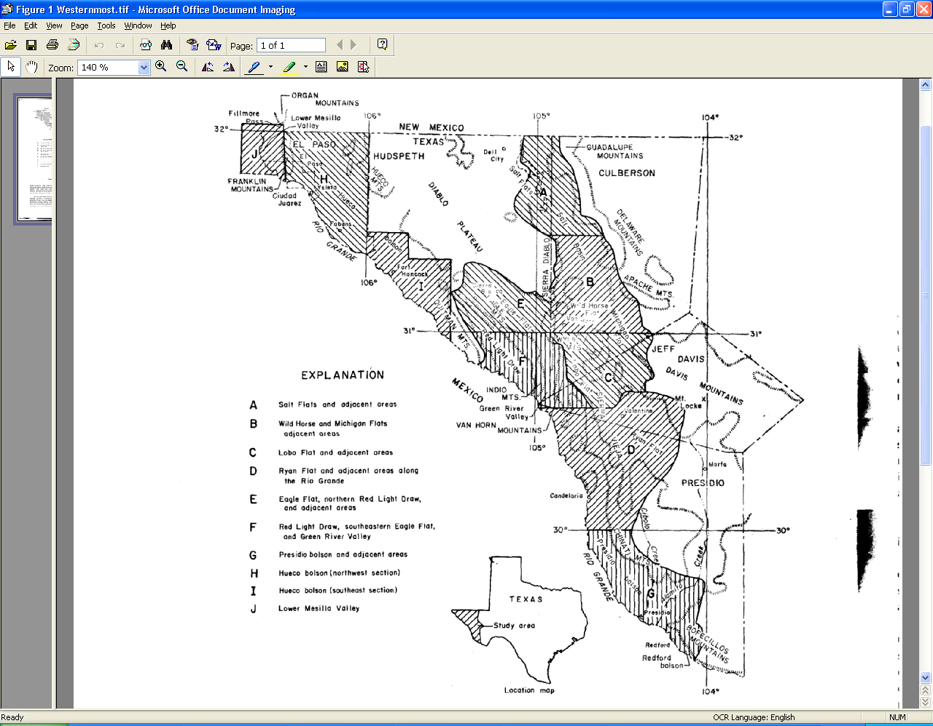
Figure 1. Gates and others (1980) study location. Aquifers selected for this Literature Review highlighted in yellow, regional groundwater flow system from recharge to groundwater outflow in blue.

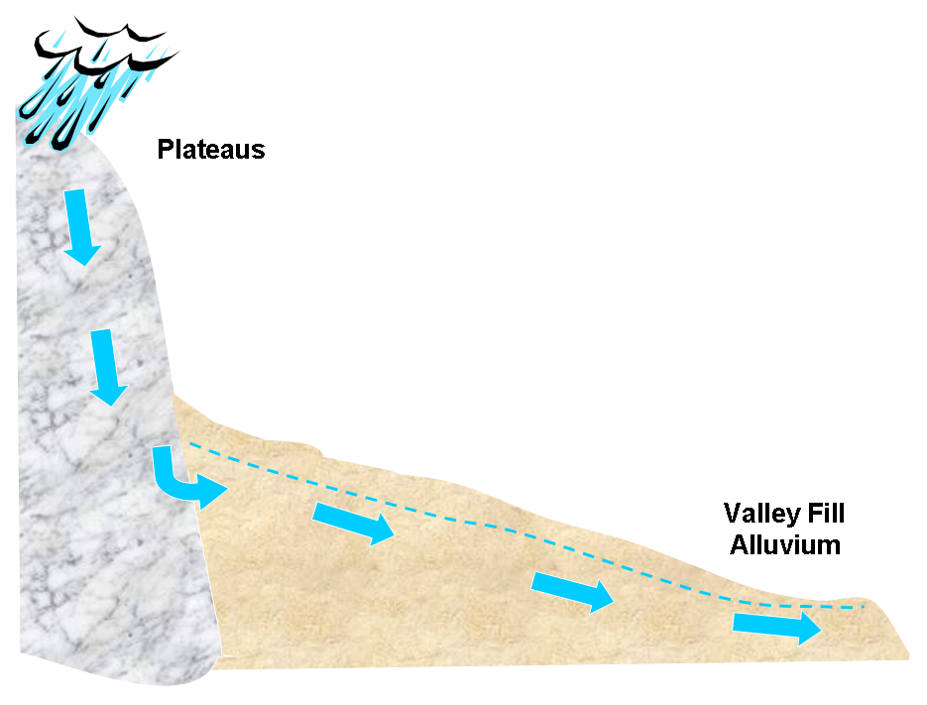
Figure 2. Conceptual model for groundwater recharge in Texas-Mexico border aquifers.

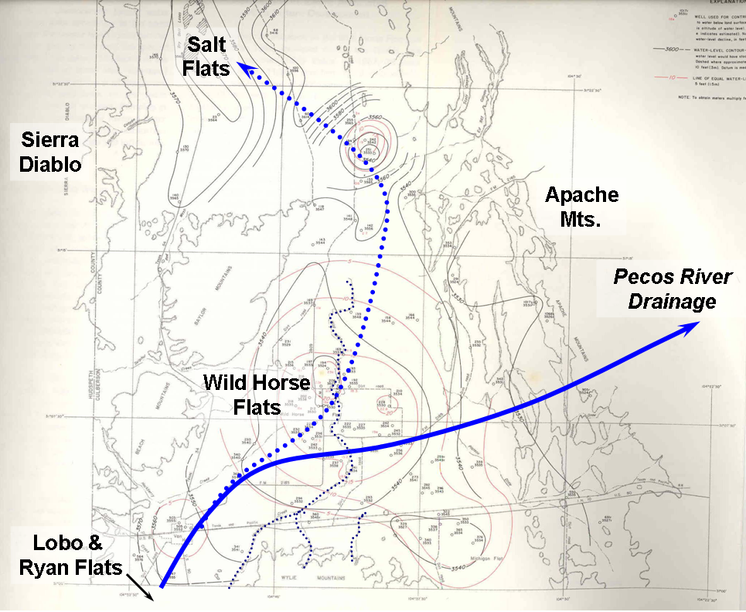

Figure 3. Regional groundwater flow system postulated by Gates and others (1980) from recharge in Lobo, Ryan, and Wildhorse Flats, to groundwater outflow under the Apache Mountains east to the Pecos River drainage (pre-development indicated by solid blue line, post-development by dashed line)
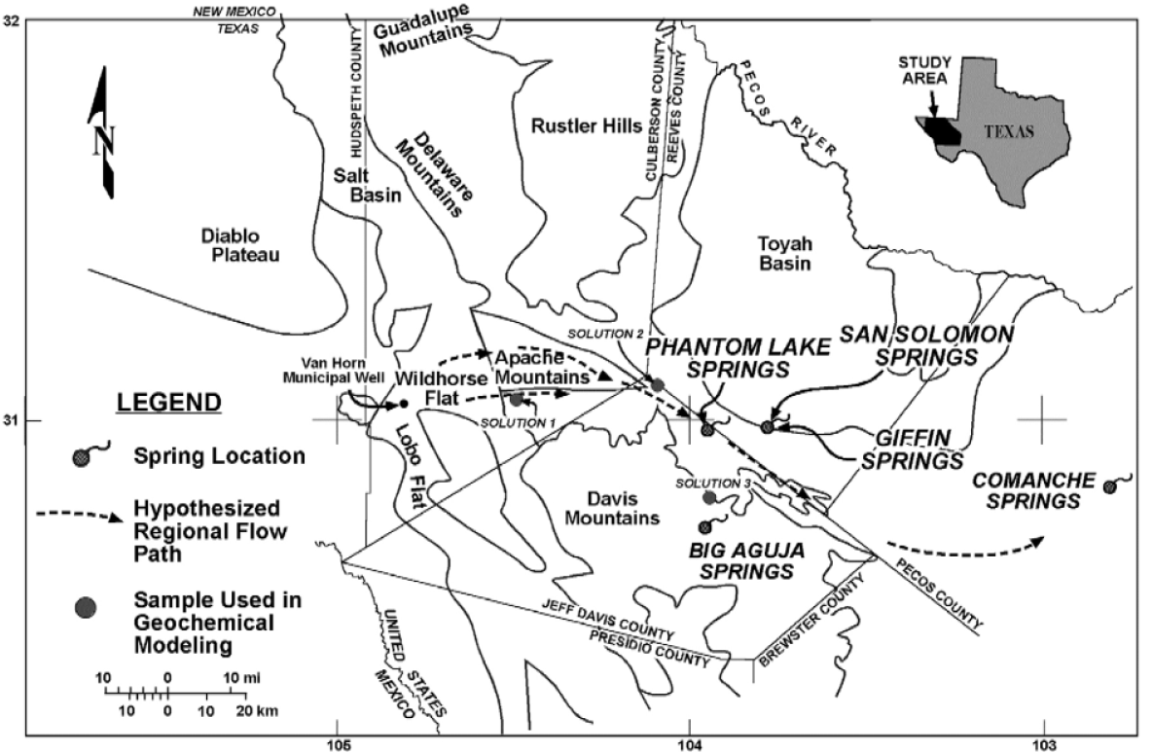
Figure 4: Map of Trans-Pecos Texas showing major physiographic features, springs, and inferred regional groundwater flow paths (dashed lines, Uliana and Sharp, 2001, simplified from Barnes, 1976, 1979, 1995ab).
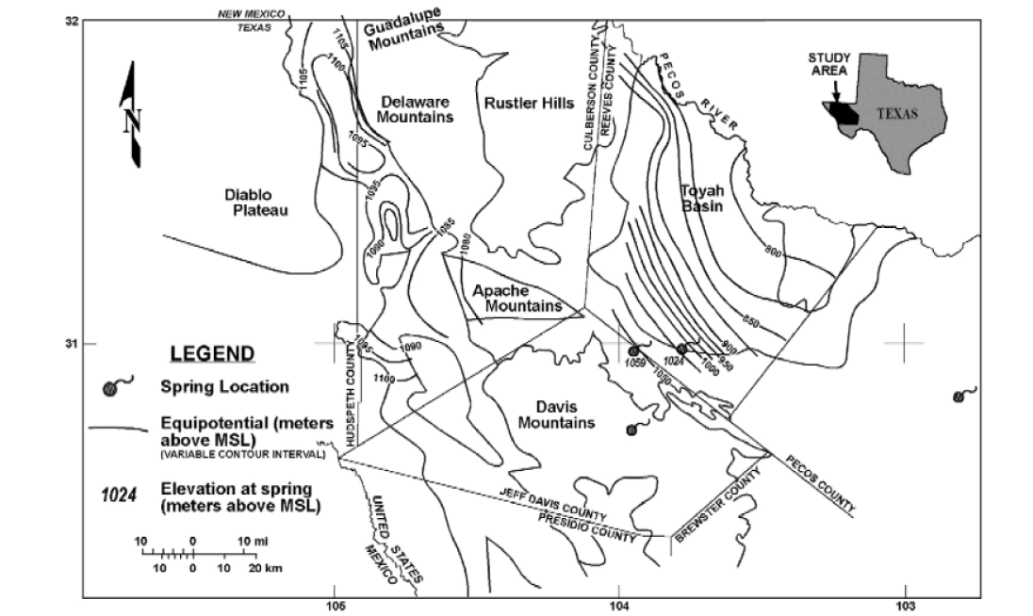

Figure 5: Pre-development groundwater heads in Trans-Pecos Texas (Uliana and Sharp, 2001, modified after Sharp, 1989).

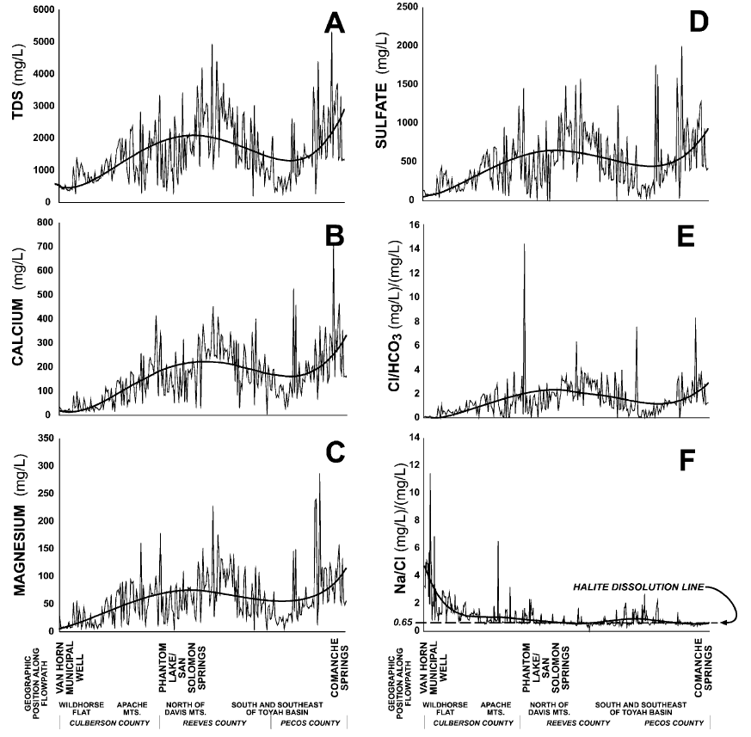
Figure 6: Graphs of geochemical parameters and ion ratios plotted against position along the hypothesized regional flow path. Curves fit to the data are polynomial trendlines; these lines illustrate the overall trends within the variability of the data (Uliana and Sharp, 2001).

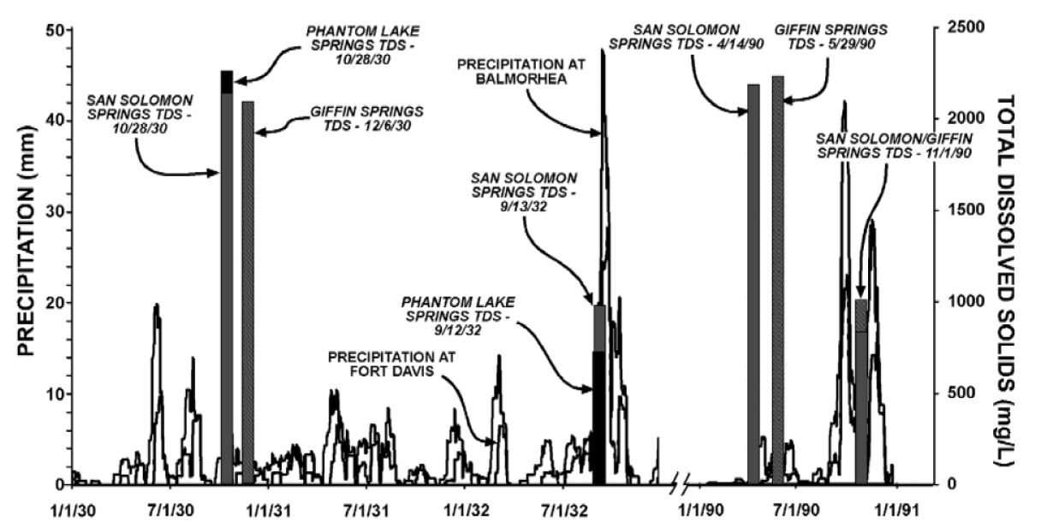
Figure 7: Graphs of local precipitation (solid lines) and spring discharge TDS (columns). Low TDS values in spring discharge are associated with major precipitation events. (Uliana and Sharp, 2001).

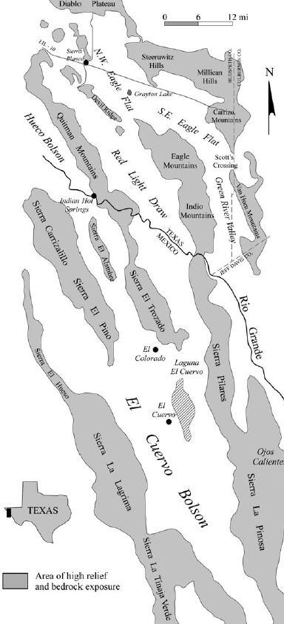
Van Horn
Wildhorse Flat

N
N

Figure 8. Location of the study area and principal basins in the region.

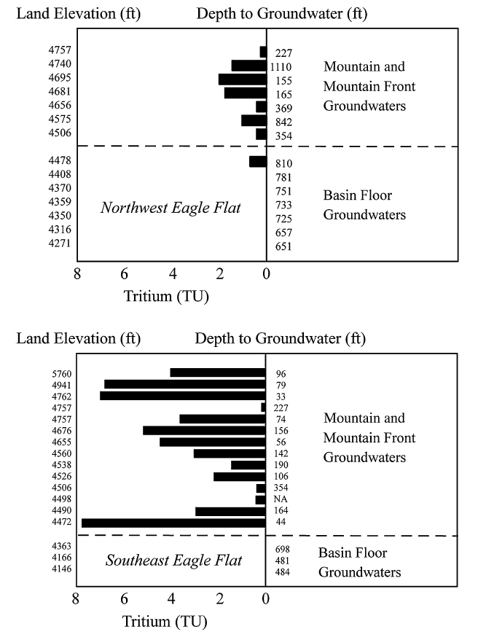

Figure 9. Tritium values (TU) in highland (mountains and mountain fronts) and lowland (basin floor) aquifers in Northwest Eagle Flat and Southeast Eagle Flat. Also shown are surface elevations and depth to ground water. Tritium values indicate that mountains and mountain fronts are active areas of recharge.
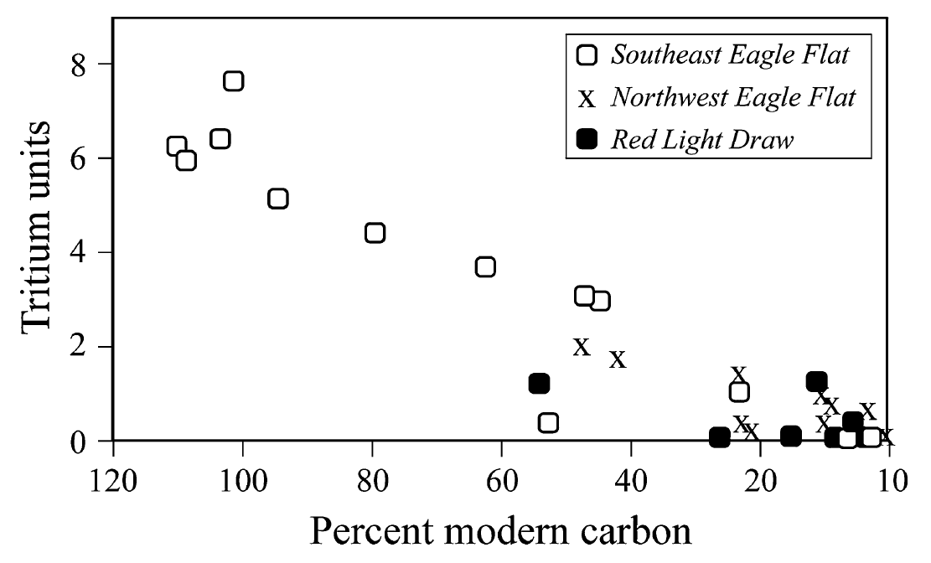
Figure 10. Plot of 3H vs. 14C couplets for water wells in the Southeast Eagle Flat, Northwest Eagle Flat, and Red Light Draw aquifers. The downward sloping trend for Southeast Eagle Flat and Northwest Eagle Flat aquifers indicates mixing between recent recharge water and older ground water (Hibbs and Darling, 2005).

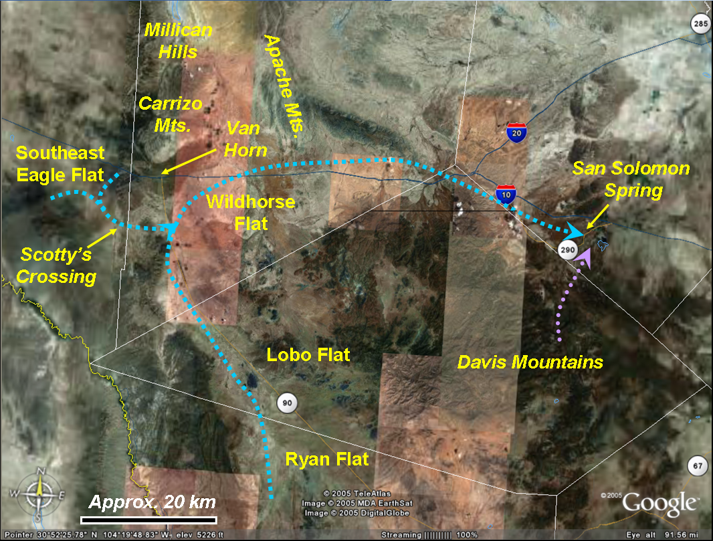

Figure 11. Postulated pre-development regional groundwater flow path (blue dashed line), based upon integrated results of Gates and others (1980), Uliana and Sharp (2001), and Hibbs and Darling (2005). Recharge occurs in the mountains surrounding Ryan Flat, Lobo Flat, Southeast Eagle Flat, and Wildhorse flat. Baseflow at San Solomon Spring is comprised significant portion of regionally derived groundwater, in addition to local precipitation from the Davis Mountains (purple dashed line).
5.0 REFERENCES CITED

BBC, 2005, BBC Weather, El Paso [Online]: http://www.bbc.co.uk/weather/world/city_guides/results.shtml?tt=TT001400 [accessed on November 29, 2005].

Brune, G., 2002, Springs of Texas: College Station, Texas A&M University Press, 566 p.

Darling, B.K., Hibbs, B.J, Dutton, A.R., 1994, Ground-water hydrology and hydrochemistry of Eagle Flat and surrounding area: The University of Texas at Austin, Bureau of Economic Geology, contract report prepared for Texas Low-Level Radioactive Waste Disposal Authority, Interagency Contract (92-93)-0910. Austin, Texas: Bureau of Economic Geology, University of Texas at Austin.

Eakin, T.E.; Price, D.; Harrill, J.R., 1976, Summary appraisals of the nation’s ground-water resources – Great Basin region: USGS Professional Paper 813-G.

Gates, J.S., White, D.E., Stanley, W.D., Ackermann, H.D., 1980, Availability of fresh and slightly saline water in the basins of westernmost Texas: Texas Department of Water Resources Report 256, 108 p.

Hibbs, B. J., Darling, B. K., 2005, Revisiting a classification scheme for U.S.-Mexico alluvial basin-fill aquifers: Ground Water, Vol. 43, No. 5, p. 750-763.

Maxey, G.B., 1968, Hydrogeology of desert basins: Ground Water, vol. 6, no. 5, p. 1-22.

Meyer, W.R., 1976, Digital model for simulated effects of ground-water pumping in the Hueco Bolson, El Paso area, Texas, New Mexico, and Mexico: U.S. Geological Survey Water Resources Investigation 58-75, 36 p.

Mifflin, M.D., 1968, Delineation of groundwater flow systems in Nevada: University of Nevada-Reno, Desert Research Institute, Technical Report Series H-W, Hydrology and Water Resources Publication 4. Reno, Nevada: Desert Research Institute, University of Nevada-Reno.

Snyder, C.T, 1962, A hydrologic classification of valleys in the Great Basin, western United States: Bulletin of the International Association of Scientific Hydrology, vol. 7, no. 3, p. 53-59.

Tidwell, V.C., 2005, Personal Communication. Senior Geoscientist, Sandia National Laboratories, Albuquerque, NM.

Uliana, M. M., Sharp, J. M., 2001, Tracing regional flow paths to major springs in Trans-Pecos Texas using geochemical data and geochemical models: Chemical Geology, Vol. 179, Issue 1-4, p. 53-72.

Winograd, I.J., Thordarson, W., 1975, Hydrologic and hydrogeochemical framework, south-central Great Basin, Nevada-California, with special reference to the Nevada Test Sites: USGS Professional Paper 712-C.

