PROPOSAL FOR THE DEVELOPMENT OF AN IMPROVED CLIMATE MODEL FOR THE ESTIMATION OF GROUNDWATER RECHARGE IN BASINWIDE AND CATCHMENT-SCALE GROUNDWATER FLOW SYSTEMS

Abstract
The NCAR CCM is a three dimensional general circulation climate model that simulates dynamic and complex climatic processes of the entire planet Earth, including biophysics, hydrologic cycle, biochemistry, and dynamic vegetation components. Recent advances to the hydrologic cycle component of the NCAR CCM added the ability to simulate total runoff (i.e., both surface and subsurface drainage) of the Earth’s major global river systems using a river routing model. While this update improves hydrologic applications of the model at a major drainage scale (calculations are made on a ½ degree grid, approximately 50 kilometer, km by 50 km), many water resource managers are interested in basin to catchment-scale hydrologic processes on a grid scale as small as 1 km by 1 km. Calculations at this scale permit more accurate estimates of river flow and associated groundwater recharge. In many karst aquifer groundwater systems, such as the Edwards aquifer of Central Texas, groundwater recharge is directly estimated by measuring stream flow upstream and downstream of the aquifer outcrop area. Thus, for influences of climate change on groundwater recharge to be estimated at a catchment scale, it is essential that the NCAR CCM be refined to run with a spatial discretization as small as 1 square km (km²).
As part of this research proposal, I propose to complete the following research objectives:
- Increase the spatial resolution of the hydrologic component of the NCAR CCM to 1 km²,
- Develop a groundwater recharge sub-model that estimates groundwater recharge based on stream losses across a karst carbonate aquifer outcrop area, and
- Conduct a groundwater recharge sub-model validation using a well-studied aquifer, such as the Edwards aquifer of Central Texas.

1. Background

Population growth in the United States is focused in arid portions of the country. Surface water resources are limited so that much of man’s water demands in this region are met from groundwater resources. However, groundwater extraction to meet human water needs often exacts deleterious environmental consequences, such as spring flow reduction or groundwater capture of surface water bodies. Due to the complexities and potential effects of groundwater resource development, groundwater resource managers rely on the use of numerical models to evaluate regional groundwater resource management decisions. On example of this trend towards regional groundwater modeling is the State of Texas, where the Texas Water Development Board (TWDB) constructed groundwater availability models (GAMS) for all of the major aquifers and many of the minor aquifer to provide reliable information on groundwater availability (Mace, 2005, TWDB, 2005).
Recently, interest in the effects of climate changes on groundwater resources has increased. In fact, Sharp (2005) asserts that while GAMS are an effective tool to provide a qualitative assessment of groundwater resources, uncertainties exist on their application. In fact, hydrogeologic, anthropologic, and climatic uncertainties conspire to reduce the accuracy of groundwater model results. Thus, Sharp asserts that new groundwater models must consider changes in groundwater recharge and evapotranspiration in response to climate change. While recent climate models attempt to incorporate surface water runoff and associated groundwater recharge, the opportunity for model improvement still exists.

2. Goals and Objectives
Advances have been made with combined climate models and numerical groundwater models. However, additional advances must occur for these two modeling systems to be useful for groundwater resource management professionals. For these models to accurately characterize surface water processes and associated groundwater recharge in karst aquifers at the basin and catchment scale, improvements must be made. Some problems still exist and include:
- The spatial discretization of models remains too coarse (i.e., ½ degree, or approximately 50 km by 50 km is finest current resolution), and
- Surface water and groundwater interactions must be improved to reflect dynamic groundwater recharge processes.
In order to accomplish these research goals, the following action items must be conducted:
- Increase model resolution to 1 km²,
- Generate an improved groundwater recharge sub-model to characterize groundwater recharge due to stream flow across an aquifer outcrop area, and
- Test the model using the Edwards aquifer of Central Texas.

3. Current Models and Hydrology
The following section includes a review of selected climate-surface water-groundwater modeling efforts. For example, Bonan and others (2002) comments that current land surface models (LSMs) do deal with the lower boundary in a fully process-based manner. However, groundwater models (GWMs) effectively quantify subsurface heterogeneities (in some cases, depending on the scale) and three-dimensional flow, but do not effectively assess runoff. In the NCAR LSM1, runoff is generated from the saturated and the unsaturated zones in response to regional precipitation events and baseflow (drainage) is a function of the hydraulic conductivity of the bottom soil layer, without an effective hydrogeologic characterization of a lower aquifer. Bonan et al. (2002) describes a modification of the NCAR CLM, called CLM1, which uses a TOPMODEL approach to saturated and unsaturated flow, in which topography influences the amount of runoff generated. Where there is gentle slope and convergent flow, saturated zones develop and contribute to surface runoff. Figure 1 illustrates how the CLM calculates the water budget. Unfortunately, CLM1 permits return flow to lakes, wetlands, and downstream outflow, but does not appear to adequately address groundwater recharge from surface water flow.
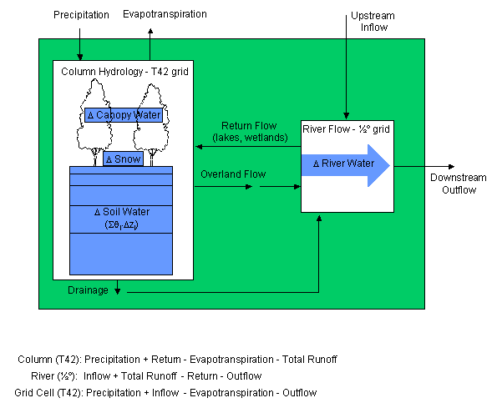
Figure 1. Water budget calculation in the CLM (NCAR, 2005).

When dealing with groundwater, Yusoff (2002) coupled a MODFLOW numerical groundwater model with a climate change models created at the United Kingdom’s Hadley Centre for Climate Prediction and Research to evaluate changes in river baseflow, groundwater recharge, and groundwater levels in the Chalk aquifer of west Norfolk, United Kingdom based on climatic forcing. While this study approaches groundwater resources management at a catchment scale, its main shortcoming is that the transient numerical groundwater model relies on monthly recharge estimates from the climate model, but the climate model does not receive input from the groundwater model during 15-year simulations. Similarly, Yarnal and others (2000) investigated the response of the Susquehanna River Basin to simulated precipitation using the Penn State-NCAR high-resolution mesoscale meteorological model (MM5) with a suite of coupled hydrologic models. Precipitation is distributed over the basin at a scale as fine as 4 km by 4 km from MM5 and drives the Hydrological Modeling System (HMS) of physically-based surface routing, soil water, channel leakage, and groundwater models to produce a simple hydrograph. Yarnal and others (2000) comment that future model improvements include improving the system from a linked to coupled model, improving efficiency, and expanding the time scale of analysis. In fact, if the model only evaluates the basin response to one storm even, perhaps a climate model is not necessary; instead, they could simply apply spatially-distributed precipitation. Also, the main output of the model is a surface water hydrograph. Ideally, the model would also produce a groundwater hydrograph. Yu (2005) couples a coarse-grid regional climate model with a fine-grid hydrologic model to simulate changes in major rivers, lakes, and groundwater at a 20 km by 20 km scale. Similarly, the NCAR CLM operates on a large grid size and only investigates river routing at the scale of major global drainage (see Figure 2). While these modeling efforts deserve appreciation, in order to be valuable to groundwater resource management professionals, climate-surface water-groundwater models must assess processes on a basin or catchment scale with a spatial discretization as fine as approximately 1 km².

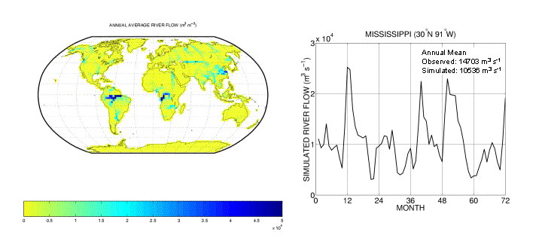
Figure 2. River routing at the scale of major global drainages in NCAR CLM (NCAR, 2005).
4. Proposed Research
The following section discusses the goals of the proposed research. As part of this proposal, we outline the following goals: 1) Increase model resolution to 1 km², 2) Generate groundwater recharge sub-model for recharge of stream flow, and 3) Test the model using the Edwards aquifer of Central Texas (see the following section for a description).
The first project goal proposes to increase model resolution to 1 km². While limits on computational power probably do not permit the entire globe to be modeled at this resolution, perhaps the model can be run at two resolutions. The larger model may be run at typical 50 km by 50 km cells (or even coarser resolution) for the entire globe. The results of this model may be used as the boundary conditions for a model with finer (i.e., 1 km²) resolution for the basin of interest to optimize computation.
Second, within the finer model, surface water-groundwater interaction can be improved to model groundwater recharge processes due to stream flow across an aquifer outcrop recharge area. As mentioned in the previous section, current modeling efforts do not adequately characterize this component of the water budget at a basin or catchment scale. The updated model could borrow methodology from the MODFLOW numerical groundwater model (Harbaugh and McDonald, 1996), which permits water to flow from the river to the groundwater in a losing river reach, or from the aquifer to the river in a gaining river reach (Anderson and Woessner, 2002). As shown in Figure 3, river leakage is calculated using the following equation:
QRIV = (KLW / M ) * (HRIV – h )
Where:
QRIV = river leakage
K = vertical hydraulic conductivity of river sediments
L = channel length
W = channel width
M = thickness of river sediments
HRIV = head in source reservoir
H = head in aquifer directly below source reservoir
This same approach may be used within a revised model to accurately represent groundwater recharge due to surface water runoff generated by a large climate model.
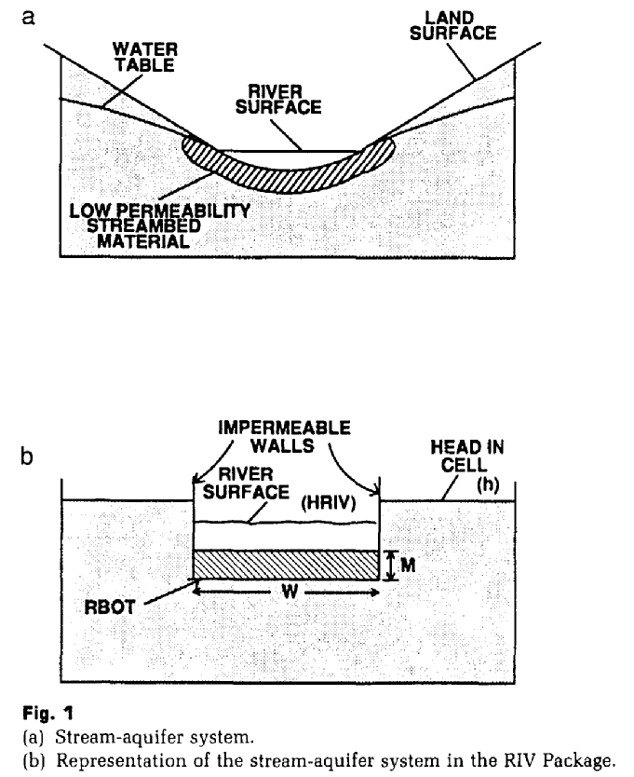
Figure 3. River routing at the scale of major global drainages in NCAR CLM (Anderson and Woessner, 2002).

Third, the proposed research will be tested by applying the methodology to a hydrogeologically well-characterized aquifer. For the purposes of a model test, the Edwards aquifer of Central Texas will be used and described in following section.

5. Case Study: The Edwards Aquifer of Central Texas
In order to verify the improved model, we will test it by applying it to the hydrogeologically well-characterized karst Edwards aquifer. As we are interested in groundwater recharge from surface water flowing over outcrop aquifer area, we will examine a test case of the Guadalupe River basin, located between San Antonio and Austin, Texas. See Figure 4 for a map of the approximate location of the Guadalupe River basin. A map of the Guadalupe River basin and Blanco River (a major tributary of the Guadalupe River) is shown in Figure 5.

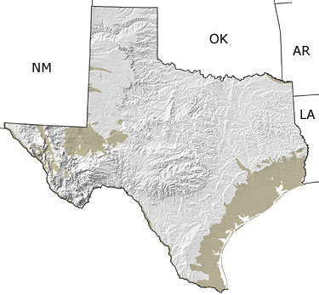
Figure 4. Approximately location of the Guadalupe River basin indicated by blue circle (Figure from: www.paleoportal.org).

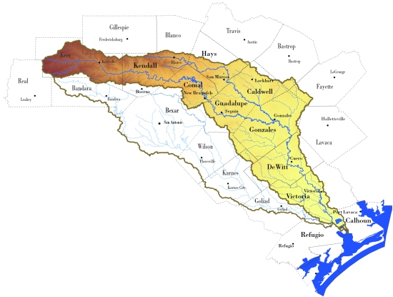
Figure 5. Guadalupe River basin with tributary Blanco River (Figure from the Guadalupe-Blanco River Authority at: www.gbra.org).

The Guadalupe River basin is a suitable test case for the improved model because the river recharges the Edwards aquifer as it flows over the aquifer outcrop. See Figure 6 for a map of the Guadalupe River basin and corresponding Fredericksburg, Washita, and Taylor Groups of the Edwards aquifer. These groups have a high permeability due to faulting along the Balcones Fault Zone and subsequent limestone dissolution, which permits the rapid infiltration of surface water (Mace and others, 2004).

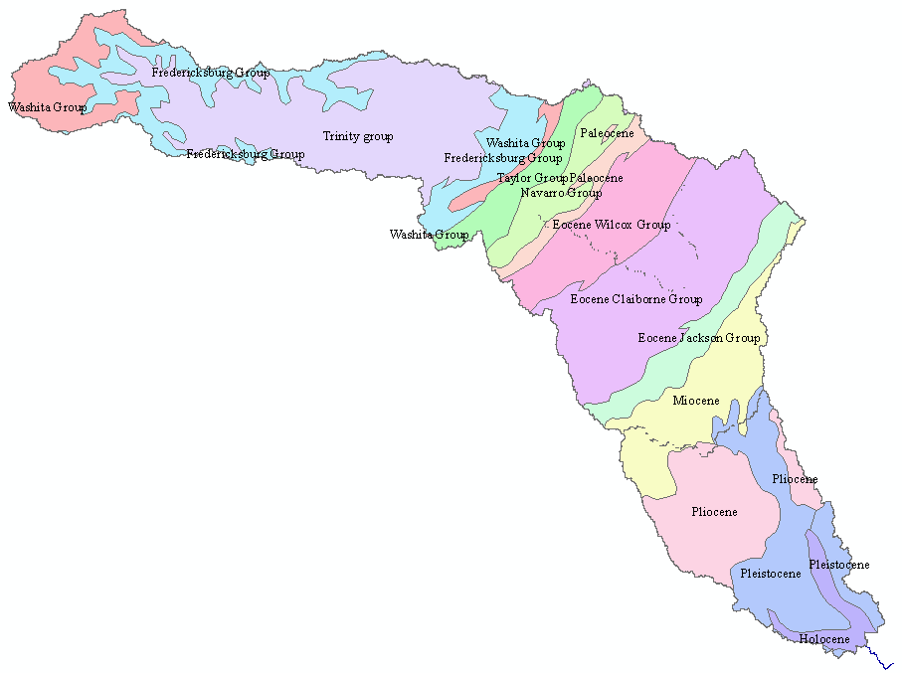
Figure 6. Guadalupe River basin and surface geology of the associated units of the Edwards aquifer, Miocene, Pliocene, Holocene formations towards the Gulf of Mexico.

A three-dimensional view of terrain, streams, and Edwards aquifer outcrop area in the Guadalupe River and neighboring basins is shown in Figure 7. The location of several stream gages maintained by the United States Geological Survey (USGS, 2005) on the Guadalupe River basin is shown on Figure 8. The gages are desirable for use in testing the model, as historic stream flow data can be downloaded rapidly online without charge.

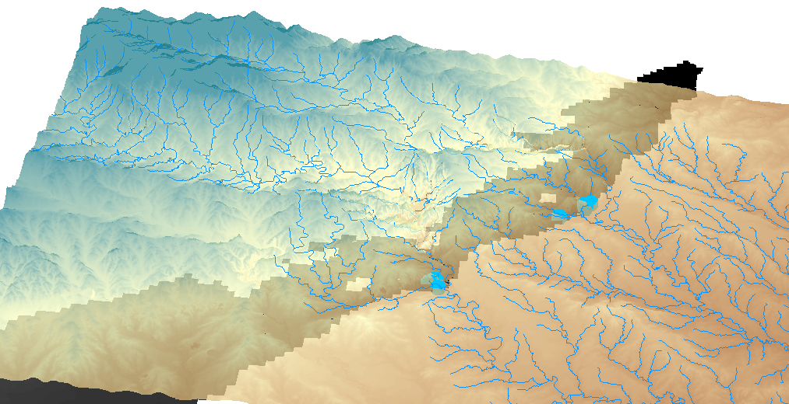
Figure 7 Guadalupe River and neighboring basins indicated with a three-dimensional view of terrain, streams, and Edwards aquifer outcrop area.

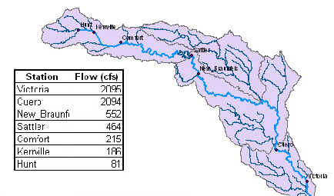
Figure 8 Selection of Guadalupe River basin stream gage locations maintained by the U.S.G.S.

A sample stream flow hydrograph for the Guadalupe River gage at Cuero, Texas is shown on Figure 9.

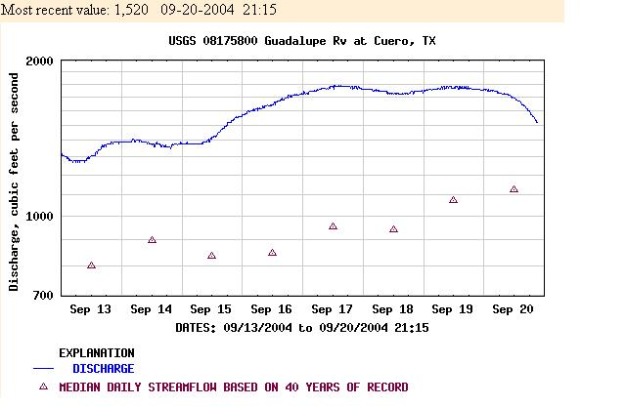
Figure 9. Stream flow hydrograph of the Guadalupe River at Cuero, Texas gage.

Figure 10 shows stream flow on the Blanco River (a major tributary of the Guadalupe River) at the Wimberly and Kyle, Texas gages. During peak runoff events (i.e., greater than 50 cubic feet per second, cfs), stream flow at Kyle (downstream from Wimberly) is greater than that at Kyle, as would be expected. During low flow periods, flow downstream at Kyle is less than upstream at Wimberly. This relationship underscores the importance of stream flow due in the direct recharge of Edwards aquifer (and other karst aquifers) groundwater recharge.

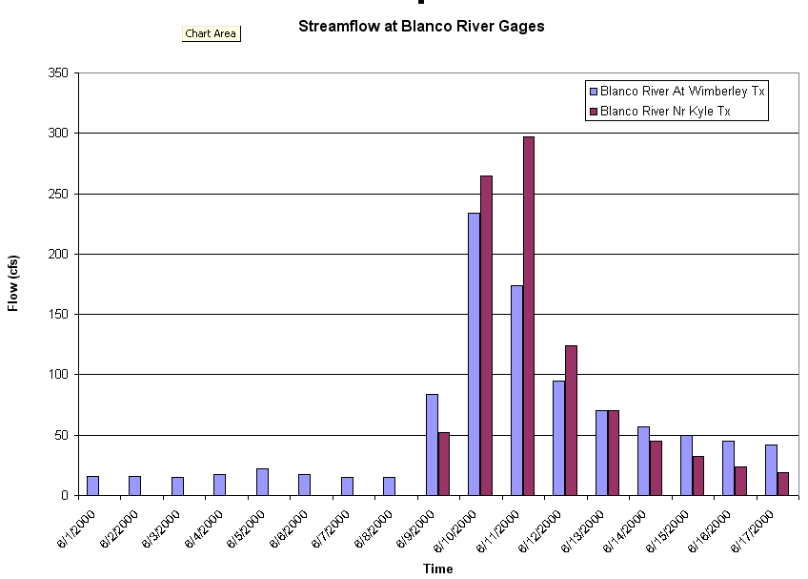
Figure 10. Wimberly and Kyle, Texas gages on the Blanco River (Guadalupe River tributary) indicating groundwater recharge due to stream flow. During low flow events, flow only occurs at upstream Wimberly gage due to groundwater recharge of stream flow.

Within the Guadalupe Basin, runoff from precipitation events controls periods of high stream and resulting elevated groundwater recharge. We will apply the model to the Guadalupe River basin. Based on changes in climate (i.e., precipitation and temperature), resulting runoff to streams and associated groundwater recharge will be evaluated for a variety of climate forcing scenarios on time scales that range from 1 hour (for extreme precipitation events) to annually (for simulations considering long-term, average annual conditions).

6. Expected Results and Benefits
As part of the proposed research project, the following goals will be accomplished:
- Increase model resolution to 1 km² (at least for regional case)
- Improve surface water-groundwater interaction to effectively model groundwater recharge processes of stream flow across an aquifer outcrop recharge area.
- Test methodology in the well-know Edwards aquifer of Central Texas.
The expected results include the generation of a climate, runoff, groundwater model that can accurately assess changes in groundwater recharge in response to changing climatic conditions. The new model will help groundwater resource managers and planners, such as those who currently use the GAMS of the TWDB, to effectively manage future groundwater resources.

7. References
Bonan, G.B., Oleson, K.W., Vertenstein, M., Levis, S., Zeng, X., Dai, Y., Dickinson, R.E., Yang, Z.L., 2002, The land surface climatology of the Community Land Model coupled to the NCAR Community Climate Model: Journal of the American Meteorological Society, p. 3123-3149.

Mace, R. E.; Angle, E. S.; Mullican, W. F., Eds., 2004, Aquifers of the Edwards Plateau: Texas Water Development Board, Report 360

Mace, R. E., 2005, Personal Communication. Director of the Texas Water Development Board Groundwater Resources Division, Austin, Texas.

Maxwell, R.M., Miller, N.L., 2005, Development of a coupled land surface and groundwater model: Journal of the American Meteorological Society, p. 233-247.

NCAR, Climate and Global Dynamics, 2005, Community Land Model [Online] http://www.cgd.ucar.edu/tss/clm [accessed on November 15, 2005].

Sharp, J. M. Jr., 2005, Forgotten and emerging issues in Trans-Pecos groundwater systems: Abstract with Programs - Geological Society of America, Vol. 37, Issue 3, p. 3.

Texas Water Development Board, 2005, Groundwater Availability Modeling [Online] http://www.twdb.state.tx.us/gam/GAM_define.htm [accessed on November 11, 2005].
United States Geological Survey, 2005, Real-Time Data for Texas [Online] http://waterdata.usgs.gov/tx/nwis/rt [accessed on November 13, 2005].

Yarnal, B., Lakhtakia, M.N., Yu, Z., White, R.A., Pollard, D., Miller, D.A., Lapenta, W.M., 2000, A linked meteorological and hydrological model system; the Susquehanna River Basin Experiment (SRBEX): Global and Planetary Change, Vol. 25, Issue 1-2, p. 149-161.

Yu, Z., 2003, On the coupling of climate and hydrology models at a continental scale: Abstract with Programs - Geological Society of America, Vol. 35, Issue 6, p. 526.

Yusoff, I., 2002, Climate change and chalk aquifer groundwater resources in west Norfolk, UK: Bulletin of the Geological Society of Malaysia, Vol. 45, p. 193-200.

