LITERATURE REVIEW:
THE IMPACT OF CLIMATE WARMING ON THE HYDROLOGY GLACIER AND SNOW MELTING IN THE HIMALAYAS

(Andy) Wa Seong Chan
Submitted to: Dr. Zong-Liang Yang
The University of Texas at Austin
GEO 387H
11/20/07
Introduction

Apart from the Arctic Circle and the Antarctica, the Himalaya Mountains are home of the third largest area of glaciers of Earth (Barnett, 2005). More importantly, these glaciers are acting as water towers for much of the South Asia and China region. The water runoffs from the Himalayas glaciers and snow/ice accumulation supply several major rivers with significant portion of their streamflows. It is the head water of the Ganges River in Northern Indua, the Indus River in Pakistan, the Brahmaputra in Bangladesh, the Mekong that descends through China, Myanmar, Thailand, Laos, Cambodia, and Vietnam, the Irrawaddy in Burma, and the Yellow River and Yangtze River rivers in China.

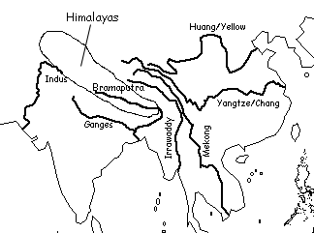
Figure 1. A map showing the major rivers in South and East Asia that originate from the glaciers of the Himalayas.
<http://www.enchantedlearning.com/asia/riveroutlinemapanswers/>

Recent warming trends generated concerns as the rising temperature melt away glaciers in a rapid rate. Some predicted that the glaciers could all be gone in 50 years (Reuters, 2007). This will have an effect on the glacial melt water as a freshwater resource. The Himalayas is sometimes known as the “Water Tower of Asia”. Up to 70% of the summer flow in the Ganges and 50-60% in other rivers come from the melt water in Himalayas (Barnett, 2005). It supplies water to 500 million people in the Indus, Ganges, and Brahmaputra river basins (Rees, 2006, WWF, 2005) and 800 million in China through Yellow and Yangtze Rivers (Asian Economic News, 2007). The change of streamflow pattern and the possibility of reduction in streamflow due to glacier retreat could cause water resources management problems and even the livelihood of more than 1 billion downstream residents.
The global average mean temperature has increased 0.6°C±0.2°C between 1980 to 2000. (Singh, 2004 and 2006) The glaciers in the Himalayas have been retreating as the Earth temperature rised. One of the largest glaciers in the region, the Gangotri glacier in India, has retreated 850 m out of 2 km of its length in the last 200 years (Rees, 2006). It is commonly agreed that the increase in temperature on Earth is caused by the emission of greenhouse gases (such as carbon dioxide, methane, anthropogenic, nitrous oxide, tropospheric ozone) from anthropogenic activities. Temperature in the Himalayan nation of Nepal was predicted by climate-change model to further increase 1.2°C by 2050 and 3°C in 2100 (Cyranoski, 2005). Some experts predict that the Himalayan glaciers will vanish in 40 years (WWF, 2005). This will have a dramatic change in annual streamflow, streamflow pattern, and create water shortage problems in the aforementioned regions.
For this reason, it is important to study how the climate change has affected the hydrology of the glaciers in recent years and predict the future as the Earth continues to get warm.
Experts believe that the melt water runoff will initially increase due to increase in temperature and then decline as glaciers are depleted completely. This makes sense because as temperature increases, the more volume of the glaciers will melt compared to the same time of the year in previous years. However, when the glaciers are all depleted as temperature is predicted to be several degrees higher than present, winter precipitation will fall as rain instead of snow. There will no longer be any snow or glaciers in winter time to hold water until the summer. Moreover, the lack of snow or ice covers increases evaporation from the soil surface, and compound with the increase of soil moisture recharge in the winter due to increased rainfall instead of snowfall, the disappearance of glacier will reduce the total runoff in the rivers.
It is important to note that the current warming and climate change predictions are all based on calibrated models. Different models provide different results as the future climate such as surface temperature and precipitation continue to change in unpredicted ways. However, it is quite certain that the global temperature will continue to increase in a less certain rate. The hydrological models for glacial river runoff predictions can only provide results based on predetermined scenarios (such as how much temperature will increase). In the model results reviewed in this literature review, scientists enter a specific temperature increase into the streamflow model to predict how the specified change in temperature will affect the river streamflow.

Literature Review
Several hydroglacial modeling for the Himalayas region had been performed and published in the last decade. Singh and Kumar (1997) was one of the first such modeling publications. They used the global coupled atmosphere-ocean GCM to provide projection for future climate in hypothetical greenhouse gas emission scenarios. They adopted the European Community HAMburg model (ECHAM) and Large Scale Geostrophic ocean model (LSG) because it showed good simulations with characteristics of the Asian summer monsoon and other features of the Indian subcontinent. The location selected was the Spiti River, which is a major tributary of the Satluj River, which joins the Indus River system. It has an area of 10071 km² with elevation from 2900 to 7000 m. It is located in the greater Himalayan range with about 2.5% covered by glaciers. Majority of the precipitation in this region comes in the form of snow between October and March, and monsoon rain has much less influence than winter precipitation.

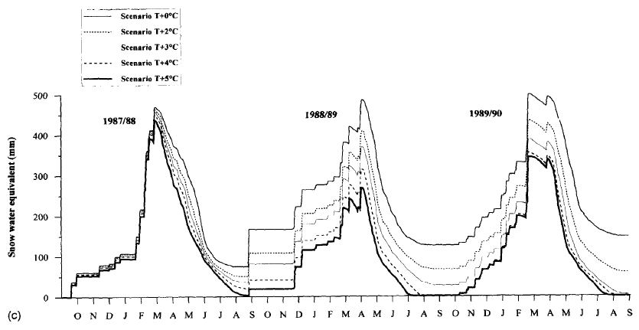
(a) Distribution of Snow Water Equivalent

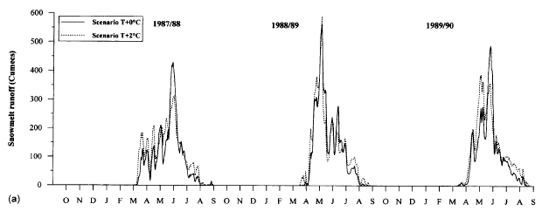
(b) Daily Snowmelt Runoff

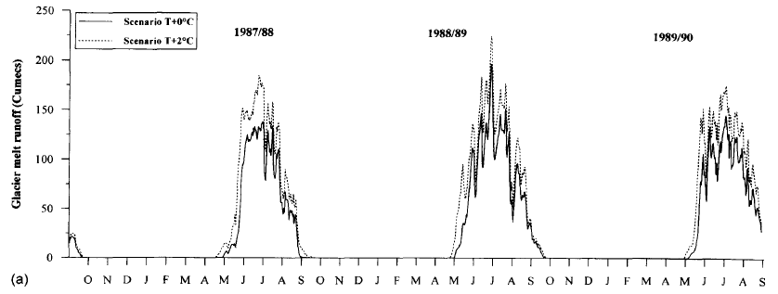
(c) Daily Glacier Melt Runoff
(d) Daily Total Streamflow

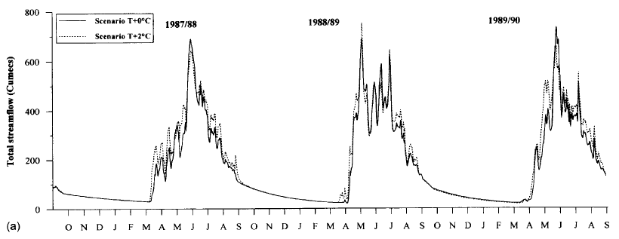
Figure 2. The response of the Spiti River to temperature change scenarios in Singh and Kumar (1997).

The model scenario was set to investigate how streamflow will respond if temperature during 1987 to 1990 was increased by 2°C. The results showed that the snow water equivalent decreased minimally in the first year because the temperature was far below the threshold where snowfall turns into rainfall (Figure 2a). As it warmed in the spring of the following year, the temperature rose to the threshold to turn what was snowfall before the warming to rainfall. The snow never completely melts in the T+0°C scenario. But in the spring of 1989 (the end of the second simulation year), snow completely melted away in the T+4°C and T+5°C scenarios.
The daily snowmelt increased in the early melting months of January to May and decreased in the summer month of June (Figure 2b). The pattern was inconsistent in all three years of simulation because the temperature cycle in those three years were different. The snowmelt peak in the T+2°C scenario was about the same as the T+0°C scenario. The overall snowmelt was, however, higher in the T+2°C scenario because of higher temperature. There was a peak snowmelt in May of 1990 in the T+2°C scenario, and the annual snowmelt in the 1989/90 year increased as well. The additional in snowmelt peak was expected because the melting temperature was reached earlier in the year in the T+2°C scenario.
The glacier melt runoff did not shift in peaks under the T+2°C scenario since glaciers were always present and its availability did not depend on seasons like snowfall (Figure 2c). Glacier melt mostly took place in the summer months of May to September. Its runoff increased in the T+2°C scenario in all months. The total streamflow reflected the combined effects of snow and glacier melts (Figure 2d). Significant increase in streamflow was observed in the spring of 1988 and the early appearance of runoff peak took place in May of 1990. In the T+2°C scenario, the daily snowmelt runoff, glacier melt runoff and total streamflow increased from 4-18%, 33-38%, and 6-12% respectively.
Singh and Bengtsson (2004) used a conceptual snowmelt model (SNOWMOD) together with the same ECHAM+LSG atmosphere-ocean model as Singh and Kumar (1997) to generate the extent of climate change in the Indian subcontinent. The study area is the Satluj River Basin upstream of the Bhakra Dam. This region contains the Spiti Basin studied in Singh and Kumar (1997) and the Satluj River Basin downstream from Spiti. Thus the hydrology of the region consists of mainly snowmelt and rainfall and less percentage of glacier melt. In this publication, Singh and Bengtsson wrote that this basin receives on average 60% of streamflow from snow and glaciers, and only 11% of the area is covered by glacier after the ablation period. This study focused on the contribution of the snowmelt and rainfall, and not the glacier melt, to the streamflow. The model streamflow was calibrated to three years (1986/87, 87/88, and 88/89) of actually streamflow data.
(a) Mean Monthly Snowmelt Runoff
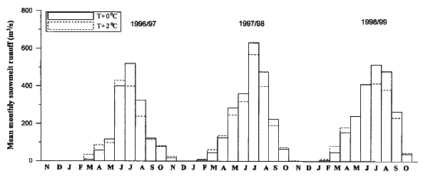
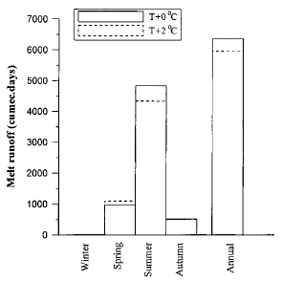
(b) Seasonal Snowmelt Runoff
Figure 3. The response of snowmelt in the Satluj River basin to temperature change scenarios in Singh and Bengtsson (2004).

The snowmelt from this model showed that snowmelt runoff increased in the spring and decreased in the summer, and it stayed the same for autumn and winter (Figure 3a and 3b). The total annual snowmelt runoff decreased 5-6% because of the significant drop in the summer months. This result was different from the snowmelt runoff result in Singh and Kumar (1997) in which snowmelt runoff increased 4-18% overall.
(a) Mean Monthly Streamflow
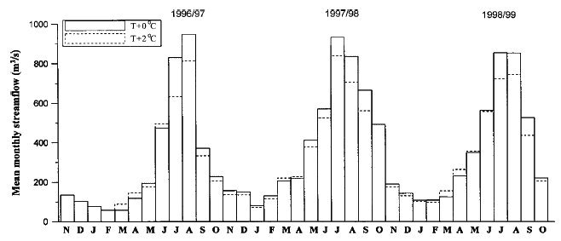

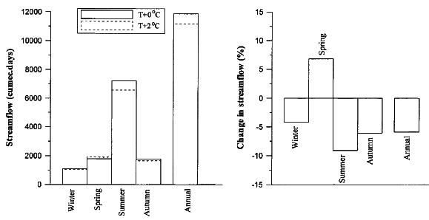
(b) Seasonal Streamflow
Figure 4. The response of streamflow in the Satluj River basin to temperature change scenarios in Singh and Bengtsson (2004).

The streamflow results showed the same trend as snowmelt. The 2°C temperature increase in the Singh and Bengtsson (2004) study predicted snowmelt to increase in spring and decrease in summer, and together with the reduction of rainfall predicted in all seasons created the result in less streamflow annually and in all seasons except spring (Figure 4c). This study indicated that in region where streamflow is dominated by snowmelt from snowfall in winter will experience streamflow higher in the spring and lower in the summer due to early snowmelt. This could be a problem for the downstream water users because water demand is higher in the summer. Water management strategies will have to adjust to this streamflow pattern due to climate warming.
In another modeling study Singh et al. (2006) looked at the Dokriani Glacier basin. Dokriani Glacier ranged from 3950 m to 5800 m above sea level. It was about 5.5 km long and from 0.1 to 2.0 km wide. A gauging station was located 800 m downstream of the glacier and covered a drainage area of 16.13 km². The streamflow data of 1997 and 1998 were used in the study. From the two-year study, it was found that the runoff recorded at the gauging station was contributed 87% by glacier melt and 13% by rainfall.
The SNOWMOD was again used in this study to predict daily runoff. Only four summer months were included in this simulation: June to September. The results showed that the summer runoff increased by 27.4% and 28.4% respectively in 1997 and 1998 (Table 1).
Table 1. The change of basin runoff in different temperature scenarios.
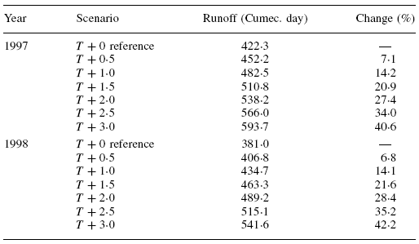

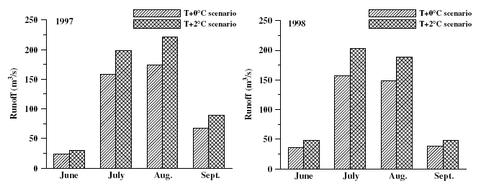
Figure 5. The response of runoff in the Dokriani Glacier basin to temperature change scenarios in Singh et al. (2006).

Table 1 and Figure 5 both showed that the runoff during the summer months in the Dokriani Glacier basin with majority of its runoff from glacier melting. The runoff increase was up to 42.2% when the temperature was increased by 3°C. Runoff increase was observed in all four summer months. The 27.4 and 28.4% increase of runoff in the T+2°C scenario was consistent with the result of 33-38% increase of glacier melt runoff in Singh and Kumar (1997), and with the ~19% increase in Romanche River in French Alps at 2°C warmer presented in another study (Rees, 2004).
Rees and Collins (2006) performed a modeling study to examine how the response of a Western and Eastern Himalayan catchments differ in terms of glacier cover and discharge. The Western catchments are part of the in Batura Glacier in Karakorum, Pakistan and the Eastern catchments are located in the Langtang Glacier in Central Nepal (Figure 6). It was noted in this research paper that relative difference in the results between the Eastern and Western catchments is more important than the absolute values. Since there is a lack of similar simulation results published in the literature, the absolute values in this study will be the emphasis of this literature review.
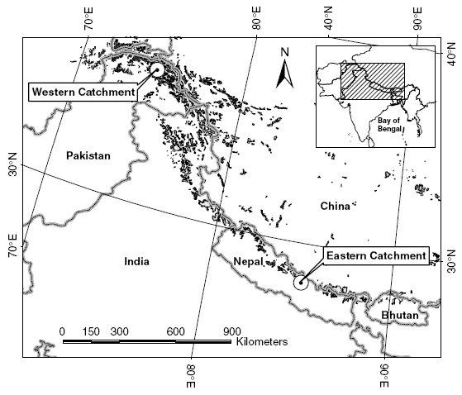 | Figure 6. Location of the hypothetical catchments in Rees and Collins (2006).
The hydro-glaciological model used in this study was a conceptual, semi-distributed model with three parts. There is a rainfall-runoff model, glacier-melt model, and a snowpack module. The largest basin in both nests of catchments was 5000 km². Each catchment has a 50 km² glacier at the headwater. The glaciers were part of larger catchments that contain the glaciers (Figure 7a). The glacier was subdivided into 20 ice bends. The horizontal elevations of these ice bends were placed at 100 m intervals (from 4000m to 6000 m elevations, Figure 7b). This distribution of ice surfaces is typical in alpine valley glaciers (Rees, 2006).
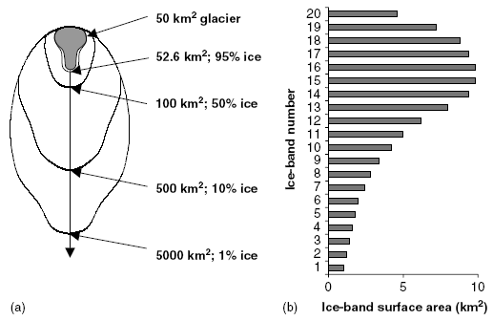 | Figure 7. (a) The model catchments and (b) The ice bends and their surface areas used in Rees and Collins (2006).

The model predicted the ice (glacier) cover area of both catchments in the future 150 years. The results are shown in the figures below.
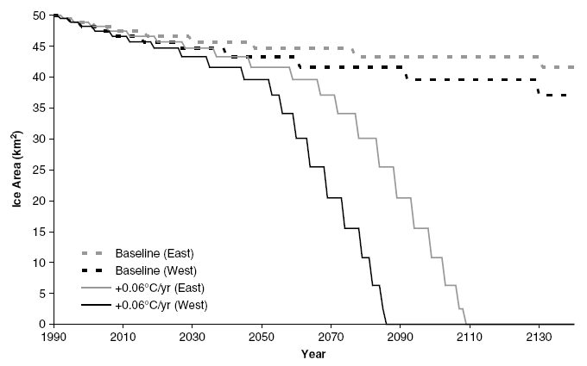 | 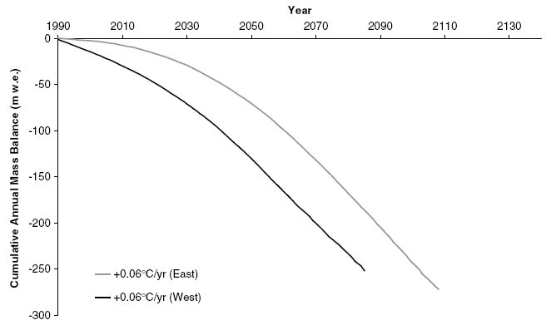
Figure 8. The ice cover area in the future 150 years in Rees and Collins (2006). | Figure 9. The cumulative annual mass balance in the future 150 years in Rees and Collins (2006).

In Figure 8, it is shown that the ice area would decrease from the original 50 km² in 1990 to none in 2086 in the Western catchment and 2109 in the Eastern catchment if temperature would rise at the rate of 0.06°C per year. The baseline curve showed the response in the standard period (1961-1990). The baseline curve is the rate of reduction of ice area if the temperature increase were to maintain at the rate of the standard period. The precipitation was maintained at the standard level in both conditions. The mass balance graph of Figure 9 showed the accumulative annual mass balance of the glaciers. The model predicted that both glaciers would lose more than 250 m water equivalent up to the time when all glaciers are gone.
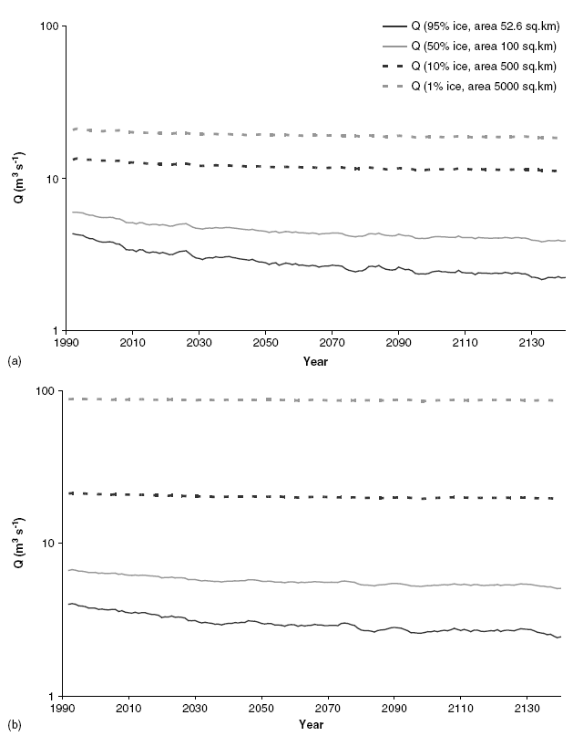 | 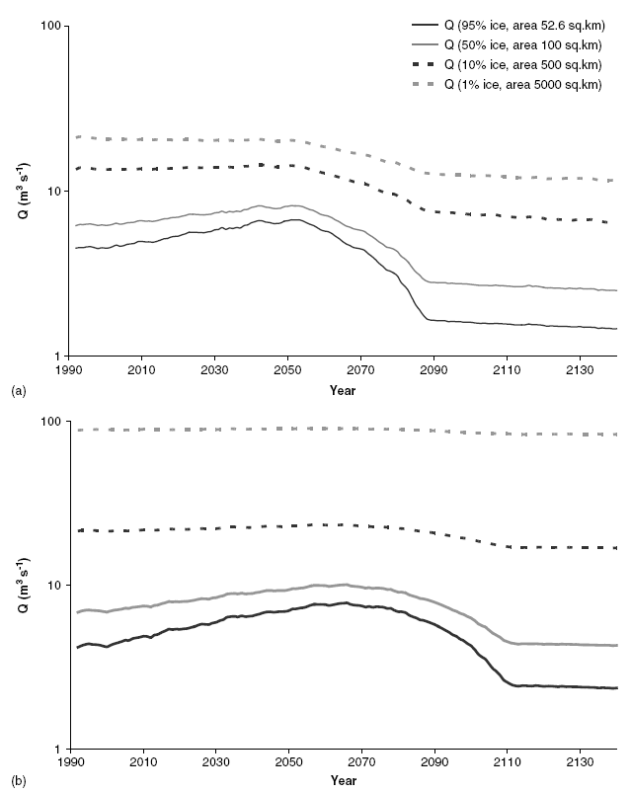
Figure 10. The discharge of the hypothetical catchments in 150 years under baseline condition. (a) Western catchment; (b) Eastern catchment. | Figure 11. The discharge of the hypothetical catchments in 150 years under 0.06°C/year warming condition. (a) Western catchment; (b) Eastern catchment.

The discharge graphs of baseline condition showed a gradual but slight decrease (Figure 10). The decrease is more prominent in catchments with ice area more than 50% (the two solid lines). This slight decrease was due to the gradual loss of ice bends at lower elevations. The change in catchments with less than 50% ice was barely noticeable in this semi-log graph.
The discharge under the T+0.06°C scenario appears very different from the baseline condition (Figure 11). The discharge values from the Western and Eastern sub-basins with 95% glacial area increased gradually until they reached 170% and 150% of the initial discharge respectively. Such increase was less drastic in the catchments with less ice cover percentage (dash lines) since the runoff discharge observed in these catchments would receive larger percentage of runoff from the more consistent rainfall instead of the reducing glacier melt.
At the years when glaciers completely vanished in each catchment, the annual flow decreased by about 33% and between 4 to 18% from the initial values in the Western and Eastern catchments respectively. The higher percentage of reduction in annual flow in the Western catchment indicated that the disappearance of glacier has a greater impact in the Western regions of the Himalayas where the rivers are composed of higher portion of glacier melt water.
The difference of the streamflow at the two catchments in Rees and Collins (2006) showed that the problem of water shortage is worst in regions where the water source is predominantly from snow and glacier melt. The summer monsoon moves from the Bay of Bengal east of India and weakens as it moves into the west. The Eastern catchment thus receives much higher volume of rain annually from the monsoon. The main source of moisture for the Western catchment is from the westerly. The annual precipitation generally decreases from east to the west in the Himalayas. The Western Himalayas will therefore be hit hard when the glaciers are melted away.
Modeling research for the China side of the Himalayas was not commonly found in English literature. Many were published in Chinese and thus harder to find through search engines online. However, some modeling results were available in English literatures which cited from papers published in a Chinese-language Journal of Glaciology and Geocryology (which is not available through the University of Texas web network).
Two journal papers were cited in the report by the WWF (2005). Shi Yafeng (2001) predicted that the temperature in the Qinghai-Tibet Plateau will increase by 2.5°C by 2050. It is more likely that the temperature in the summer will rise by 1.4°C which elevates the equilibrium altitude by 100 m. Qaidam Basin and most of the Qinghai-Tibet Plateau (Northeast of the Himalayas) is covered by continental type glaciers. This type of glaciers is at low temperature, with low level of mass balance, and takes a much longer time to retreat. Xie Zichu et al. (2001) used their model to predict that glacier meltwater runoff would take more than 100 years to reach the maximum in this type of glaciers. The southeast part of the Qinghai-Tibet Plateau is predominantly maritime type glaciers which have higher temperature, high level of mass balance, and are supplied with heavier precipitation. This type of glaciers melts faster, reaches its runoff maximum in 10-30 years, and returns it its initial state in less than 100 years.
According to Shi and Liu (2002) estimated that the maritime (temperate) type, sub-continental (sub-polar) type, and extreme continental (polar) type glaciers each take 22%, 46%, and 32% of all glaciers in China (most located in the Himalayas and Qinghai-Tibet Plateau). They predicted that the glaciers will retreat by 12%, 28%, and 45% respectively on the type of glaciers. The following table summarized the prediction of glacier retreat.

Table 2. Prediction of temperature rise and areal reduction of glaciers in China in the 21st century.
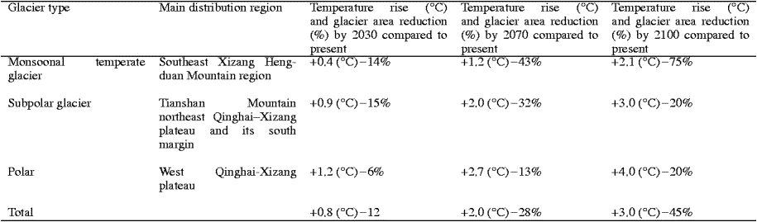
If the reduction of area continues for the monsoonal type glacier after 2100, this type of glacier could completely vanish by around 2130 if the prediction presented in Table 2 is extrapolated. The prediction of complete glacier disappearance is consistent with the prediction found in Rees and Collins (2006).

Conclusion and Summary
It is widely agreed in the scientific community that global temperature will continue to rise in this century. This will have a dramatic effect on the water availability in regions where river runoff consists of high portion of snow and glacier meltwater. The Himalayas is headwater of several major rivers that supply water to about a third of the world population. The retreat and complete melting of Himalaya glaciers will have serious consequences to the inhabitants downstream.
This literature review gathered research papers which presented modeling results of the glacier retreat and streamflow response to climate warming published in the last decade. Most English literature published concerning the Himalayas were work performed for the west and south side of the Himalayas in India, Pakistan, and Nepal. These models (Singh, 1997, 2004, 2006) indicated that snowmelt runoff will start early and may peak early in the spring instead of the summer. Glacier meltwater will generally increases. Together they create higher streamflow in the spring and less in the summer. This could create problems for water resources management because summer is the season of higher water demand for agriculture.
Other models (Rees, 2006) predicted that glaciers could be gone by the end of the century. Streamflow would increase by 150-170% annually before decreasing by more than 30% upon the depletion of glaciers in region with less monsoon precipitation.
Models for the China side of the Himalaya glaciers (and on the Qinghai-Tibet Plateau) focused on the distinction between different types of glaciers (WWF, 2005, Shi, 2000). They predicted that the maritime type glaciers will melt faster than the continental type glaciers. One model predicted that the maritime glaciers could all be melted away by 2130.
It is important to note that the climate change predictions on which all these models were based on are after all just predictions. Climate warming modeling and predictions are hardly accurate and errors always exist. However, these hydrological models offered us a range of things to come. Water Availability is already an issue at the present. It is almost certain that the melting of glaciers will exacerbate the problem, especially at near the upstream of rivers fed by the Himalaya glaciers and other glaciers around the world.
References

An S., Wang Z., Zhou C., Guan B., Deng Z., Zhi Y., Liu Y., and Xu C. et al., 2006. The headwater loss of the western plateau exacerbates China's long thirst. Ambio, 35:271–272.

Asian Economic News, 2007. Melting Himalayan glaciers threaten Chinese water supplies.
Available at <http://findarticles.com/p/articles/mi_m0WDP/is_2007_March_26/ai_n18745537>

Barnett, T.P., Adam J.C., Lettenmaier D.P., 2005. Potential Impacts of a Warming Climate on Water Availability in Snow-Dominated Regions. Nature, 438, 303-309.

Cyranoski, D, 2005. The Long-Range Forecast. Nature, 438, 275-276.

Rees, H.G., Collins, D.N., 2006. Regional Differences in Response of Flow in Glacier-fed Himalayan Rivers to Climatic Warming, Hydrological Processes, 20, 2157-2169.

Reuters, 2007. Vanishing Himalayan glaciers threaten a billion.
Available at <http://www.alertnet.org/thenews/newsdesk/DEL187610.htm>

Shi, Y.F., Liu S.Y., 2000. Estimation on the Response of Glaciers in China to the Global Warming in the 21st Century. Chinese Science Bulletin, 45 (7): 668-672.

Singh, P., Arora, M., Goel, N.K., 2006. Effect of Climate Change on Runoff of a Glacierized Himalayan Basin. Hydrological Processes, 20, 1979-1992.

Singh P., Bengtsson L., 2004. Hydrological sensitivity of a large Himalayan basin to climate change. Hydrological Processes, 18, 2363–2385.

Singh P., Kumar N., 1997. Impact assessment of climate change on the hydrological response of a snow and glacier melt runoff dominated Himalayan river. Journal of Hydrology, 193: 316–350.

WWF Nepal Program, 2005. An Overview of Glaciers, Glacier Retreat, and Subsequent Impacts in Nepal, India and China.
Available at <http://www.panda.org/downloads/climate_change/himalayaglaciersreport2005.pdf.>

Su, Z., Shi, Y.F., 2000. Response of monsoonal temperate glaciers to global warming since the little ice age, Quaternary International, 97-8, 123–131.

