Shiri Avnery
11/24/05
GEO 387H

Quaternary Biomass Burning: Methods of Analysis and Primary Controls on Fire Regimes

Abstract

The interaction between long-term orbital parameters, higher frequency ENSO events, and erratic anthropogenic burning and land use activities has produced Quaternary fire patterns that vary according to the fluctuations in each forcing mechanism and to local environmental conditions. Because accurate records (satellite imagery and archival evidence) of fires exist for only the most recent decades, researchers must employ multiple proxy techniques that represent various spatial and temporal scales in order to understand the multi-faceted relationship between climate, humans, and wildfires. This paper examines the multiple methodologies employed by geologists, geographers, and fire ecologists to study how and why fire regimes have changed through time and space during the Quaternary. Researchers continue to face the difficulty of distinguishing anthropogenic influences on fire patterns from those induced by changing climatic conditions, including those due to short-term El Nino events and longer term orbital mechanisms.

Introduction

Carbon dioxide and methane are two primary greenhouse gases whose fluctuations through time have important implications for global climate. Because biomass burning is one of the most important producers of both CO₂ and CH₄, fires play a vital role in the regulation of greenhouse gases, biogeochemical cycles, and the global carbon budget (Crutzen and Andreae, 1990). While fire has existed since the emergence of vegetation 350-400 million years ago (Crutzen and Andreae, 1990), paleoecological studies demonstrate that local fire regimes—the magnitude, frequency, and intensity of fires—fluctuate on decadal, centennial, and millennial time-scales depending on climate, volcanic activity, vegetation, and, in more recent times, anthropogenic burning practices. Because of the important implications of fire on terrestrial and atmospheric compositions, understanding the driving forces that modify fire behavior is integral to our comprehension of global environmental change, particularly during the late Pleistocene and Holocene when man has become a primary agent of environmental modification. This paper examines how various techniques are employed to identify the causes of variations in Quaternary fire behavior on multiple temporal and spatial scales, specifically distinguishing climatic verses human-induced signals in proxy and historical records.

Methods

Researchers reconstruct fire events using a variety of methods depending upon the spatial and temporal scales of analyses; the studies analyzed in this report use a combination of the techniques described in this section. Documentary records evidence fires of the past few centuries, where the accuracy of such records varies by location and method of documentation; researchers must therefore verify the consistency and accuracy of documentation through time and recognize the areal limitations of the records. The advent of satellite images and remote sensing technologies provide unique opportunities to document and quantify burned areas of the last few decades. Combing various satellite images and performing backscatter analyses also allow researchers to determine which vegetation communities and land use types are most intensely burned by wildfires.
Where direct evidence of fire does not exist, proxy records must be used. Dendrochronological reconstructions provide temporally accurate, short-term histories of fire events. Fires that burn (yet do not kill) trees leave distinctive fire scares that, after carefully counting the tree rings surrounding the scar, can be used to determine the year and season of fire occurrence. Tree ring cores are obtained from multiple (20-30) samples per acre to obtain a complete fire history; surveys of trees can be made on spatial scales from individual stands to regional areas of thousands of square kilometers. Dendrochronological analyses thus provide the most high resolution determination of when a fire occurred, as well as its precise incidence across space. However, the accuracy of such fire reconstructions decreases with time, as younger fires destroy fire scares left by older events. The temporal scale of dendrochronological analyses is further limited by the age of the oldest trees, as fire evidence fades when a tree dies and decomposes. Therefore, accurate dendrochronological analyses are limited to fires that have occurred within the last millennia, and the response of fire to changes in climate or land use can only be examined on short (annual to centennial) time scales.
By contrast, charcoal analyses are well suited for fire reconstructions on centennial and millennial time scales, thereby allowing for the comparison of fire regimes and long-term climate histories. Charcoal is produced by the incomplete combustion of organic matter. Studies have demonstrated that low intensity fires produce more particulate matter and proportionately smaller charcoal particles than high intensity fires (Whitlock and Larson, 2001). Charcoal particles embedded in lake sediments were produced during different fires and deposited via eolean or hydrologic processes from local or regional sources. The amount of charcoal found in a sediment core is therefore a function of the characteristics of the fire as well as the processes of charcoal transport (Fig. 1a). In a well dated core where the method of charcoal production, transport, and deposition have been carefully investigated, the quantification of charcoal particles in different sediment strata can be used to determine historical variations in fire intensity and frequency in a watershed area.
Different sized charcoal particles are used in fire reconstructions (Whitlock and Larson, 2001). Determining the amount of microscopic charcoal (<150 µm) from a pollen slide provides evidence of regional fire on annual (if varved sediments are used) to millennial time scales. The accuracy of the spatial and temporal reconstruction using this method may be reduced, however, due to the potentially larger transport distance and transport time attributed to charcoal particles of this small size. Macroscopic charcoal (>150 µm) quantification from petrographic thin sections or sieved sediment fractions can also be used to characterize fire frequency (Fig. 1b); the larger size of these particles usually ameliorates the accuracy of determining a fire source area, but the temporal resolution of this method is generally diminished to 5-20 years, depending on sedimentation rates. Thus, macroscopic charcoal analyses often lead to general conclusions about a “fire event” that may encompass multiple fires within years or decades of one another, as opposed to individual fires that can be systematically identified. Finally, peaks in charcoal quantities interpreted as fire events must be distinguished from background charcoal, which is present in lake sediments due to secondary processes. For example, erosion and transport of charcoal may occur long after a fire (Fig. 1a), and changes in biomass fuel accumulation (due to previous fires, climate change, or human influence) may change the amount of charcoal produced per fire. Thus, while both dendrochronologic and charcoal analyses provide evidence of paleofires, researchers must recognize the limitations of their reconstructions when using proxy data.

Controls on Fire Regimes

As previously stated, multiple factors determine fire frequency, magnitude, and intensity at a given location, the most important of which are sources of ignition and biomass fuel availability. While lightning incidence is assumed to remain relatively constant through time, humans present additional ignition sources to their surroundings. Humans also employ multiple practices that fundamentally alter natural vegetation communities, thereby affecting the characteristics of the fires associated with inhabited ecosystems. Fluctuations in natural conditions due to short-term climate phenomena (such as ENSO) as well as longer term changes (e.g., due to insolation fluctuations or Milankovich cycles) may also modify vegetation and corresponding fire regimes. Thus, researchers must grapple with the multiple possibilities that produce their observed fire histories and attempt to disentangle climatic verses anthropogenic influences on fire regimes.
El Nino Southern Oscillation and Fire
The El Niño Southern Oscillation (ENSO) is a global climatic phenomenon that affects regions of the earth in different ways and to various degrees; ENSO events also change in their magnitude and periodicity through time, thereby implicating an important temporal as well as spatial fluctuation. ENSO influences regional wildfire occurrence and intensity by modifying effective moisture conditions, the timing and duration of precipitation events, the quantity and type of biomass fuel available, and atmospheric circulation patterns. The 1997-1998 El Niño event generated regional drought conditions that produced increased fire activity across the globe; synchronous fire activity was observed in Central America, the Amazon basin, Africa, and parts of North America and Eurasia (van der Werf et al., 2004).
Kitzberger et al. (2001) document the interhemispheric synchronicity of mid-latitude fire over the past several centuries. The authors compare the southwestern United States to northern Patagonia, Argentina, as these two regions share similar fire-climate relationships and responses to ENSO: in both regions, El Niño events trigger above average precipitation in winter months, providing increased moisture availability to vegetation during the growing season, while La Niña events generate regional drought. Using spectral analysis comparing multiple ENSO records (archival documents, tree-ring calibrated reconstructions, tropical coral, and ice core records) with historical documentation and robust dendrochronological reconstructions of fire chronologies (as described in the Methods section), the authors suggest that increased fire activity has historically occurred in the transitory years from El Niño to La Niña phases (Fig. 2). The authors argue that augmented precipitation during El Niño enhances the production of biomass fuels that are then desiccated during ensuing La Niña-induced droughts, thus creating ideal conditions for the generation and propagation of wildfires. Further, the authors propose that a period of decreased fire occurrence in both northern and southern hemispheric locations (1780-1830), which also corresponds to a decreased correlation between the two regions’ fire records, reflects a time of diminished amplitude and frequency of ENSO events (as demonstrated by the multiple ENSO proxies). Cross spectral analyses between the fire records indicate that during this period of decreased fires, coherence was stronger in the 5-7 year periodicity band than the 2-4 year band, which characterizes common fire occurrence before 1780 and after 1830 (Fig. 3). This analysis provides additional evidence demonstrating an interhemispheric fire signal driven by the strength of ENSO cycles, which maintain lower frequencies and correspondingly fewer fires during 1780-1830.
Insolation and Fire
Depending on the timescale of analysis, the interaction between ENSO and fire must be considered in context of other possible forcing mechanisms. On millennial timescales, climate is primarily controlled by orbital parameters; the examination of millennial-scale fire patterns must therefore account for the potential influence of eccentricity, obliquity, and precessional cycles (with periodicities of 100 kyr, 41 kyr, and 23 kyr, respectively), as well as fluctuations in solar insolation. Millspaugh et al. (2000) use charcoal analyses to produce a 17,000 year fire history reconstruction from Yellowstone National Park, a location where vegetation has remained constant throughout the Holocene despite regional changes in climate. With a fixed vegetation assemblage, the authors argue that the centennial and millennial scale variations in charcoal concentrations and charcoal accumulation rates (CHAR) are primarily the result of insolation-driven climate change.
The authors examined macroscopic charcoal particles (as described in the Methods section) from continuous 1 cm samples, as well as magnetic susceptibility, sedimentation rate, and organic content; these data were compared to a pollen profile from a previously analyzed core, as well as to the July insolation anomaly over the past 17,000 years. The authors found that fire frequency variations strongly correlate with July insolation (Fig. 4). They attribute the low frequency of fires (4/1000 yr) 17,000 years ago to the cool, humid late glacial climate, and the increase in fire frequency (to 6/1000 yr) from 17,000 to 11,7000 years ago to the warmer, drier climate of this time as well as to changes in vegetation from tundra to forest (after which vegetation remained constant). Peak fire frequency (15/1000 yr) occurred at 9,900 years B.P., correlating with the Holocene insolation maximum; since this point, fires have decreased to present day frequencies (2-3/1000 yr) reflecting cooler and effectively wetter conditions. The strong link between climate and fire regime in this region lead the authors to contend that the recent trend toward infrequent and severe fires will be replaced by a regime of smaller, lower intensity fires in the future as a result of the drier climatic conditions predicted by increased levels of CO₂.
Anthropogenic Biomass Burning

While the link between climate and fire regimes has been well established in proxy and historical records, scientists must also allow for the possibility of human-ignited fires and anthropogenic changes in vegetation patterns as sources of variations in regional fire patterns. In Australia, charcoal records indicate dramatic increases after ~ 40,000 yrs before present (B.P.), corresponding with the earliest colonization of the continent by humans, as well as with sharp pollen declines in rainforest conifers and other rainforest taxa (Pyne, 1998). In more recent history, researches have argued that native peoples altered the North American landscape via land clearing for settlement construction, agriculture, cultivation, fuel foraging, and hunting, where the most pervasive and lasting environmental impact was caused by anthropogenic burning (Denevan, 1992). The effect of anthropogenic burning as a modifying force on the landscape largely depends on whether fuel load (dry biomass) or lightning ignition sources limit wildfire occurrence (Vale, 2002). If the magnitude and frequency of fires is already limited by vegetation and climate dynamics, additional burning may not have altered the natural fire regime against a backdrop of frequent lightning strikes and naturally short fire return intervals. By contrast, if lightning ignition sources limit wildfire occurrence where an abundance of biomass fuel exists, anthropogenic burning may play a significant role in modifying the environment.
One area characterized by a lightning-limited fire regimes and where anthropogenic burning could alter fire characteristics is southern California. Minnich (1983) utilize Landsat images to evaluate the occurrence of severe wildfires in southern California and adjacent northern Baja California (Mexico), finding that fire suppression practices in the U.S. affect plant communities differently depending on their unique successional processes, growth rates, fuel accumulation, decomposition rates, and length of flammability cycles. In coastal sage scrub and grassland, suppression has had a minimal effect on fire regime; in chaparral, however, Minnich argues that fire control has created larger, more intense, and faster spreading fires (Fig. 5). Figure 5 illustrates that Baja chaparral is prone to frequent fires that burn less than 800 ha, while southern California chaparral is characterized by fire regimes of less frequent and greater burned area.
Minnich argues that the fire regime in Mexico has likely remained unchanged through time, as suppression practices have not been employed in this country. By contrast, the contemporary fire regime in southern California (where suppression occurs) is a product of the intense coarsening of the chaparral stand mosaic: larger, more pervasive fires and longer fire return intervals allow greater amounts of chaparral to grow to flammable successional stages—when fires do strike, they are therefore more intense, spread quickly, and cover greater areas. However, while humans have purportedly altered the fire regime in southern California chaparral today, Minnich cautions that indigenous burning unlikely changed natural fire characteristics in the past; the nonflamability of chaparral—and thereby the limit of fuel availability—in the initial decades of succession after a fire precludes this possibility. Thus, fire in southern Californian vegetation is only affected when anthropogenic fire suppression practices allow for full chaparral succession to occur.
To investigate the role of man and fire in preserving Central American savanna ecosystems, Robert Dull (2004) uses charcoal in conjunction with stable carbon isotopes, pollen, magnetic susceptibility, total organic content, and charred grass cuticle records from Laguna Lake to examine the historical ecology of the Ahuachapan savanna in western El Salvador. Pollen and average carbon isotopic values indicate that the Ahuachapan savanna has existed at least since 3,300 years B.P.; more evidence from the Holocene is needed to determine the savanna’s precise date and means of origin. The proxy data further indicate that regional inhabitants used frequent burning to prevent shrub and tree encroachment between 2,500 and 500 years ago; a decrease in burning occurred around 500 years B.P. with the arrival of the Europeans and native population decline, as evident by decreased charcoal and increased pollen from tree and shrub (woody) taxa. In this study, charcoal analysis is used to demonstrate that pre-Columbian settlers employed biomass burning to preserve the grass dominated savanna of western El Salvador, and that, despite changing fire practices throughout the late Holocene, the savanna has been generally preserved with some tree and shrub invasion. While anthropogenic burning did facilitate the maintenance and areal extent of the savanna, climate is thus also implicated as a strong driver in determining plant communities and corresponding fire regimes.
Recent remote sensing and Geographical Information Systems techniques allow for clear evidence of the affect of anthropogenic activities on fire regimes. Using a combination of NOAA (National Oceanographic and Atmospheric Administration)-AVHRR (Advanced Very High Resolution Radiometer) hotspot and ERS-2 SAR (European Radar Satellite-2-Synthetic Aperture Radar) imagines able to penetrate smoke and cloud cover (Figs. 6a-b, respectively), Siegert and Hoffmann (2000) quantify the burned area of the Indonesian East Kalimantan province during the ENSO-induced 1998 fire season (January through May): an estimated 1.3 million of 1.85 million ha (71%) was found to have burned in East Kalimanta alone. More importantly, the authors use three separate speckle and texture filtering operations on the ERS-2 images to demonstrate a clear change in radar backscatter and/or image texture depending on the intensity of burned vegetation, thereby providing the means to characterize not only burned areas, but also the degree to which different regions were affected by the wildfires (Fig. 7). These results were verified by AVHRR hotspot data as well as field analyses, leading to the characterization of six subgroups of fires and burn intensity identifiable via remote sensing means: a) weak ground fire in a selectively logged forest; b) medium damage in a logged forest; c) intensive fire in a logged forest; d) complete destruction of a selectively logged forest; e) intensive fire in a pulp wood plantation; and f) completely destroyed pulp wood plantation.
The comparison of vegetation and land use images with those documenting the intensity of burned areas demonstrates a clear correlation between the damage caused by the fires and the intensity of logging operations in Indonesia. The authors argue that high amounts of logging activity generates a heavily disturbed canopy, which fosters dense understory growth and provides ideal fuel conditions for fire intensification and propagation. By contrast, fires in areas of little logging activity have lower thermal energy and thereby cause less damage to trees; the spread of fire is further hindered by the lack of a highly combustible understory and flammable logging wastes. Thus, while the widespread 1997-1998 fires were instigated by a natural ENSO event, the fire regime in certain areas—particularly the spatial extent and intensity of the fires—was likely affected by anthropogenic land use practices.

Discussion and Conclusions

In the attempt to understand regional fire records, the affect of humans on fire regimes must clearly be accounted for (as demonstrated by Minnich, 1983; Dull, 2004; and Siegert and Hoffmann, 2000) in addition to short- and long-term climatic forcing (Kitzberger et al., 2001; Millspaugh et al., 2000). However, in order to suggest an anthropogenically-induced fire regime, one must adequately demonstrate that fire cycles are different from that which climate would portend. The endeavor to evaluate fire histories is further complicated by our proxy records of burning and vegetation, which cannot isolate a possible anthropogenic signal, and which may best represent different temporal and spatial scales with varying degrees of accuracy. For example, charcoal can be transported great distances and particle accumulation may persist long after a fire has occurred, thereby rendering the temporal and spatial resolution of the fire record less than that of tree-ring reconstructions. However, while the true age or source of a fire can not usually be guaranteed by charcoal analyses, they do provide extraordinary insight into investigations where the temporal and spatial resolution of fire occurrence is less important than the general response of an area to long-term land use or climate changes.
Because the boundary between natural and anthropogenic fires is obfuscated by hundreds of thousands of years of human fire practices, researchers may also assimilate multiple climate proxies with archeological knowledge to help distinguish fire ignition sources. Where a comparison can be made between some known prehistorical human population disturbance (due to disease, war, and/or migration) and a sudden change in charcoal abundance, fire can usually be attributed to human influence with relative confidence (e.g. Dull, 2004). With the appreciation that, depending on cultural practices, demographics, and inhabited ecosystem characteristics, the impact of mankind on fire behavior varies in nature as well as spatial and temporal extent, we must limit our generalizations about a monolithic people modifying a homogeneous landscape. Instead, scientists must investigate individual regions to identify the relevant influences on fire regimes—including climate, fuel load fluxes, and human land use—and understand that these factors will distinctly interact to produce a mosaic of environments with unique fire histories through time and space.

References

Crutzen, P.J. and Andreae, M.O. 1990. Biomass burning in the tropics: impact on atmospheric chemistry and biogeochemical cycles. Science 250:1669-1678.
Dull, R.A. 2004. A Holocene record of Neotropical savanna dynamics from El Salvador. Journal of Paleolimnology 32:219-231.
Denevan, W. M. 1992. The Pristine Myth: The Landscape of the Americas in 1492. Annals of the Association of American Geographers 82: 369-385.
Kitzberger, T., Swetnam, T.W., and Veblen, T.T. 2001. Inter-hemispheric synchrony of forest fires and the El Niño-Southern Oscillation. Global Ecology and Biogeography 10:315-326.
Millspaugh, S. H., Whitlock, C., and Bartlein, P. J. 2000. Variations in fire frequency and climate over the past 17,000 years in central Yellowstone National Park. Geology 28:211-214.
Minnich, R. A. 1983. Fire mosaics in southern California and northern Baja California. Science 219: 1287-1294.
Pyne, S.J. 1998. Forged in fire: history, land, and anthropogenic fire. In Advances in Historical Ecology. Ed. William Balee. Columbia University Press.
Siegert, F. and Hoffmann, A.A. 2000. The 1998 forest fires in East Kalimantan (Indonesia): a quantitative evaluation using high resolution, multitemporal ERS-2 SAR images and NOAA-AVHRR hotspot data. Remote Sensing of the Environment 72:64-77.

Vale, Thomas. 2002. “The pre-European landscape of the United States.” Fire, Native Peoples, and the Natural Landscape. Ed. Thomas R. Vale. Washington, D.C.: Island Press, 1-39.
van der Werf, G.R., Randerson, J.T., Collatz, G.J., Giglio, L., Kasibhatla, P.S., Arellano Jr., A.F., Olsen, S.C., Kasischke, E.S. Continental-scale partitioning of fire emissions during the 1997 to 2001 El Niño/La Niña period. Science 303:73-76.

Whitlock, C. and Larsen, C. 2001. “Charcoal as a fire proxy.” Tracking Environmental Change Using Lake Sediments. Volume 3: Terrestrial, Algal, and Siliceous Indicators. Ed. J.P. Smol, H.J.B. Birks, and W.M. Last. Dordecht, The Netherlands: Kluwer Academic Publishers, 75-97.

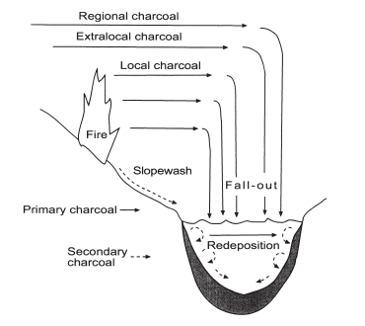

Figure 1a: Schematic diagram illustrating sources of primary and secondary charcoal and processes of charcoal transport and deposition. From Whitlock and Larsen, 2001.

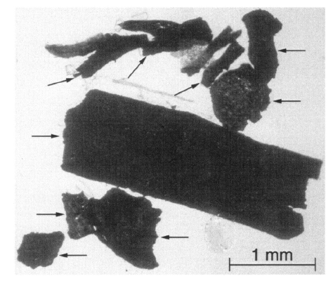

Figure 1b: Macroscopic charcoal particles (arrows) after sieving through 250 µm screen. From Whitlock and Larsen, 2001.
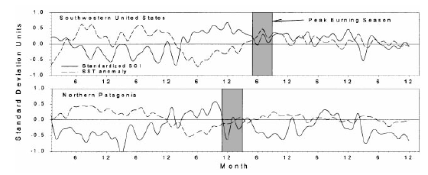

Figure 2: Standard deviations of mean monthly southern-oscillation indices (SOI, Darwin-Tahiti, solid lines) and of sea surface temperature (SST, dashed lines) before, during, and after the years in which largest areas burned in the southwestern U.S. (1914–87, 14 events), and the years with largest number of lightning-caused fires in Patagonia (1938–96, nine events). Shading indicates peak burning season during the study period. Note that La Niña conditions (high SOI values and low SSTs) immediately precede peak burning seasons, while El Niño conditions (low SOI values and high SSTs) occur in earlier seasons and years. From Kitzberger et al. (2001).

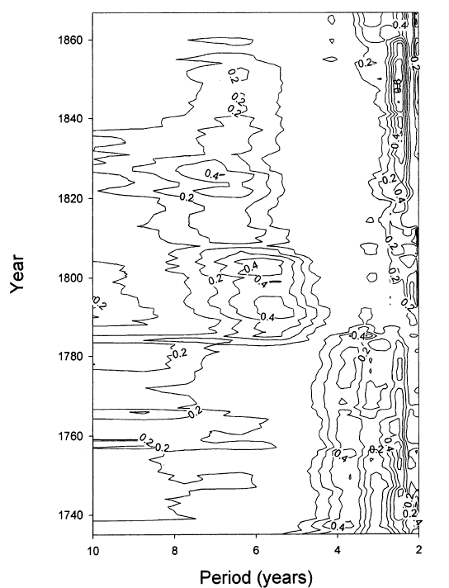

Figure 3: Spectral coherence between the southwestern U.S. and northern Patagonia fire-scar series (1700–1900). Note that during the period of decreased fires (1780-1830), coherence was stronger in the 5-7 year band (red shading) than the 2-4 year band (blue shading), which characterizes common fire periodicities before 1780 and after 1830. From Kitzberger et al., 2001 with shading added by current author.

Figure 4: Charcoal concentration and CHAR with smoothed fire frequencies and the July insolation anomaly record. Note that fire frequencies peak with the insolation maximum approximately 9,000 years B.P. and decrease towards recent times with cooler, effectively wetter conditions. From Millspaugh et al., 2000 with shading by current author.
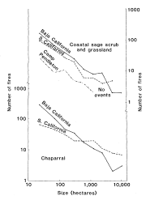

Figure 5: Number of fires plotted against area burned from the study period (1972-1980) in two vegetation communities: coastal sage scrub and grassland (top), and chaparral (bottom). Note that while suppression practices in southern California had little effect on fire regimes in the sage scrub, fires in southern California chaparral have become larger and less frequent than where such practices are not employed (Baja, California). From Minnich, 1983.

Figure 6: A) NOAA-AVHRR hotspot and B) ERS-2 SAR imagines able to penetrate smoke and cloud cover. From Siegert and Hoffmann (2000).

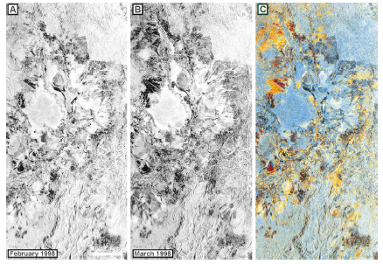

Figure 7: Gamma map filtered, multitemporal ERS-2 image mosaic: A) February 1998; B) March 1998; and C) composite image showing burned areas in shades of yellow through red depending on the severity of damage (red is most severe); blue shades are unburned vegetation. From Siegert and Hoffmann (2000).

