The Debate Surrounding the Hockey Stick
Jeremy Krimmel
Physical Climatology

Fall, 2006
Abstract
Global warming is an issue that has garnered much attention as of late, not only in the scientific community, but in the political and pop-cultural realms as well. It is an issue that has often been represented by Mann’s “Hockey Stick” graph, and scientists fall on one side of the line or the other. Although Mann’s methods in the construction of the “Hockey Stick” might have been questionable, his findings are important enough to be noticed by the international community.
Introduction
In 1998, the article “Global-scale temperature patterns and climate forcing over the past six centuries” written by Michael Mann, Raymond Bradley, and Malcolm Hughes was published in the journal Nature, introducing the world to the “Hockey Stick Model.” The article was praised by many as scientific proof of global warming and the findings were even used as support for global climate policy by the highly influential Intergovernmental Panel on Climate Change (IPCC) in their assessment reports. However, many detractors have brought up points disputing the validity of the findings of this article, lead by such scientists as Ross McKitrick and Stephen McIntyre. The accuracy of the graph and the model of past climate patterns it represents is still a highly contentious area of debate in the scientific community.
Mann’s Side of the Argument
Mann’s paper, released in 1998, garnered much attention from scientists and non-scientists alike because of its surprisingly bold central claim: global warming was being fueled by the increase of greenhouse gases. There is little debate about whether or not the Earth is warming; instrumental data gathered over the past century indicate clearly that it is. Mann’s paper stands out because it attempts to determine first whether the recent warming is uncharacteristic of natural climate patterns in the past and second, if the warming is unnatural, what is causing the warming trend. Mann concludes that the global warming occurring in the past century is uncharacteristic of climate patterns in the past and that this warming is caused primarily by increased greenhouse gas concentrations. As he states himself at the end of the article, “greenhouse gases appear to play an increasingly dominant role during this century.” From his study, he concludes that three of the past eight years have had the greatest mean temperature in the Northern Hemisphere since at least as far back as he measured, 1400 AD.
The method of data acquisition used by Mann was specifically designed to best represent global climate patterns in the past six centuries. Proxy indicators had to be used since no instrumental data is present prior to the 19th century. These indicators included the width of tree rings, isotopic compositions of ice cores, and chemical composition of coral, all of which were designated as a good gauge for past temperature trends. Since the amount of data needed is too large to be acquired by a small group of scientists, Mann solicited a network of paleoclimate researchers for their data. Due to the quality and amount of data he obtained, he termed this data “widely distributed high quality annual-resolution proxy-climate indicators.” Figure 1 shows the places from which the data for his study comes.
One of the larger problems faced by Mann was the issue of climate pattern reconstruction, or reconstructing the patterns of climate in the past based on proxy records. Mann found that conventional approaches were generally ineffective because they were too narrow-focused to be able to deal with multi-proxy indicators. Mann’s solution was simple: the multi-proxy indicators are calibrated with instrumental data in the interval of time in which they overlap, from 1902 to 1995. From this calibration the much longer proxy data set could be used to deduce climate patterns in the past. The main difference with Mann’s approach to climate pattern reconstruction that separated his study from previous ones is that his calibration is based on a statistical method which has been used to fill in sparse early instrumental data sets.
Mann admitted that he made three fundamental assumptions in this method of climate pattern reconstruction upon which the rest of his study is based upon. First, the proxy indicators must linearly represent global climate patterns, not specialized local ones. Second, the proxy indicators must be widely distributed enough to sample all degrees of freedom in climate patterns. Third, the patterns represented by the proxy indicators must be analogous with the patterns represented by the instrumental data, or that the variability within global climate patterns apparent today are similar to those that have occurred in the past.
The temperature field is simplified into dominant patterns of variability, or eigenvectors. These eigenvectors are then ranked based on their contribution to the variance of the data during the calibration period. The first eigenvector is commonly related to the global warming pattern of the past century. Each of the eigenvectors has a distinguishing spatial pattern referred to as empirical orthogonal functions. These are shown in Figure 2 for the first five eigenvectors. Only the empirical orthogonal function associated with the first eigenvector shows an overall spatial trend of global warming. This, along with other data from the study, shows that the first eigenvector is dominant with relation to the climate patterns over the past century, and the subsequent eigenvectors are responsible for spatial or smaller-scale temporal variations in the climate like the El Nino/Southern Oscillation and the North Atlantic Oscillation. These eigenvectors, once verified through calibration with instrumental data, made significant contributions to Mann’s climate pattern reconstructions.
Mann reached several conclusions from the study. He finds that greenhouse gas concentrations, measured by amounts of CO₂ in the atmosphere, do not serve as a significant forcing factor on the climate until the twentieth century. The other factors that dominated the climate patterns prior the twentieth century are solar irradiance and volcanic aerosols. As Mann puts it in the conclusion of the article, “it is reasonable to infer that greenhouse-gas forcing is now the dominant external forcing of the climate system.”
In the article “Northern Hemisphere Temperatures During the Past Millennium: Inferences, Uncertainties, and Limitations” published in Geophysical Research Letters in 1999, Mann expands on the conclusions previously made and presents the famous (or infamous) Hockey Stick graph. He claims that although data prior to the year 1400 exhibit many uncertainties, enough information has been acquired to deduce that the recent warming trend is anomalous in nature. According to his studies, the 1990’s were the warmest decade of the millennium and 1998 was the warmest year. He also downplays the significance of the Medieval Warm Period, a period of time between the years 1000 and 1400 when temperatures were a few degrees higher than in the following years, stating that although this period approached the temperatures of modern day, the 20th century remains anomalously warm.
The most famous part of the paper, however, is the introduction of the Hockey Stick graph. It has grown to represent all that is the global warming debate in scientific communities. Sometimes it seems as if the validity of the theory of anthropogenic causes behind recent global warming rests solely on the validity of the Hockey Stick graph. The first iteration of the graph from the 1999 paper (Figure 3), although somewhat boring and colorless, made a significant impact on the scientific community. The updated version of the Hockey Stick graph is more modern and easier to read (Figure 4). The entire debate about the validity and accuracy of Mann’s studies have boiled down to whether the “Hockey Stick” graph, or model, correctly represents past climate patterns or not.
Opposition to the “Hockey Stick” Model
Not everyone took kindly to Mann and his cleverly named graph. Stephen McIntyre and Ross McKitrick spearhead the opposition to Mann et. al. and their famous “Hockey Stick” model. They argue that unusual methods were used in the study that led the researchers to deeply flawed conclusions. On a more political level, McKitrick believes that the international community is making a huge mistake by rallying behind the “Hockey Stick” model without properly assessing its validity.
The first complaint McKitrick and McIntyre filed against Mann et. al. is that, according to their research, one of the methods carried out during the study, namely the MBH98 method of transforming data collected from tree rings, effectively mined the data for hockey stick patterns. The method in question is a rather unusual technique of transforming data, or an attempt to make the data clearer and easier to analyze by a computer. In Mann and company’s method, each series of tree ring data was transformed by subtracting the series of mean temperatures during the 20th century, dividing by the standard deviation of that same series, then dividing the tree ring series again by the standard deviation of the residuals of a linear trend superimposed on the series of mean temperatures during the 20th century. McKitrick and McIntyre discover that this somewhat strange method was absent from the published article, raising even more alarm in their eyes about its scientific validity. They make the argument that when data without trends is transformed using Mann and company’s method, the result is always a hockey stick shaped pattern (Figure 5). This is especially disquieting to McKitrick and McIntyre because the tree ring series that was used by Mann et. al. has been reported to be essential to the overall shape of the Northern Hemisphere temperature reconstruction. They made a graph (Figure 6) where they believe they correctly analyzed the data collected by Mann and his network, and it differs greatly from the “Hockey Stick.” This data came from ancient bristlecone trees from the western United States, which are not an accurate representation of the climate patterns of the time since they experienced a late growth spurt, unrelated to the climate.
The use of statistics in the study was also particularly disturbing to McKitrick and McIntyre. The Reduction of Error (RE) statistic is used to establish significance in a model. In Mann et. al. (1998), the Reduction of Error statistic assessed the significance of their particular Monte Carlo model, a computation model used to simulate physical systems. An incorrect 99% significance level was reported in Mann et. al (1998) because the Reduction of Error statistic was applied incorrectly. Instead of adapting the Monte Carlo model to one that more effectively simulated the happenings of the data set transformed by MBH98, this data set was deemed more significant to the overall climate patterns of the Northern Hemisphere from the 15th century on than it actually is. Several suggestions are made that possibly could have identified this significance discrepancy early, including the R² and the CE statistics.
McKitrick also finds contention with the influence that Mann et. al. and the “Hockey Stick” model have had over international policy. In particular, he finds that the IPCC has been making wild claims under the guise of science based solely on the conclusions of the “Hockey Stick” model. Not only does he believe that the IPCC are misguiding the global community with their reliance on Mann et. al., he claims they are doing so with intent. A page (Figure 7) from the 2001 highly influential Third Assessment Report published by the IPCC shows the “Hockey Stick” graph dominating one page of the report and data of arguably equal importance given much less space on a previous page. He also notes that the graph appears numerous times during the report, lending to it a sort of significance it otherwise may not have had.
Another study that supports the case made by McKitrick and McIntyre against Mann et. al. was published in 1997 by Shaopeng Huang, Henry N. Pollack, and Po Yu Shen. They drilled over six thousand boreholes on every continent in America and came up with climate patterns that are at odds with the “Hockey Stick” model (Figure 8). Huang et. al.’s study supported a Medieval Warm Period (time period from 1000 AD to 1400) that was warmer than present day, suggesting that the rapid warming we are experiencing today is simply an artifact of natural mechanisms, a part of a cyclical pattern that can be considered today as mild with relation to past warming events. This study received little attention in the assessment reports published by the IPCC and the graph was never featured in any report.

Mann’s Retort
The nay Sayers made such a raucous about the “Hockey Stick” graph that Mann himself published a response to defend his claims and his methods. First of all, as Mann states, the data that McKitrick and McIntyre used to rebuke his claims and perform their own study were inadvertently corrupted data. Therefore, any conclusions they reached based on that data were false.
In a defense against those who believe the bristlecone data to be inherently flawed, he suggests a separate way to come up with the same results without relying so heavily on the bristlecone data. 112 data series were taken total for the original study. 71 of these were individual site records and 31 were weighted averages of larger underlying groups or “Principal Components.” Instead of only relying on two principal components for the data for North America, one of which being the controversial bristlecone series, he suggests using an extra three principal components that were not included originally because of incompleteness of the data. Analysis of these five principal components, Mann states, will result in the same exact “Hockey Stick” graph achieved from analysis of only the bristlecone data series. He also cites ten independent studies that back up his “Hockey Stick” graph.

Conclusions
The final word has not been said in this very contentious and fiery debate, and strong evidence and bold studies on both sides will continue into the foreseeable future. It is a debate that extends beyond the scientific realm into the world of politics and pop-culture. Every day our world leaders make decisions based on the evidence presented by these scientists, and even movies like “An Inconvenient Truth” are applauded with critical acclaim and commercial success. I believe it is fair to say that although it is far too early in our understanding of this issue for any government to latch onto one side of this debate too strictly, our world could suffer dire consequences if Mann et. al. and his “Hockey Stick” model are correct.
Figures

Figure 1: The areas from which data was taken for MBH98.
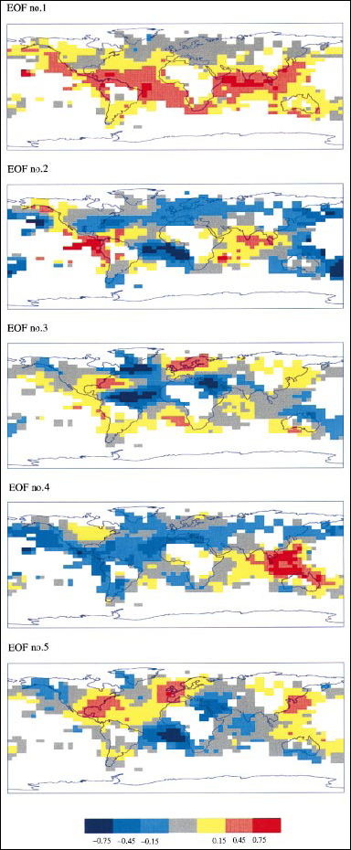
Figure 2: The empirical orthogonal fields associated with the first 5 eigenvectors. Note that only the EOF for eigenvector 1 shows a significant warming trend.
Figure 3: The original “Hockey Stick” graph.
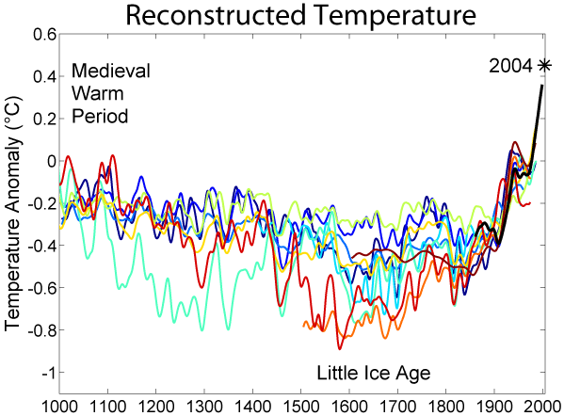
Figure 4: The updated “Hockey Stick” graph.
Figure 5: Two different randomly generated data series both resulted in a “Hockey Stick” shaped graph.
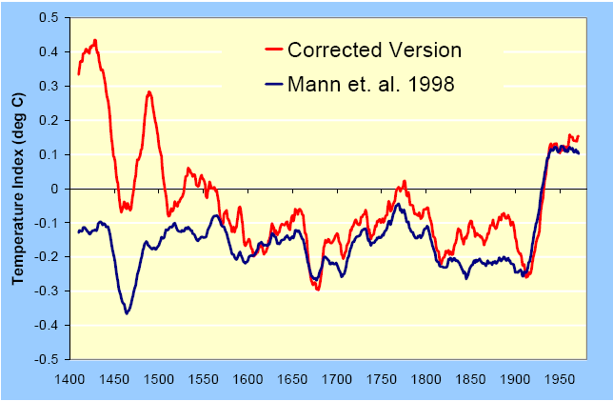
Figure 6: A comparison between the analysis of the same data by both Mann et. al. and McKitrick and McIntyre.
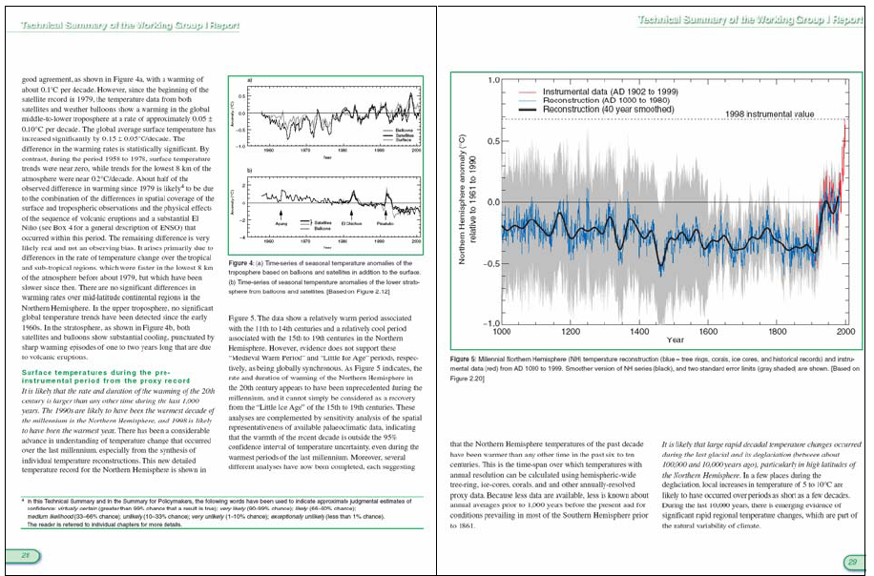
Figure 7: A page from the Third Assessment Report from the IPCC. Note the relative size of the “Hockey Stick” graph on the right in comparison to other visual aids on the left page.
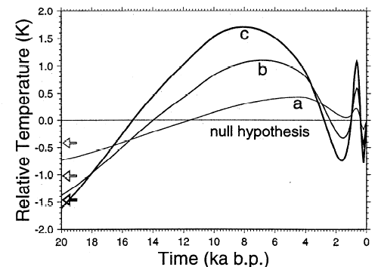
Figure 8: The findings of Huang et. al. by drilling over 6,000 boreholes worldwide.

References
Kerr (2005) Millenium’s Hottest Decade Retains Its Title, for Now, Science, Volume 307

Mann, M.E., R.S. Bradley and M.K. Hughes (1998), Global-scale temperature
climate forcing over the past six centuries, Nature, 392, 779-787.

Mann, M.E., R.S. Bradley and M.K. Hughes (1999), Northern Hemisphere temperatures during the past millennium: Inferences, Uncertainties, and Limitations, Geophyics Research Letters, 26, 759-762.

McIntyre, Stephen and McKitrick, Ross (2005) Hockey Sticks, Principal Components and Spurious Significance, Geophysical Research Letters, Volume 32, Number 3

McKitrick, Ross (2005), What is the ‘Hockey Stick’ Debate All About?

